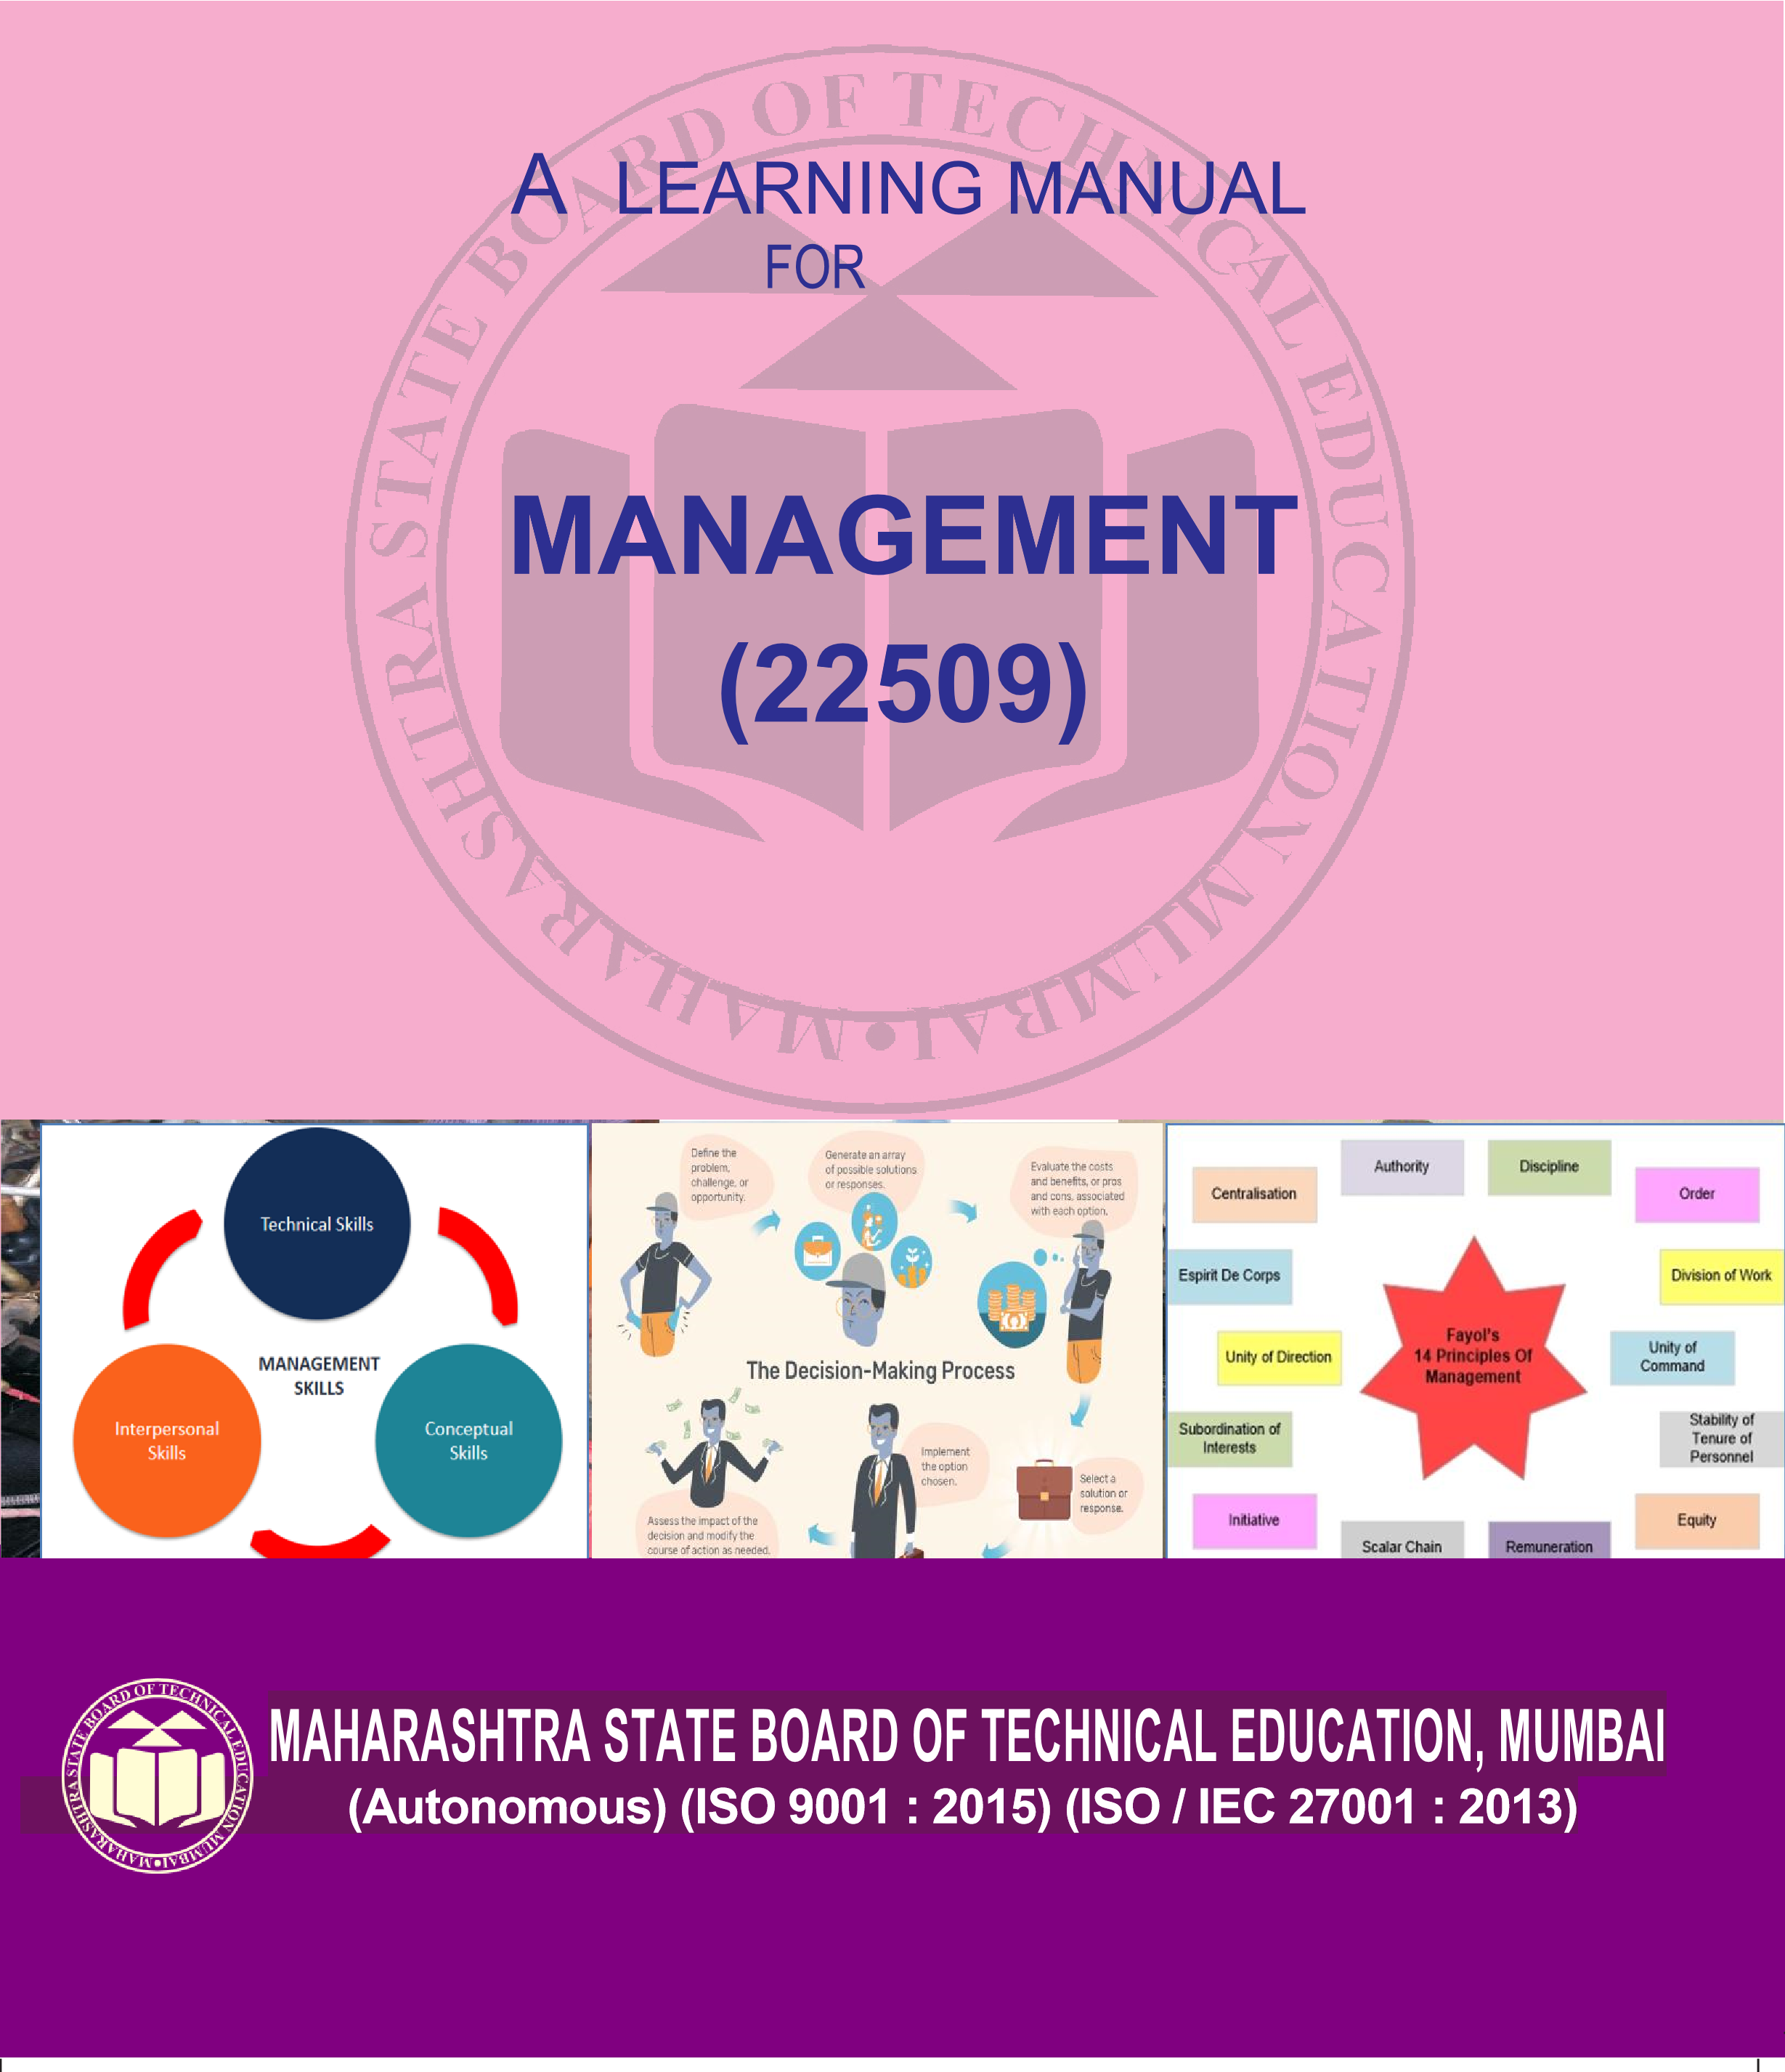 **SEMISTER V AND VI** |  **DIPLOMA IN ENGINEERING AND TECHNOLOGY**



**Nam**

**e**

**Roll**

**No**

.

**20**

**____**

**___**

**Exam Seat**

**No.**

**____________________________**



**A Learning Manual**

**for**

**Management**

**(**

**22509**

**)**

**Maharashtra State**

**Board of Technical Education, Mumbai**

**(**

**Autonomous) (ISO**

**:9001:**

**2015**

**)**

**(ISO/IEC**

**27001:2013)**

|  |
| --- |
| **Maharashtra State**  **Board of Technical Education, Mumbai**  **(Autonomous) (ISO:9001:2015) (ISO/IEC 27001:2013)**  **4th Floor, Government Polytechnic Building, 49, Kherwadi, Bandra (East), Mumbai -400051.** |

|  |
| --- |
| **Maharashtra State**            **Board of Technical Education**    **Certificate**    This is to certify that Mr. / Ms. …………………………………. Roll No……………………….of ………… Semester of Diploma in……...……………………..………………………….of Institute …………………………………….………(Code………………..)  has attained pre-defined practical outcomes(PROs) satisfactorily in course **Management** **(22509)** for the academic year 20…….to 20…..... as prescribed in the curriculum.    Place ………………. Enrollment No……………………    Date:…..................... Exam Seat No. ………………......      **Course Teacher Head of the Department Principal**  Seal of the  Institute |

**Preface**

The primary focus of any engineering work in the technical education system is to develop the much needed industry relevant competency & skills. With this in view, MSBTE embarked on innovative “I” scheme curricula for engineering diploma programmes with outcome based education through continuous inputs from socio economic sectors. As per AICTE guidelines and recommendations of Industry experts, the common course of Management is introduced in all Programmes. Management has many facets in every field and therefore it’s utility to diploma students was essentially to be confined. This was done by involving well known academic and industry experts.

The views of industry and academic experts were further discussed in the academic committee of MSBTE, wherein it was decided to prepare learning material for its uniformity in implementation, understanding and evaluation.

This learning manual is designed to help all stakeholders, especially the students, teachers and instructors to develop in the student the pre-determined outcomes. The manual begins by identifying the competency and course outcomes. The students will become aware about the concepts of Management.

This manual also provides guidelines to teachers to effectively facilitate student-centered activities through each chapter by arranging and managing necessary resources ensuring the achievement of outcomes in the students.

A technologist (engineering diploma holder) has to work in industry with human capital and machines. Therefore, managerial skills are essential for enhancing their employability and career growth. This course is therefore designed to provide the basic concepts in management principles, safety aspects and Industrial Acts required for this group of people.

MSBTE wishes to thank the Learning Manual development team, specifically the Mr. R A Panchal, Chairman of the Course Committee, Industry Experts, Mr. Anant Zanpure, Coordinator & Mr. Sanjay Harip, Co-coordinator of the Programmes and experts for their intensive efforts to formulate the learning material on “Management”. Any suggestions towards enrichment of the topic and thereby course will be highly appreciated.

**(Dr. Vinod M.Mohitkar)**

**Director MSBTE, Mumbai**

.

i

**List of Content**

|  |  |  |
| --- | --- | --- |
| **S. No** | **Name of Topic** | **Page No.** |
| 1. | Introduction to Management concepts and Managerial skills | 01 |
| 2. | Planning and Organizing at Supervisory Level | 32 |
| 3. | Directing and Controlling at Supervisory Level | 60 |
| 4. | Safety Management | 76 |
| 5. | Legislative Act | 98 |
|  | References | 120 |

ii

**Unit No. 1:**

**Introduction To Management Concepts And Managerial Skills**

**Introduction:**

* Management is the art of getting work done through people with satisfaction for employer, employees and public.
* It is the process of designing and maintaining an environment in which individuals, working together in groups, effectively accomplish selected aims.
* All organizations need management for directing and unifying the group efforts through collective action towards a common objective.
* Management may be called anArt as well as Science **:** Art because it requires a range of skills to coordinate and get work done from others and Science because management techniques are concepts based on measurements and factual determinations
* The block diagrams given below are representing the working of an organization without management and with management.

**Resources**

**Man. Machine, Materials**

**Goal/Task to be**

**completed**

**Errors/losses /lack**

**of perfection**

# Figure No 1: Without Management

**Resources**

**Man. Machine,**

**Materials**

**Management**

**Goal/Task to be**

**completed**

**Desired goal achievement/task**

**completion**

# Figure No 2: With Management

Management is the process of effectively utilizing resources like manpower, money, materials and machinery to achieve goals of enterprise through proper methods.

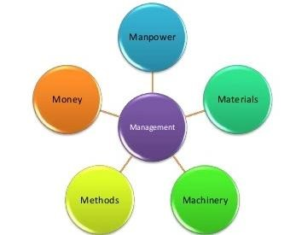

**Figure No. 3 Management**

**1.1 Definitions of Management, Role And Importance of Management:**

As it is very difficult to define management through a single definition, listed below are a few definitions provided by renowned experts.

1. **Mary Parker Follet :**

Management is the art of getting things done through people.

1. **George R Terry:**

Management is a process consisting of planning, organizing, actuating and controlling performed to determine and accomplish the objectives by the use of people and resources.

1. **Ralph C Devis :**

Management is the function of executive leadership anywhere”.

1. **William Spriegal :**

Management is that function of an enterprise which concerns itself with the direction and control of various activities to attain business activities.

1. **Peter Ferdinand Drucker:**

Management is a multipurpose organ that manages a business and manages managers and manages workers and work.

1. **Donald J Clough:**

Management is the art and science of decision making and leadership.

**7.Joseph L Massie:**

Management is the process by which a cooperative group directs actions towards common goals.

**8. F.W. Taylor:**

Management is the art of knowing what you want to do and then seeing that it is done in the best and cheapest way.

**9.John F Mee:**

Management is the art of securing maximum results with minimum efforts so as to secure maximum prosperity for employer and employee and give the public the best possible service.

**10. Harold Koontz:**

It is the art of getting the work done through and with people in formally organized groups.

**Role of Management**

* In any organizational unit, whether it is a company or a section in a company, the manager stands between the organization and its environment. The role of the management is to ensure that the goals of the organization are achieved.
* Today, the society has become very complex and a change in one part generates changes in other parts. These changes are reflected in both tangible and intangible forms.
* Tangible changes are concerned with changes in technology, size of organization, specialization of work and theories which affect the society. Intangible changes are changes in attitude, human values, culture, etc. The challenge of changes can be met by management only.
* Management ensures that all the activities are designed effectively such that the working of each individual employee will contribute to the attainment of the organizational goals.
* Management encourages all individual activities that will lead to reaching organizational goals and discourages those individual activities that will hinder the accomplishment of the organization objectives.

**Importance of Management:**

1. **Optimum utilisation of resources:**

Management brings all the available resources -men, money, machines, materials and methods together for optimum utilization.

1. **Expansion and diversification:** 
   * Management helps the organization to achieve its goals efficiently, systematically, easily and quickly.
   * It helps the organization to face competition to grow, expand and diversify.
2. **Reduction of employee’s absenteeism and turnover:** 
   * Management motivates people. It provides different incentives to the employees which include positive, negative, monetary and non-financial incentives. These incentives increase the willingness and efficiency of the employees.
   * This increases the productivity and profitability of the organization. Management also develops team spirit and increases the efficiency within the organization. It reduces labour turnover and absenteeism.
3. **Utilization of the benefits of science and technology:**

Management utilizes the advancements made in the field of Science and Technology to provide industries with the latest machines and the consumers with the latest products.

1. **Encouraging initiative and innovation:**

* Management encourages initiative from employees and inspires them to give their suggestions for the growth of the organization. Initiative gives satisfaction to the workers and success to the organization.
* Management also encourages innovation. It brings innovative ideas, modern methods, and latest techniques to the organization.

1. **Minimizing wastage:**

Management minimizes the wastage of materials, men and monetary resources by doing work through proper arrangement, manufacturing and control. Managers motivate subordinate to reduce wastage. Reduction in wastage brings a higher return to the firm.

1. **Team work:**

Management always builds a team spirit in the organization. The combined effort of work and unity lead to the prosperity within the Organization. Team work plays an important part in the success of Organization.

1. **Motivation:**

Management motivates employees by sharing the profits in the form of bonus. It also provides many incentives to the employees. This motivates the employee to work harder, which results in higher efficiency in production.

1. **Reduction in labour turnover:**

* Employee turnover takes place when some employees leave the organization and others join in their place. Frequent labour turnover increases the selection and training cost.
* Management creates a sense of responsibility among the employees and helps to reduce labour turnover in the organization.

1. **Higher efficiency:**

Proper management ensures that the efficiency of the organization is high with higher return at minimum investment.

1. **Improving the quality of life of the workers:**

Management offers bonus and incentives to the employees for their work. It provides a healthy work environment. It also provides medical and insurance faculties to worker and their families. It provides a financial stability which helps in boosting the workers’ lives.

1. **Cordial industrial relations:** Management ensures industrial peace. It gives more importance to the ‘Human Element’ in business. It applies positive motivation. All this improves the relations between the employees and the employers.
2. **Corporate image:**

Efficient and effective management maintains a good image and goodwill of organization. This is because of quality of products and services offered by the organization and also due to the social responsibility of organization towards society.

1. **Promotes national development:** 
   * Management is regarded as a key to the economic development of nation. It puts resources to the optimum use. It leads to capital formation and technological advancement. It generates handsome revenue for government.
   * It increases national income and standard of living of people. Thus, it leads to development across all sectors, and significant growth throughout the nation.

1. **It helps society:**

* For any organization, profit is not the only objective. It provides the society with a regular supply of good quality goods and services at reasonable prices.
* It provides employment opportunities to people. It pays taxes to the government which is used for developing the nation. As part of Corporate Social Responsibility, many organizations use their profits to build hospitals, schools, colleges, etc. In this way it contributes towards the uplift of society.

**1.2 Management Characteristics**

**1. Universal**

* The principles and concepts of management are applicable to every type of industry. All the organizations, whether profit-making or not, require management for managing their activities. Hence it is universal in nature.
* However, the practice of management may vary from one organization to another according to their nature.

1. **Goal Oriented**:

All organizations have objectives that are laid down. Management achieves the organizational goals by coordinating the efforts of the personnel.

1. **Continuous process:**

The process of management consists of functions like planning, organizing, directing and controlling the resources to ensure that resources are used to the best advantages of the organization. Management involves continuous planning, organizing, directing and controlling.

1. **Multi-dimensional**:

Management is not confined to the administration of people only, but it also manages work, processes and operations, which makes it a multi- dimensional. It is the unifying force which integrates human and other resources to obtain the desired objectives.

1. **Group activity**:
   * An organization consists of various members who have different needs, expectations and beliefs. Every person joins the organization with a different motive, but after becoming a part of the organization, he works for achieving the same goal.
   * This requires supervision, teamwork and coordination, and it is achieved by, management.
2. **Dynamic function**: 
   * Management is not static. Over a period of time new principles, concepts and techniques are developed and adopted by management. It changes according to the social changes.
   * The working of an organization depends upon various factors like social, political, legal, technological, economical, etc. A slight change in any of these factors will affect the organization’s growth and performance. To overcome these changes, management formulates strategies and implements them.

1. **Authority**
   * Management represents a system of Authority – a hierarchy of command and control. Managers at different levels possess varying degrees of authority.

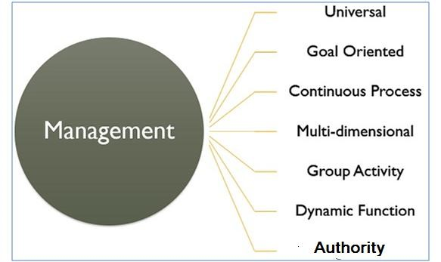

# Figure 4- Principles of Management

**Principles of Management**

|  |
| --- |
| **Taylor’s Principles of Scientific Management** |
| F.W. Taylor is regarded as father of Scientific Management. His principles of scientific |

management are-

|  |  |  |
| --- | --- | --- |
| 1. **Science, Not Rule of Thumb:** This means usingscientific methods to study work and determine the most efficient way of performing specific tasks instead of working by "rule of thumb" or habit. | | |
| 2. **Development of each and every person to his or her greatest efficiency:** | Employees |  |

should be scientifically selected and placed depending upon their skills, capabilities and aptitudes. They should be provided proper training to learn the best method of doing a job.

1. **Harmony, Not Discord**: Harmony means there should be complete agreement on ideas and opinions between workers and management. Discord or difference in opinion will lead to conflicts.
2. **Cooperation, Not Individualism:** This lays stress on mutual cooperation between workers and the management. Cooperation, mutual confidence, sense of goodwill should prevail among both, managers as well as workers. It will replace internal competition with cooperation.
3. **Maximum output in place of restricted output:** By maximizing the production efficiency, the earnings of employees and employers will also increased.
4. **Financial Incentives:** According to this principle the wages paid should be as per performance of the worker. An efficient worker should be paid more than an inefficient worker. This will motivate the workers to become more efficient.

**Henry Fayol’s Principles of management**

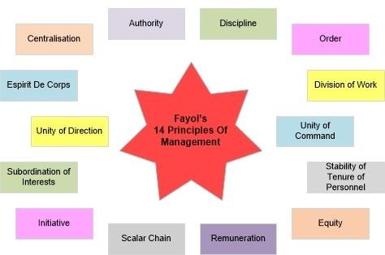

**Figure 5 Fayol’s 14 Principles of Management Henry Fayol** presented 14 principles of management as general guides for Management process and management practice. They are:

1. **Division of work:** 
   * According to this principle, work should be divided among workers according to their personal aptitude and skills.
   * Division of work leads to specialization which is necessary for efficient utilization of labour. This will result in increased efficiency and productivity.
2. **Authority and Responsibility:** 
   * Managers need to have the authority (and with it responsibility) to command their teams. When managers have teams reporting to them they are usually responsible for the team's performance.
   * **A**uthority and Responsibility should go hand in hand and must be related to one another. An executive can do justice to his responsibility only when he has authority.

Responsibility without **A**uthority or vice versa is meaningless.

1. **Discipline:** 
   * Discipline is absolutely necessary for efficient functioning of all sections of an organization.
   * Discipline is described as “respect for agreements that are directed at achieving obedience, application, and the outward marks of respect”.
   * Fayol declares that discipline requires good superiors at all levels, clear and fair agreement and judicious application of penalties.
2. **Unity of command:** 
   * This principle relates to the functioning of personnel. According to this principle, an employee should receive orders and instructions from one superior only.
   * This principle is useful to avoid confusions, mistakes and delays in work.
3. **Unity of direction:**

This is a broader concept than unity of command. It deals with the functioning of the body corporate. According to this principle, each group of activities having the same

objective must have one head and one plan.

1. **Subordination of individual interest to general interest:**

In any organization, the interest of the organization should be above that of the individual. This is necessary to maintain unity and avoid friction among employees.

1. **Remuneration of personnel:**

* Remuneration is the price paid by the organization to its employees for the services rendered by them.
* The remuneration and methods of payment should be fair and provide maximum satisfaction to employee and employer.

8. **Centralization:**

* Centralization means the concentration of authority with top management. In a centralized organization, power is held by head office or a small number of managers, whereas decentralized organizations allow departments and individuals to make decisions.
* According to Fayol, it is important to have a balance between centralization and decentralization for proper working. The appropriate level of centralization will depend on the organizational structure and objectives.

9. **Scalar chain:**

* The unbroken line of authority from the highest level to the lowest levelis calledscalar chain.
* Managers are regarded as ‘Chain of Superiors” from the highest to the lowest ranks and the unbroken line of command and authority should be maintained.
* However the chain may be short-circuited when scrupulous following of it would be detrimental for the organization

1. **Order:**

According this principle, everything(material)and everyone (human being), has a specific place in the organization. They should be arranged such that right material/right person should be located at the right place for effective functioning.

1. **Equity:** 
   * According to this principle, managers should treat all employees/subordinates with fairness, kindness and justice.
   * This will make the employees to be more loyal and devoted towards the organization.
2. **Stability of tenure of personnel:** 
   * Stable and secure work force is an asset to an enterprise. Stability of tenure means ensuring that employees do not leave the company.
   * Instability is a result of bad management and increases the costs of unnecessary labour turnover.
3. **Initiative:** 
   * Initiative is conceived as thinking and execution of a plan. It is one of the keenest satisfactions for an intelligent employee.
   * Managers should encourage and motivate the employees to take initiative which will help the organization to improve.
   * Employee initiative can include employee suggestions, new ideas, solutions to a problem and dealing with situations without being asked to do so.
4. **Esprit de corps:** 
   * This trimanagement emphasizes the need for team work, i.e. harmony and understanding among the employees and shows the importance of communication in obtaining such team work.
   * “Union is strength” is the essence of this principle.

**Levels of Management and their functions**

* + People in an organization are arranged in hierarchy and they all have the relationship of superior-subordinates.
  + The term “**Levels of Management**’ refers to a line of demarcation between various managerial positions in an organization. The number of levels in management increases when the size of the business and work force increases and vice versa.
  + The level of management determines a chain of command, the amount of authority & status enjoyed by any managerial position.
  + Every manager in an organization performs all five management functions. The relative importance of these functions varies along the managerial levels. There may be as many levels in the organization as the number of superiors in a line of command. Some of these levels are merged into one on the basis of nature of functions performed and authority enjoyed.
  + Management may be broadly classified as top level, middle level and lower level management.

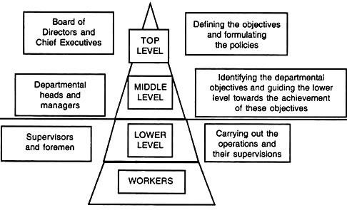

# Figure 6 Levels of Management with Functions

**1. Top Level Management**

* It consists of Board of Directors, Chief Executives, Managing Directors, General managers and Owners. The top management is the ultimate source of authority and it manages goals and policies for an enterprise.
* It devotes more time on planning and coordinating functions.

The functions of the top management can be summarized as follows -

* 1. To lay down the objectives and broad policies of the enterprise.
  2. To issue necessary instructions for preparation of department budgets, procedures, schedules etc.
  3. To prepare strategic plans & policies for the enterprise.
  4. To appoint the executives for middle level i.e. departmental managers.
  5. To control& coordinate the activities of all the departments.
  6. To maintain a contact with the outside world.
  7. To provide guidance and direction.
  8. To be responsible towards the shareholders for the performance of the enterprise.
  9. To design/redesign the organization system
  10. To shoulder financial responsibilities and related functions.

**2. Middle Level Management**

* This level comprises of branch managers and departmental managers like marketing manager, production manager, HRD manager, R&D manager, etc.They are responsible to the top management for the functioning of their departments.
* They devote more time to organizational and directional functions. In small organization, there is only one layer of middle level of management but in big enterprises, there may be senior and junior middle level management.
* Their functions are -

a. To execute the plans of the organization in accordance with the policies and directives of the top management. b. To establish the organization.

* + 1. To make plans for the sub-units of the organization.
    2. To participate in employment & training of lower level management.
    3. To interpret and explain policies of top management to lower level.
    4. To coordinate the activities within the division or department.
    5. To send important reports and other important data to top level management.
    6. To evaluate performance of junior managers.
    7. To inspire lower level managers towards better performance.

**3. Lower Level Management**

* + This level is also known as supervisory level or operative level of management. It consists of Supervisors, Foremen, Section officers, Superintendents, Inspectors, etc.
  + Supervisory management refers to those executives whose work has to be largely with personal oversight and direction of operative employees. They are concerned with direction and controlling function of management.
  + Their functions are -

1. To assign jobs and tasks to various workers.
2. To guide and instruct workers for day to day activities.
3. To be responsible for the quality and quantity of production.
4. To be responsible for maintaining good relation in the organization.
5. To act as a link between top management and workers.
6. To communicate workers problems, suggestions, and recommendatory appeals etc. to the higher level and higher level goals and objectives to the workers.
7. To solve the grievances of the workers.
8. To supervise & guide the sub-ordinates.
9. To provide necessary training to the workers.
10. To arrange necessary materials, machines, tools etc for getting the things done.
11. To prepare periodical reports about the performance of the workers.
12. To ensure discipline in the enterprise.
13. To motivate workers.

**Management, Administration and Organization Management:**

* It is defined as an art of managing people and their work, for achieving a common goal by using the organization’s resources.
* It creates an environment under which the manager and his subordinates can work together for the attainment of objectives of organization.
* Management brings together 5M’s of the organization, i.e. Men, Material, Machines, Methods, and Money for achieving the desired output.
* The main functions of management are planning, organizing, staffing directing and controlling

**Administration:**

* Administration relates to top level of management.
* They are the either owners or business partners who invest their capital in starting the business. They get their returns in the form of profits or as a dividend.
* The functions of administration are legislative and largely determinative. It does not need technical ability.
* It makes policies and decides the goals of an enterprise to be achieved. It is not directly concerned with the implementation of the policies.
* It frames the organizational structure and exercises control over the enterprise.
* It is mainly concerned with decision making, policy making and making necessary adjustments
* It coordinates finance, production and distribution.

**Organization:**

* Organization is the framework of management. It is the function of putting together the different parts of an enterprise into working order.
* Management carries out the policies of Administration through the frame work of organization.
* It is the foundation upon which the whole business is built. Without efficient organization, no management can perform its function smoothly. Strong organization contributes greatly to the continuity and the success of an enterprise. A poor organization structure makes good performance impossible, no matter how good the individuals are.
* It is a structure of relationships among the individuals working together for a common goal.
* Organization is concerned with the building, developing and maintaining of a structure of working relationships in order to accomplish the objectives of the enterprise.
* Organization means the determination and assignment of duties to individuals and also the establishment and the maintenance of authority relationships among the grouped activities.

**Relation between Management and Administration**

The major differences between management and administration are given below:

1. Management is a systematic way of managing people and things within the organization. Administration is defined as an act of governing the whole organization by a group of people.
2. Management is an activity of business and functional level, whereas Administration is a high-level activity.
3. Management focuses on policy implementation; policy formulation is performed by the Administration.
4. Functions of administration include legislation and determination. Functions of management are executive and governing.
5. Administration takes all the important decisions of the organization while Management makes decisions under the boundaries set by the Administration.
6. A group of persons, who are employees of the organization is collectively called Management. Administration represents the owners of the organization.
7. Management can be seen in profit making organizations like business enterprises. Administration is found in government and military offices, clubs, hospitals, religious organizations and all non-profit making enterprises.
8. Management is all about plans and actions, but Administration is concerned with framing policies and setting objectives.
9. Management plays an executive role in the organization. Administration’s role is decisive in nature.
10. The manager looks after the management of the organization, whereas administrator is responsible for the administration of the organization.
11. Management focuses on managing people and their work. Administration focuses on making the best possible utilization of the organization’s resources.

The differences between Management and Administration can be summarized under two categories: -

* + 1. **Functions**
    2. **Usage / Applicability**

**On the Basis of Functions: -**

|  |  |  |
| --- | --- | --- |
| **Basis** | **Management** | **Administration** |
| Meaning | Management is an art of getting things done through others by directing their efforts towards achievement of predetermined goals. | Administration is concerned with formulation of broad objectives, plans & policies. |
| Nature | Management is an executing function. | Administration is a decision-making function. |
| Process | Management decides who should do the activities assigned by Administration& how he should do them. | Administration decides what is to be done & when it is to be done. |
| Function | Management is a doing function because managers get work done under their supervision. It is productive. | Administration is a thinking function because plans & policies are determined under it. It is non productive. |
| Skills | Mainly requires technical and human skills | Mainly requires conceptual and human skills |
| Level | Middle & lower level function | Top level function |

**On the Basis of Usage: -**

|  |  |  |
| --- | --- | --- |
| **Basis** | **Management** | **Administration** |
| Applicability | It is applicable to business concerns i.e.  profit-making organization. | It is applicable to government, military organizations, schools, hospitals etc. |
| Influence | Management decisions are influenced by the values, opinions, beliefs & decisions of the managers. | Administration is influenced by public opinion, govt. policies, religious organizations, customs etc. |
| Status | Management constitutes the employees of the organization who are paid remuneration (in the form of salaries & wages). | Administration represents owners of the enterprise who earn return on their capital invested & profits in the form of dividend. |

**1.3 Functions of Management**

**There are basically five primary functions of management.**

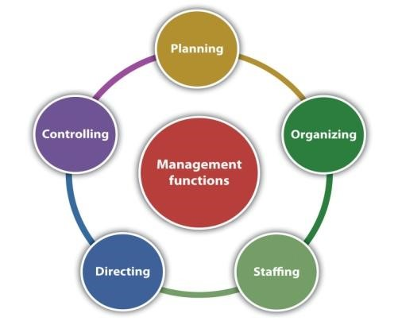

**Figure 7**

**Functions of Management**

1. **Planning** 
   * It is the first step of management function.
   * Planning is deciding in advance what to do, how to do, when to do, who will do and where to do.
   * Planning is essential for utilizing all available resources in the best way to achieve goals, to develop and establish the enterprise.
   * It is a process by which a manager anticipates the future and discovers alternatives to get the work done. Then he decides how best to achieve goals, profit and applying best strategies.
   * Without proper planning, the activities of the enterprise will become confused and ineffective.
2. **Organizing** 
   * Organizing is the second function of management. It follows planning. It is the process by which structure and allocation of jobs is done.
   * Organizing refers to the relationship between people, work and resources to achieve goals.
   * This involves dividing the work into convenient tasks, and grouping them properly into departments and sections. Then the jobs are allotted to proper people with the necessary amount of authority and responsibility.
3. **Staffing** 
   * Staffing is a process of recruitment, selection, acquiring, training, appraising employees. It is a continuous process.
   * Employees are the most important resources of any organization. The right staff is very important for a company because they can change and ensure the organization’s success.

1. **Directing**

* Usingis a process in which the managers instruct, guide and overview the performance of the workers to achieve the company’s goals.
* It includes functions like Leadership, communication, motivation and supervision.
* Leadership: It is the quality of the manager to inspire confidence and trust in his subordinates, get maximum cooperation from them and guide their activities to create an organized effort.
* Communication: It is the process by which ideas are transmitted, received and understood by others for producing desired results. It may be verbal or written orders, reports, instructions, etc. Ineffective communication leads to confusion, misunderstanding and dissatisfaction.
* Motivation : Motivation means inspiring the subordinates to do work or to achieve company objectives efficiently.
* Supervision: Supervision is necessary to ensure that work is going on as per the established plan and the workers are doing work as they were directed to.

**5. Controlling**

* It is a continuous process which measures the current performance and guides it towards the predetermined goal. This process helps the managers evaluate the company’s performance and know whether any change is needed.
* Controlling involves the following steps:

Setting up or establishment of standards:

Measuring the actual performance

Comparing the actual performance with established standards

Take corrective actions if needed

1.4 Types of planning

Planning can be classified on the basis of coverage of activities, importance of contents in planning, approach adopted in planning process, time dimension and degree of formalization in planning process.

1. **Coverage of activity:** Corporate and functional planning
2. **Importance of contents**: Strategic and tactical/operational planning
3. **Time period involved**: Long term and short term planning
4. **Approach adopted:** Proactive and reactive planning
5. **Degree of formalization**: Formal and Informal planning

**Corporate and functional planning**:

**Corporate planning**:

* The planning activities at the corporate level which cover the entire organizational activities are called corporate planning.
* The focus in corporate planning is to determine long term objectives as a whole and to generate plans to achieve these objectives bearing in mind the probable changes in dynamic environment. Corporate planning is the basis for functional planning.

**Functional planning**:

* It is derived from corporate planning. Itis undertaken for each major function of the organization like production, marketing, finance etc.,
* As functional planning is derived out of corporate planning, it contributes to the corporate planning.

**Strategic, Tactical and Operational Planning**:

**Strategic Planning**:

* *Strategic planning* is a process in which the top management determines its vision for the future and identify the goals and objectives for the organization.
* It sets the directions in which the organization wants to proceed in future.
* Strategic planning involves a time span of more than one year and for most of the organization it ranges from the next 3 and 5 years.
* It takes into account all the external factors, strengths and weaknesses, risks,etc and makes a long term policy for the organization.
* Examples of strategic planning may be diversification of business into new lines, new products, planned grown rate in sales etc.

**Tactical planning**:

* It is an extension of strategic planning. Tactical plans are created for all levels of organization. It is concerned with the integration of various organizational units. It involves how the resources should be used to achieve the strategic goals.

**Operational planning**:

* This planning is done by lower level management. It is concerned with day to day operations of the organization. It is detailed and specific and usually based on past experiences. It covers functional aspects like finance, production human resources, etc. The time span for operational planning is less than one year.
* The examples of operational planning may be adjustment of production within available capacity, increasing the efficiency of the operating activity by analyzing past performance. **Long and short term planning**:
* The long term planning is strategic in nature and involves more than one year period and can extend to 15 to 20 years or so.
* Short term planning usually covers one year. Short term plans are made with reference to long term plans because short term plans contribute to long term plans.

**Proactive and reactive plans**:

Planning is an open system approach and hence it is affected by environmental factors which keep on changing continuously. The organization’s response to these changes differs. Based on these responses planning may be proactive and reactive.

* Proactive planning involves designing suitable courses of action in anticipation of likely changes of environment.
* Managers adopting proactive changes do not wait for environment to change, but take action in advance of environmental changes. For this, continuous scanning of environment is necessary.

**Reactive planning:**

* In reactive planning response comes after environmental changes take place. By the time organization responds to change in environment there may be further change in environment.
* Hence this type of planning is suitable in the environment which is fairly stable over a long period of time.

**Formal and informal planning**:

* Formal Planning:

Large organizations undertake planning in a formal way. Generally a separate corporate planning cell is formed at higher level. The cell is staffed by people of different backgrounds like engineers, economists, statisticians etc., depending upon the nature. The cell continuously monitors the environment. When environment shows some change, the cell analyses the environment and suggest suitable measures to take the advantage of the changing environment. This type of planning is rational, systematic, regular and well documented and called formal planning.

* Informal planning:

Informal planning is undertaken generally by small organizations. This planning process is based on manager’s experience, intuitions rather than based on systematic evaluation of environmental changes.

* This planning process is part of manager’s regular activity and is suitable for small organizations.

**Steps in planning**

The planning process is different from one plan to another and one organization to another. The steps generally involved in planning are as follows:

**1. Establishing goals/objectives**

**Steps 2.Establishing planning premises**

**In 3.Deciding the planning period**

**Planning 4.Evaluation and selection of**

**5.Developing derivative/supportive**

**6.Measuring and controlling the**

**process**

# Figure 8 Steps in Planning

1. **Establishing goals/objectives:** 
   * + The first step in planning process is to determine the enterprise objectives. These are set by upper level managers after number of objectives has been carefully considered.
     + The objectives set depend on the number of factors like mission of the organization, abilities of the organization etc., Once the organizations objectives are determined, the section wise or department wise objectives are planned at the lower level.
     + Defining the objectives of every department is a very essential one; then only clear cut direction is available to the departments. Control process is very easy if the objectives are clearly defined.
2. **Establishing planning premises:** 
   * + This is the second step in planning. It involves the conditions under which planning activities will be undertaken.
     + Planning premises are planning assumptions or factors like the expected environmental factors, pertinent facts and information relating to the future such as general economic conditions, population trends, competitive behaviour etc.
     + The planning premises can be classified as below:
     1. Internal and External premises.
     2. Tangible and Intangible premises.
     3. Controllable and non-controllable premises.
3. **Deciding the planning period:** 
   * + Once the long term objectives and planning premises are decided, the next task is to decide the period of the plan.
     + Some plans are made for a year and in others it will be decades. Companies generally base their period on a future that can reasonably be anticipated.
4. **Identification of alternatives:**

**T**he next step in planning is identifying alternatives. A particular objective can be achieved through various actions. For example an organization’s objective is to grow further which can be achieved in several ways like expanding in the same field of business orproduct line, diversifying in other areas, joining hands with other organization, acquiring other organizations and so on. With each category there may be several alternatives.

1. **Evaluation and selection of alternative:** 
   * + After the alternatives are identified, the next step is to evaluate the alternatives according to the premises and goals, and to select the best course of action.
     + This is done with the help of quantitative techniques and operations research. In addition, software packages are available for evaluating alternatives.
2. **Developing derivative/supportive plans:**

After the best plan is selected, various other plans are derived so as to support the main plan. These may be plans for buying equipment, buying raw material etc. They are derivative plans /supportive plans formulated to support the main plan.

1. **Measuring and controlling the process:**

Managers need to check the progress of their plans so that remedial action can be taken to make plan work or change the plan if it is unrealistic. Hence process of controlling is a part of any plan.

**1.5 Types of Organization**

* + - Organization involves identification and grouping of activities to be performed and dividing them among the individuals and creating authority and responsibility relationship among them for the accomplishment of organizational objectives.
    - Organizing being process, consists of departmentalization, linking of departments, defining authority and responsibility and prescribing authority relationships. The organization structure is the result of this process.

**Organization structure**

* + - An organization structure shows the authority and responsibility relationship between the various positions of the organization by showing who reports to whom.
    - It is a set of planned relationships between groups of related functions and between physical factors and personnel required for the achievement of organizational goal.
    - A good organization structure should not be static but dynamic. It should be subject to change from time to time in the light of changes in the business environment.

**Principles of Organization:**

* + - In order to facilitate the achievement of objectives, management thinkers have laid down certain principles of organization.
    - These principles are guidelines for planning organization structure. Therefore, thorough understanding of the principles of organization is essential for good organization.
    - Few common principles of organization are discussed below:

1. **Objectives:** The objectives of the enterprise influence the organization structure. Every part of the organization and organization as a whole should be geared to the basic objective determined by the enterprise.
2. **Specialization:** Effective organization must promote specialization. The activities of the enterprise should be divided according to functions and assigned to persons according to their specialization.
3. **Span of control:** The number of subordinates that an executive or managers can supervise directly is called span of control. A manager can directly supervise only a limited number of workers. Hence, it is necessary to have a proper number of subordinates answerable to a manager. A maximum of six is normally acceptable for this purpose. Span of control may be wide or narrow depending upon many factors.
4. **Exception:** This principle requires that organization structure should be so designed that managers are required to go through the exceptional matters only.All the routine decisions should be taken by subordinates, where as problems involving unusual matters and policy decision should be referred to higher levels.
5. **Scalar principle:** This is also known as chain of command. There must be clear lines of authority running from the top to the bottom. Authority is the right to decide, direct and coordinate. Every subordinate must know who his superior is and to whom policy matters beyond his own authority must be referred for decision.
6. **Unity of command:** Each subordinate should have only one supervisor whose command he has to obey. Dual subordination must be avoided, for it causes uneasiness, disorder, and indiscipline and undermine of authority.
7. **Delegation:** Proper authority should be delegated at the lower levels of the organization also. The authority delegated must be equal to responsibility i.e. the manager should have enough authority to accomplish the task assigned to him.
8. **Responsibility:** A superior should be held responsible for the acts of his subordinates. No superior should be allowed to avoid responsibility by delegating authority to his subordinates. 9) **Authority:** Authority is the tool by which a manager is able to accomplish the desired objective. Hence, the authority of each manager must be clearly defined. Authority and responsibility must be coexistent in the organization.
9. **Efficiency:** The organization should be able to attain the mission and objectives at minimum cost.
10. **Simplicity:** The organization structure should be as simple as possible with minimum number of levels. A large number of levels of organization means difficulty of effective communication and coordination.
11. **Flexibility:** The organization should be flexible, should be adaptable to changing circumstances. It should permit expansion and replacement without dislocation and disruption of the basic design. A sound organization must avoid complicated procedures, red-tape and excessive complication of control so that it may adapt itself easily and economically to business and technical changes.
12. **Balance:** There should be reasonable balance in the size of various departments, between centralization and decentralization. There must be balance in the formal structure as regards to factors having conflicting claims.
13. **Stability**: It refers to the capacity of the organization to withstand the losses of key personnel without much loss to the working.

15)**Communication**: It is the process of transmitting instructions, ideas, suggestions and information within the organization and to outside customers, suppliers and all those who are affected. Good two way communication is essential for effective functioning.

1. **Unity of direction:** There must be one objective and one plan for a group of activities having the same objective. Unity of direction facilitates unification and coordination of activities at various levels.
2. **Personal abilities*:*** As organization is a formal group of people there is need for proper selection, placement and training. Organization structure must ensure optimum use of human resources.

**Types of organization**

The common types of organization are:

1. Line, Military or Scalar Organization
2. Functional Organization
3. Line and Staff Organization
4. Project Organization

**1. Line, Military or Scalar Organization**

* Line organization is the simplest and oldest type of organization. It is also known as scalar or military organization.
* This is called military organization as it resembles old military organizations where discipline is of high order. Orders and instructions issued from the top level is followed by the people below.
* The line organization represents the structure in a direct vertical relationship in which authority flows vertically downward from top to bottom throughout the organization.
* As the flow of authority moves from top to bottom, this is also called line or scalar organization.
* People at different levels know to whom they are accountable.
* The quantum of authority is highest at the top and reduces at each successive level.
* The superior communicates his decision and orders to his subordinates. The subordinates, in turn, can communicate them to those who are immediately under them.
* Figures below represent the structure of line organization.

Figure a represents a line organization having three main departments like production, finance and marketing. Here the flow of authority is from general manager to each department head, superintendent, foreman and then workers.

In figure b, the authority flows from works manager to Superintendent to foreman and then to workers.

.

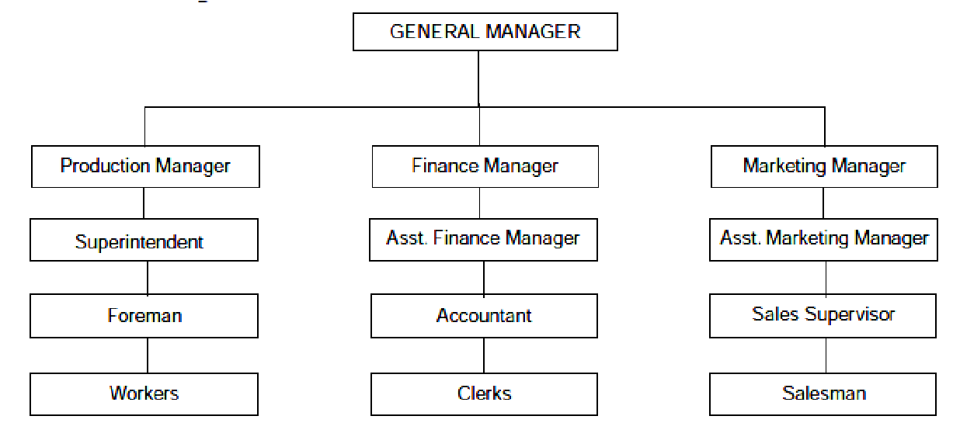

**F**

**igure 9**

Works Manager

Su

perintendent 1

Superintendent 2

Foreman 1

Foreman 2

Foreman 3

Foreman 4

Workers

Workers

Workers

Workers

# Figure 10 Line Organization

**The advantages of line organization are** 1. It is simple and easy to understand.

1. Is flexible and easy to expand or contract.
2. There is a clear division of authority and responsibility, hence no scope of shifting the responsibility.
3. There is a clear channel of communication, so there is no chance of confusion.
4. It encourages speedy action.
5. It is strong in discipline.

**Disadvantages**

* 1. There is lack of specialisation.
  2. Departmental heads are over-burdened with various routine jobs, so they do not have time for further expansion and planning.
  3. It overloads a few key executives.
  4. Due to lack of specialization, there may be chances of accidents, wastage of material and man hours.
  5. Chances of delay in communicating the orders of General Manager or any other departmental head to the workers and, therefore, possibility of distortion, due to long channel.
  6. It encourages dictatorial way of working.
  7. It has no means of rewarding good workers.

**Applications:**

1. Suitable for factories of small and medium size, where the number of subordinate and operational staff is less.
2. Suitable for continuous process such as sugar, paper, oil refining, spinning and weaving industries, textiles, etc.
3. Suitable where labour problems are not difficult to solve.
4. Suitable where automatic plants are used.

**2. Functional Organization**

* The line organization does not provide specialists in the structure. Many jobs require specialized knowledge.
* In functional organization the specialists are made available in the top positions throughout the enterprise.The functional organization was introduced by F.W.Taylor. Figures 1 and 2 below represent line and staff organization
* Under functional organization, various activities of the enterprise are classified according to certain functions like production, marketing, finance, personnel etc., and are put under the charge of functional specialists as show in fig1
* A functional in charge directs the subordinates throughout the organization in his particular area of business operation. This means that subordinates receive orders and instructions not from one superior but from several functional specialists.

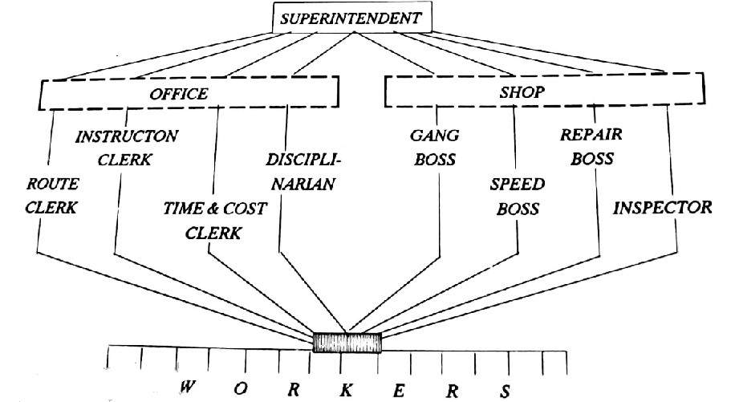

# Figure 11 Functional Organization

• In figure11 , there are 8 functional foremen like route clerk, speed boss, inspector, etc who are specialists in their own fields. Each specialist provides expert advice to workers in his field and workers receive orders and instructions from eight superiors.

**Advantages of functional organization**

1. Due to specialisation quality of work is better.
2. This system provides more specialised knowledge and guidance to individual workers through experts.
3. It helps mass production by standardisation and specialisation.
4. If any operation needs improvement, it can be improved even up to the last moment.
5. Considerable expansion of the factory is possible.
6. As expert guidance is available, chances of accidents, wastage of materials, man and machine hours are reduced. This will reduce prime cost.
7. Unnecessary overloading of responsibilities will not be there, as was in the case of line organization.
8. No special knowledge of workers is required as the instructions are supplied by drawing and experts.
9. The line executives are spared from routine specialized decisions.

**Disadvantages**

1. As each worker is responsible to all experts, it becomes difficult to maintain discipline
2. By employing high waged experts, the total cost of job may become high.
3. As line workers will not be using their skills, their initiative cannot be utilised.
4. It is very difficult to fix up the responsibility to any one foreman in case something goes wrong.
5. Workers will always be confused about the authority and activity of each expert.
6. Proper co-ordination of the work of different departments is required but it is difficult to maintain as everybody is working individually.
7. Lack of coordination among functional executives will delay decision making.
8. Industrial relationships become more complex.

**Application:**

• Due to the above disadvantages, a pure functional system is rarely found. However in modified form, it is used in a few modern advanced concerns.

**3. Line and Staff Organization**

Figures 12 and 13 below represent line and staff organization. Here the line executives are marked vertically and staff executives are placed horizontally.

* Line and staff organization has advantages of both line and functional organization.
* Here, the line executives have supervisory authority and control over subordinates. Authority flows from top to bottom as it does in the line organization
* In addition, specialists called staff are recruited to advisethe line executives on important matters. The final decision whether to accept and implement the recommendations of staff lies with line executives.
* The staff officials do not have any power of command in the organization as they are employed only to provide expert advice to the line manager.

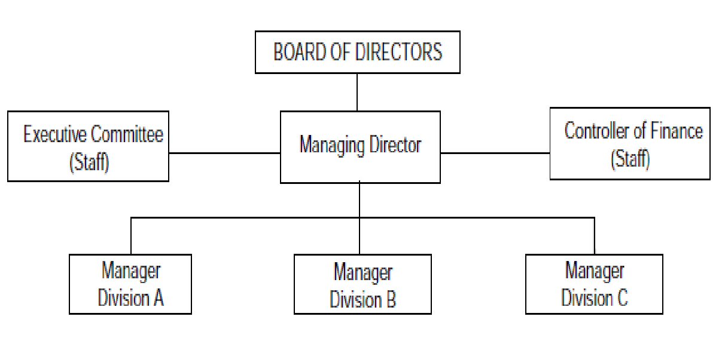

**Fig**

**ure**

**12**

**:**

**Line and Staff organization**

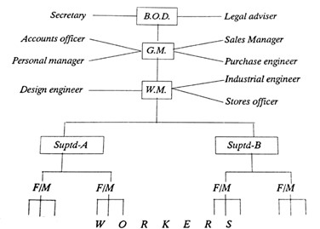

**Fig**

**ure 13**

**Line and Staff org**

**anization**

(G.M.: General Manager; W.M.: Works Manager; Suptd : Superintendent; F/M : Foreman; B.O.D: Board Of Directors)

**Advantages**

1. Specialized and expert advice from staff executives is available.
2. Reduction of burden on line managers.
3. Better decisions, as staff specialists help the line managers
4. Unity of command
5. Flexible when compared to functional organization.
6. Less wastage of material, man and machine hours.
7. Quality of product is improved.
8. Has all advantages of both line and functional organization.

**Disadvantages**

1. If allocation of duties between line and staff is not clear, it may give rise to confusions.
2. There might be conflict between line and staff executives.
3. Since staff is not accountable, they may not perform well.
4. Product cost will increase because of high salaries of staff executives.

* Now-a-days this type of organization is preferred for medium and large scale industries, depending upon internal structure, nature of productive activities and span of business area. • It is applied in automobile industries and other intermittent nature of industries **4. Project Organization:**
* When an organization takes up a new project, a Project Organization is set up in order to complete the project.
* It comprises of specialists from different functional areas of the parent organization. If needed experts are hired from outside also.
* The team of specialists work simultaneously to achieve the goals of the project.
* After the project is completed the team is dissolved. So it is a temporary in nature.

**Advantages:**

* It does not interfere with the functioning of the existing organization.
* Decision making is quick.
* It allows maximum usage of specialist knowledge.
* It provides the maximum attention that a project needs.

**Disadvantages:**

* The members are recruited for a short period so it creates a feeling of insecurity and uncertainty.
* There may be conflicts among specialists.
* The project manager may not have complete authority over team members.
* Sometimes decision may be difficult due to pressures from different specialists.

**Applications:**

In IT companies like L&T, Infosys, TCS, Wipro, etc where business is mainly project based.

CEO

Marketing

Manager

Resources

Manager

Project

-

B

Engineering

Activities

Resources

Engineering

Activities

HR Manager

Manager Project

-

A

**Figure 14 Project Organization Structure (C.E.O: Chief Executive Officer)**

**1.5. Steps in organizing**

* While organizing, a manager differentiates and integrates the activities of his organization. Steps in organizing are:

**Figure 15**

**Steps in Organizing**

**Determination**

**of objectives**

**Assignment of duties**

**Identification and grouping of activities**

**Delegation of authority**



**Providing physical**

**facilities**

**and proper environment**

1. **Determination of objectives:** 
   * The first step in organizing is to know the objectives of the enterprise. Objectives determine resources and the various activities which need to be performed and the type of organization which needs to be built for this purpose.
   * Objectives also serve as guidelines for the management and workers. They bring about unity of direction in the organization.
2. **Identification and grouping of activities:**

* To achieve the objectives, the process of organization is divided into functions and sub-functions. Then similar activities or related activities are combined and grouped into departments.
* This will enable the people to know what is expected of them as members of the group and will help in avoiding duplication of efforts. For example, the total activities ofan enterprise may be divided into major functions like production, purchasing, marketing, finance, human resource, etc. Each function is further subdivided into various jobs.

(3) **Assignment of duties:**

* After classifying and grouping the activities into various jobs, they should be allotted to the individuals for ensuring certainty of work performance.
* Each individual should be given a specific job to do according to his ability, skill, and knowledge and made responsible for that.

**Delegation of authority:**

* Authority without responsibility is dangerous and responsibility without authority is an empty vessel. Hence, corresponding to the responsibility authority is delegated to the subordinates for enabling them to show work performance.

(5) **Providing physical facilities and proper environment**:

* Provision of right type of physical facilities and proper environment isessential for the smooth running of an organization.
* Physical facilities mean proper tools, machinery, etc.
* Right environment means proper lighting, ventilation, heating/cooling arrangements at the place of work,proper hours of work,rest intervals, safety devices, job satisfaction and above all, human approach by management.

**1.6 Functional areas of Management**

* There are four functional areas of management namely production, finance, marketing and human resource(personnel). Each functional area has a number of sub-activities.

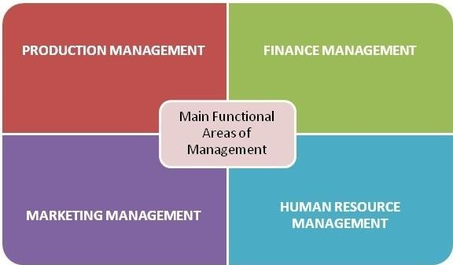

Figure 16

Functional areas of Management

1. **Production management:**

Production Management is the management of productive processes that convert inputs into goods and services. The inputs are men, material, equipment, technical knowledge, etc.It is also known as manufacturing management or operational management. The main objective of Production Management is: “To produce goods and services of right quality and quantity at the right time and right manufacturing cost”

This department is generally put under production manager and he is responsible for all production related activities.

This area has a number of activities; few of them are given below:

* 1. **Purchasing:** This is related to the purchase of various materials required by the organization. Purchasing involves procuring right quantity of materials of the right quality, at the right time and at the right price from the right supplier.
  2. **Materials management:** This involves storing of materials and issues of materials to various departments.
  3. **Research and Development:** It deals with improving the existing products and process and developing new products and process.

1. **Marketing Management:**

Marketing Management is planning, organizing, controlling and implementing of marketing programmes and policies to distribute the organization’s products to the buyers to generate an acceptable profit.

The major objectives of marketing management are: creation of demand, customer satisfaction, market share, generation of profits, creation of good will and public image.

The sub-activities are:

1. **Advertising:** Involves giving information about products to buyers.
2. **Marketing research:** It is related to the systematic collection and analysis of data relating to the marketing of goods and services.
3. **Sales management:** It involves management efforts directed towards movement of products and services from producers to consumers.

**C. Financial Management:**

Financial Management is planning, organizing, directing and controlling the financial activities like procurement and utilization of funds of the enterprise. It means applying management principles to financial resources of the enterprise. The objectives are:

1. To ensure regular and adequate supply of funds to the organization.
2. To ensure adequate returns to the shareholders
3. To ensure optimum funds utilization
4. To ensure safety on investments
5. To plan a sound capital structure

The functions are financial planning and forecasting, determination of capital composition, fund investment, maintaining proper liquidity, disposal of surplus and financial controls.

**D. Human Resource (Personnel) Management:** Human Resource Management includes the processes of planning, selecting, recruiting and inducting employees in an organization. The objectives include

1. Effective utilization of human resources
2. Motivation
3. Creating policies and procedures
4. Growth and development of Human resources.

The functions of human resource management include man power planning, recruitment, selection, performance appraisal, training, wage and salary administration, compensation and rewards, industrial relations, employee communication and personnel record maintenance.

**1.7 Managerial Skills**

* **Managerial** skills are certain abilities or attributes that an executive should possess in order to fulfil specific tasks in an organization such as his role duties, dealing with subordinates and co-workers, all of which allows for the easy flow of activities in the organization. These can be developed through learning and practical experience as a manager.
* Managerial skills are crucial for various positions and at different levels of a company, from top leadership to intermediate supervisors to first level managers

**Three Types of Managerial Skills**

The three types of managerial skills that are essential are:

* **Technical skills**
* **Conceptual skills**
* **Human or interpersonal management skills**

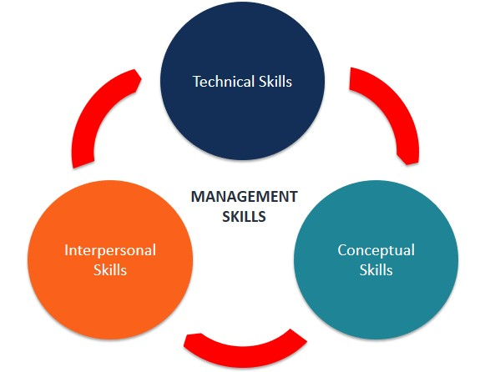

**Figure 17**

**Managerial Skills**

**Technical Skills**

* Technical skills involve the knowledge of and proficiency in activities involving methods, processes and procedures. For example, mechanics work with tools and their supervisors should have the ability to teach them how to use these tools.
* The skills are acquired through education or experiences in particular industry .These skills involve the use of tools, equipment, procedures, and techniques of the industry.
* Technical skills are most important for supervisory level or first-level managers. As we go through a hierarchy from the bottom to higher levels, the technical skills lose their importance.

**Conceptual Skills**

* **Conceptual skills** are the abilities to see the organization as a whole, to recognize inter relationships among different functions of the business and external forces and to guide effectively the organization efforts.
* It is easier to learn technical skills than the conceptual skills.
* These skills help in making long-range plans and decisions for expanding the business (forecasting).
* The conceptual skills will help managers to look outside their department’s goals. So, they will make decisions that will satisfy overall business goals.
* Conceptual skills are vital for top managers, less critical for mid-level managers, and not required for first-level managers.
* These can be classified as Decision Making skills and Organizational skills.

**Decision making skills:**

o It is the ability of a person to take timely and accurate decisions. This requires mental ability and presence of mind.

**Organizational skills:**

It helps to select and fix right people at right work.

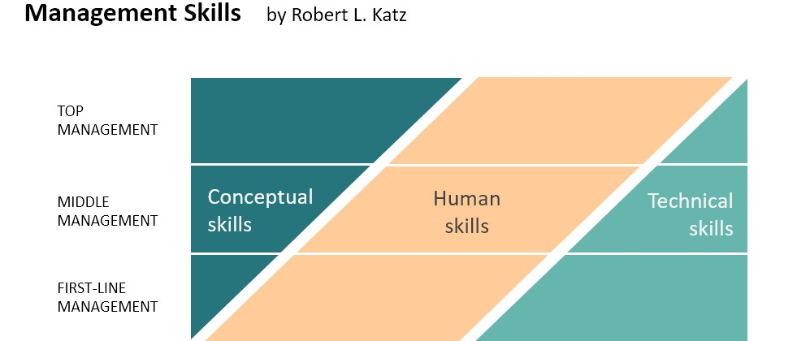

# Figure 18 Managerial Level-wise Skills

**Human or Interpersonal Managerial Skills**

* These skills represent the ability of a manager to work effectively with people.
* They help to build a team and create an environment in which people feel secure and free to express their opinions. As seen in above figure, these skills are equally essential for managers at all levels in the company.
* They are classified as:

**Communicating skills:**

* It is the ability to convey information to the other. Improper, insufficient and poorly expressed information can create confusion.

**Motivating skills:**

* It inspires people to do what the manager wants them to do. The motivation may be positive or negative.
* Positive motivation includes rewards, Negative motivation includes punishment, threats, etc **Leadership skills:**
* This skill helps the manager to lead the people working under him. It is the ability to inspire confidence and trust in the subordinates in order to have maximum cooperation from them.

**Unit 2:**

**Planning and Organizing at Supervisory Level**

**2.1 Planning by Supervisor**

**2.1.1 Planning definitions**

* According to Koontz and O’Donnel “Planning is deciding in advance what to do, how to do it, when to do it and who is to do it. It bridges the gap from where we are and to where we want to go. It is in essence the exercise of foresight”.
* According to M.S. Hardly “Planning is deciding in advance what is to be done. It involves the selection of objectives, policies, procedures and programs from among alternatives.
* Heying and Massie define “Planning is that function of the manager in which he decides in advance what he will do. It is a decision-making process of a special kind. It is an intellectual process in which creative mind and imagination are essential”.
* Every person whether in business or not has framed a number of plans during his life. The plan period may be short or long. Planning is the first most important primary function of management. It has been said that well plan is half done.
* It involves thinking ahead and getting ready for the future. It resolves in advance what should be done. It is awareness of future course of action.
* Planning is achieving the objectives and choosing a course of action to achieve those objectives.
* Planning involves conviction of specific objectives, programs, setting policies, strategies, rules and procedures and preparing budgets. Planning is a function which is executed by managers at all levels – top, middle and supervisory.
* Planning provides clear sense of direction to the activities of the organization and job behavior of managers and others. Planning is an attempt to forecast the future in order to achieve better performance.
* Supervisor or foreman is concerned with the direct supervision of the workers by planning and executing activities given by top management
* Planning safe working conditions are responsibilities of all which include supervisors, workers, managers, top level managers. However, customers can not be a part of it.
* In an organization the supervisors usually make short term plans while top level manager makes long term plans. Short term plans are mostly useful for small offices, managing group of employees, work teams, workshops etc. Short term plans are always flexible and can change as per the available conditions. Also, the operational plans are based on past performance of organization and less uncertain/flexible.
* Supervisors are internally focused in planning activity. While top level managers are externally focused on the planning.
* Planning may get failed if there is sudden change in technology, narrow focus, ignorance of historical data, ignoring competitors etc.

**2.1.2 Importance of planning**

Planning is very important in all types of organization whether business or nonbusiness, private or public, small or large. The organization which thinks much ahead about what it can do in future is likely to as compared to one which fails to do so. Planning is important because of the following reasons.

1. **Primacy of planning:** Planning is the first and foremost function of management, other functions follow planning. What is not planned cannot be organized and controlled. Planning establishes the objectives and all other functions are performed to achieve the objectives set by the planning process.
2. **To minimize risk and uncertainty:** The organization continuously interacts with the external dynamic environment where there is great amount of risk and uncertainty. Planning helps the manager to cope up with and prepare for changing environment. Manager can reduce the risk and uncertainty by using rational and fact-based procedure for making decisions.
3. **To focus attention on objectives:** Planning focuses on organizational objectives and direction of action for achieving these objectives. It helps managers to apply and coordinate all resources of the organization effectively in achieving the objectives. The whole organization is forced to embrace identical goals and collaborate in achieving them.
4. **To facilitate control:** Planning sets the goals and develops plans to achieve them. These goals and plans become the standards or benchmarks against which the actual performance can be measured. Control involves the measurement of actual performance, comparing it with the standards and initiating corrective action if there is deviation. Control ensures that the activity confirm to plans. Hence control can be exercised if there are plans.
5. **To increase organizational effectiveness:** Effectiveness implies that the organization is able to achieve its objectives within the given resources. The resources are put in a way which ensures maximum contribution to the organizational objectives. Effectiveness leads to success.

**2.1.3 Hierarchy of plans**

Various organizational plans discussed above are interlinked and may be arranged in hierarchy in which higher order plans helps to derive lower order plans. In turn a lower order plan contributes to the achievement of the objectives of a higher order plan. The hierarchical nature of various plans is represented in figure 1.

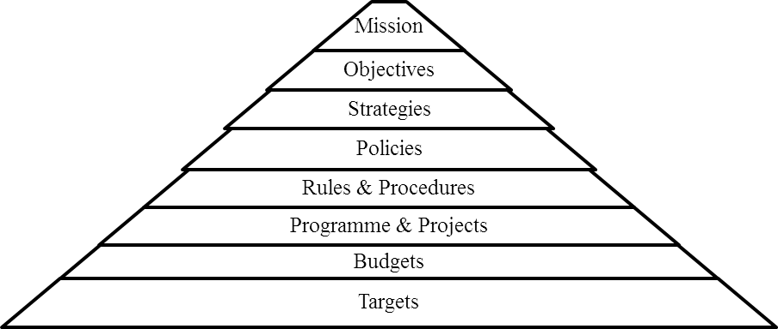

# Figure 1 Hierarchy of Plans

1. **Mission and Purpose**: Every organization is purposive creation which has some objectives and the end results for which the organization strive. These end results are referred to as mission, ‘purpose’, ‘goal’, ‘target’ etc. which are often used interchangeably. However, there are differences in the contest in which these terms are used. The supervisor role is to follow the mission set by authorities and to suggest any improvement to top management for necessary actions.
2. **Objectives:** According to Mc Farland, “Objectives are the goals, aims or purposes that the organizations wish to achieve over varying periods of time”. Every organization is established for the purpose of achieving some objectives. An individual who starts a business has the objective of earning profits. A chartable institution which starts schools and colleges has the objectives of rendering service to the public in the field of education. The objectives may differ from one organization to another. Objective is the term used to indicate the end point of activity for which an organization is established and tries to achieve. Supervisor consider main defined objectives and split it into smaller objectives in order to implementing day-to-day work from workers.
3. **Strategies:** Every organization has to develop plans logically from goals by considering strength, weaknesses, opportunities and threats to the organization. A strategy is a plan which takes into these factors and provides an optimal match between the firm and external environment. Two activities are involved in strategy formulation namely environmental appraisal and corporate appraisal. Supervisor is engaged into internal activities so his roles is to look into internal factors i.e. strengths and weaknesses.
4. **Policies:** According to George R Terry, “Policy is a verbal, written or implied overall guide, setting up boundaries that supply the general limits and directions in which managerial action will take place”. A policy is a general guideline for decision making. It sets up boundaries around decisions. Policies channelize the thinking of the organization members so that it is consistent with the organizational objectives. Policies provide framework within which decisions are to be made by the person in various areas.
5. **Procedures:** Procedures are detailed guidelines. A procedure provides a detailed set of instructions for performing a sequence of actions involved in doing a certain piece of work. A procedure is a list of systematic steps for handling activities that occur regularly. The same steps are followed each time that activity is performed. A streamlined, simplified and sound procedure helps to accelerate clerical work without duplication and waste of efforts and other resources. Supervisor plays key role in formulating procedures to implement defined objectives. He makes procedures to implement plans, handling machinery, carrying out work stepwise etc.
6. **Methods:** A method is a prescribed way in which one step of procedure is to be performed. A method is thus a component part of procedure. It means an established manner of doing an operation. Medical examination is a part of recruitment and selection procedure, method indicate the manner of conducting medical examination. Methods help in increasing the effectiveness and usefulness of procedures. The reduced fatigue, better productivity and lower costs can be achieved by improving existing methods. Methods can be improved by eliminating wastes and conducting “motion study”. So, supervisor must be always focused, attentive to find methods for improvement in his surroundings.
7. **Rules:** The rules are the simplest and most specific type of standing plans. Every organization attempts to operate in an orderly way by laying down certain rules. Rules are detailed and recorded instructions that a specific action must or must not be performed in a given situation. Rules are more rigid than policies. Supervisors define rules to handle machinery, code of conduct, discipline, precautions for handling machinery, etc.
8. **Programme:** A programme is single use plan. It is a sequence of activities directed towards the achievement of certain objectives. A programme is action based and result oriented. A programme lays down the definite steps which will be taken to accomplish a given task. A programme is a complex of objective, policies, procedures, task assignments, steps to be taken, resources to be employed and other elements to carry out a given course of action.
9. **Budgets:** A budget is a single use plan since it is drafted for a particular period of time. A budget is a statement of expected results expressed in quantitative terms i.e. rupees, man hours, product units etc. Budget is also used as an instrument of managerial control. It provides a standard by which actual operations can be measured and variation could be controlled. Making budget is clearly planning. The important budgets are sales budgets, production budgets, cash budgets, and revenue and expenses budgets. The supervisor is mainly involved in making material budget, manpower budget etc.

**2.1.4 Planning at supervisor level**

Supervisor is a person who is in charge of, and coordinates the activities of a group of workers engaged in related activities within a unit of an organization. He is a front-line manager. He is responsible for getting the work done from workers with respect to plans and policies set by the management. A supervisor plan, direct, motivate, and monitor the work performed by workers at the operational level of the organization. Place of supervisors in the organizational structure is given in below figure 2

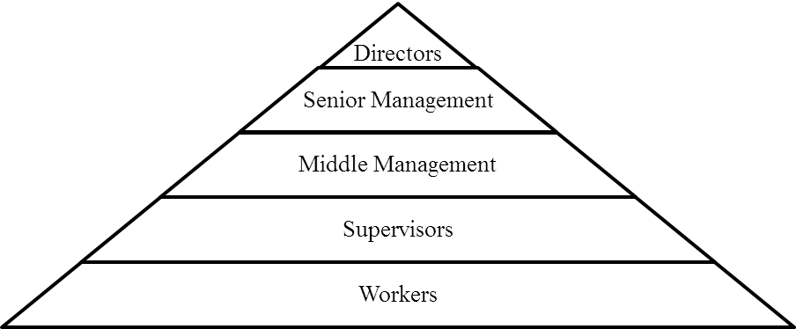

**Figure 2 Place of supervisor in the organizational structure**

The job of a supervisor is mainly focussed on supervision which involves activities like instructing, monitoring, guiding, and observing the workers and to ensure weather they are performing their duties with respect to work assigned. So, he plays very important role in the organizational functioning. Supervisor connect the workers to the management and vice versa and hence become the primary person for the bidirectional flow of information within an organization.

**Types of plans**

Three major types of plans can help supervisors achieve their organization's goals i.e. strategic, tactical, and operational. Operational plans lead to the achievement of tactical plans and tactical plan lead to the attainment of strategic plans. In addition to these three types of plans, supervisors/managers should also develop a contingency plan in case if their original plans fail.

**A. Operational plans**

An **operational plan** is one that supervisor uses to accomplish his or her job responsibilities. Supervisors, team leaders, and facilitators develop operational plans to support tactical plans. The specific results expected from any department, small work groups, project teams and individuals are the **operational goals.** These goals are precise and can be measured. For example, “Processing 200 sales applications each day” or “Publish 10 books this month” etc.

Operational plans can be a singleuse plan or an ongoing plan.

* **Single****use plans** apply to activities that do not repeat. These are one time plans like a special sales program as it deals with who, what, where, how, and how much of an activity. A budget is another example of a singleuse plan because it predicts sources and amounts of income, also it predicts how much they are used for a specific project.
* **Continuing or ongoing plans** are usually made once and retain their value over a period of years while undergoing periodic revisions and updates. These are recurring plans.

* + - 1. **Tactical plans**

Tactical plans are concerned with shorter time frames and narrower scopes than are strategic plans. These plans usually span one year or less because they are considered shortterm goals. Longterm goals, on the other hand, can take several years or more to accomplish. Normally, it is the middle manager's responsibility to take the broad strategic plan and identify specific tactical actions.

* + - 1. **Strategic plan**

A **strategic plan** is an outline of steps designed with the goals of the entire organization as a whole in mind, rather than with the goals of specific divisions or departments. A strategy is a complete and all-inclusive plan for achieving said objectives. In strategic plans we establish long term objectives or vision or mission, define future decisions, select specific course of action and allocate necessary resources needed to implement the plans. The strategic plans are made at top level of management.

**D. Contingency plans**

Contingency planning involves identifying alternative courses of action that can be implemented if and when the original plan is not adequate due to changing circumstances. Success of any work always depends upon a degree of adaptation, its flexibility, and efficient handling of changing conditions. So, in case any deviation in implementing any plan, the supervisor needs a “keeping all options open” approach at all times.

**2.2 Planning activities, detailing and following of each step.**

**2.2.1 Functions of planning by supervisor**

An organizational strategic plan always defines its long-term goals and mission. We must define the necessary daily operations and participating groups to achieve these goals, i.e. we must do operational planning. Supervisors play an important role in the function, and success, of such operational planning.

**Role and Responsibilities of supervisor while planning activities**

* + - 1. **Planning and Organizing -** Supervisor’s basic role is to plan the daily work schedule of the workers by guiding them the nature of their work. He divides the work amongst the workers as per their skills, knowledge, interests and aptitudes.
      2. **Provision of working conditions -** A supervisor plays an important role in the physical environment in the factory. He looks at arrangement the physical resources like machine, material at right place. His role is to provide proper sitting place, ventilation, adequate lighting, drinking water facilities etc. to workers. Thus, supervisor is responsible for providing healthy and hygienic condition to the workers.
      3. **Leadership and Guidance -** A supervisor is the leader of workers under his guidance. He leads the workers and influences them to work their best. He guides the workers by fixing daily production targets. He provides an instructions and guidelines to workers for achieve given targets.
      4. **Motivation -** A supervisor plays an important role by providing different incentives to workers to perform better. It will motivate them to work better and efficiently for next given works. He can offer different types of incentives to workers i.e. monetary and non-monetary incentives.
      5. **Controlling -** Controlling is an important function performed by supervisor. It involves,
         1. Recording the actual performance with respect to the given time schedule.
         2. Checking of progress of work. iii. Finding out deviations if any and find solution for eliminating deviation.

iv. If not independently solved, reporting it to top management.

* + - 1. **Linking Pin -** A supervisor is a linking pin between management and workers. He communicates the policies of management to workers. He passes instructions to the workers on behalf of management. He has a close contact with the workers and he interact the problems, complaints, suggestions, etc. to the management.
      2. **Grievance Handling -** The supervisor can handle the grievances of the workers effectively. For this he has to do the following things: -

He should be in direct touch with workers.

He should win the confidence of the workers by solving their problems. iii. He should consider worker problems on humanitarian grounds. iv. If he cannot tackle it independently, he can take the help and advice of management to solve it.

* + - 1. **Reporting -** A supervisor has an important role of reporting about the cost, output, performance, quality and any factor which is responsible for increasing productivity.
      2. **Introducing new work methods -** The supervisor has to be curious to know about the external environment of market and competition present. So, he can innovate the various techniques of production. He can shift the workers into fresh schedules whenever possible. He can also try his best to keep on improving to the physical environment around the workers. As a result, organization will have higher productivity, high Morale among workers, satisfying working condition, improving human relations, higher profits, and high stability.
      3. **Enforcing Discipline -** A supervisor can undertake many steps to maintain discipline. It can be in the form of regulating checks and measures, strictness in orders, keeping an account of general discipline of factory, implementing penalties and punishments for the indiscipline workers. All these above steps help in improving the overall discipline of the factory.

**Scope of plans for supervisor**

* Supervisors make short-term planning which can involve scheduling daily activities, raw material, completing production targets purchasing etc.
* Supervisors look into work of his subordinates. He takes care of work flow.
* Supervisors look after Subordinates report to him about their work.
* Supervisors are internally focused in planning. They manage groups of employees. Their duties are focused on internal operations.
* Supervisor’s plans the budget related to manpower, overhead, raw material and other projects small expenses.

**2.2.2 Steps in Planning and detailing activities**

The planning process is different from one plan to another and one organization to another. The steps generally involved in planning are as follows:

1. **Establishing goals/objectives:**

The first step in planning process is to determine the goal or objectives. These are set by top level management after number of objectives has been carefully considered. The objective set depends on the number of factors like mission of the organization, abilities of the organization etc., The section wise or department wise objectives are planned at the lower level after determining organization objectives. Defining the objectives of every department is a very essential. After this only clear-cut direction will be available to the departments. Control process is very easy if the objectives are clearly defined.

1. **Establishing planning premises:**

Planning premises means the conditions under which planning activities will be undertaken. Planning premises are planning assumptions like the expected environmental factors, pertinent facts and information relating to the future such as general economic conditions, population trends, competitive behavior etc. The planning premises can be classified as below:

* + - * **Internal and External premises:** Premises may exist within or outside the enterprise. Internal premises include sales forecasts, ability of the organization in the form of machines, methods of design, behavior of the owners and employees etc., The external premises exist outside the enterprise and include general business and economic environment, technological changes, government policies and regulations, population growth etc.,
      * **Tangible and Intangible premises:** Tangible premises are those which can be quantified. They include population growth, industry demand, capital and resources invested etc., On the other hand political stabilities, sociological factors, attitudes and behavior of the owners etc., are intangible premises.
      * **Controllable and non-controllable premises:** Some of the planning premises are controllable and others are non-controllable. Some examples of non-controllable factors are strikes, wars, natural calamity, legislation etc., Because of the presence of non-controllable factors; organizations have to revise plans periodically in accordance with current development. The controllable factors are availability of resources, skill of managers and labor etc.

1. **Deciding the planning period:**

The period or duration of plan is decided after establishing planning premises.Some plans may vary depending upon type of objective or work. Companies generally base their period on a future that can reasonably be anticipated. The factors which influence the choice of a period are:

* + - 1. ***Lead time in development and commercialization of a new product:*** The lead time must be considered while deciding time. For example, an aircraft building company planning to start a new project should have a planning period of five to ten years where as a small manufacturer of spare parts who can commercialize his idea in a year or so makes annual plans.
      2. ***Time required for recovering capital investment or the payback period:*** The payback period also influence the planning period. For example, if a machine costs 10 lakhs and generates cash inflow of Rs. 02 lakhs a year, it has a payback period of 5 years. Therefore, the plans should also be for at least five years.
      3. ***Length of commitment already made***: The plan period should be long enough to enable the complete already made commitments. For example, if a company has agreed to supply goods for two years, it needs to plan for the same period to fulfill its commitments.

1. **Identification of alternatives:** A particular objective can be achieved through implementing various course of actions. For example, an organization’s objective is to grow further which can be achieved in several ways like expanding in the same field of business or product line, diversifying in other areas, joining hands with other organization and so on. With each category there may be several alternatives. For example, diversification may point out the possibility of entering into one of the several fields.
2. **Evaluation and selection of alternative: E**valuation of the alternatives is done to determine which is the most appropriate course of action for achieving goals and objectives. This is done with the help of various quantitative techniques and operations research methods. In addition, sometimes few software packages are also used for evaluating alternatives.

1. **Developing derivative/supportive plans:** Once the plan is selected, various plans are derived so as it supports the main plan. The supporting plans may be done for buying equipment, buying raw material etc. The development of the plan requires following activities,
   * + - **Programming:** Identify the activities or tasks that need to be completed in order to reach the desired objectives. Activities then need to be put into an appropriate order/sequence in which they should be completed.
       - **Allocating resources:** It is important to identify resources within the organization to carry out specified activities. Resources are normally divided into three general categories: *human resources (manpower)*, *physical resources (materials, machines, tools, facilities and equipment)* and *financial resources*. In planning, both internal as well as external resources are identified.
       - **Scheduling:** Establish the required time needed to complete each activity. It will involve an assessment of how long each task takes to be completed.
       - **Fixing accountability:** Determine specific individual or institutions will be responsible for the accomplishment of identified activities. Simple instruments like Gantt Chart can be used to indicate tasks and planned completion which indicate tasks vertically on Y-axis and time horizontally on X-axis.
2. **Measuring and controlling the process:** We must monitor the progress of plan else it may result in huge loss. Supervisors need to check the progress of their plans and accordingly take remedial action on it. So, process of controlling is a part of any plan.

**2.3 Prescribing standard forms for various activities.**

* + - Supervisor plays vital role in carrying short term plans of organization. For that supervisor must deals with available resources, manpower by keeping customer expectations in mind.
    - The planning can be machine wise planning, manpower planning, material flow, appropriate method for implementation or any measurement.
    - So, to do all these activities supervisor requires a systematic documentation. Thus, prescribed form helps the supervisor and his team to carry out tasks very efficiently. It also brings standardization in the work, enable right decision making, effective utilization of available resources, establishing link between authority and responsibility, clarity in the work etc.
    - Few standard forms for various activities are as below:

**1. Material Requisition Form**

This form is used to procure material from supplier to factory so that production will not be stopped. The requirement of raw material is communicated to supplier through factory. The material requisition form is shown as below,

|  |  |  |  |  |  |
| --- | --- | --- | --- | --- | --- |
| **Material Requisition Serial No.______ Date: _________** | | | | | |
| **Material Code No** | **Description** | **Quantity** | **Rate** | **Unit** | **Total** |
|  |  |  |  |  |  |
|  |  |  |  |  |  |
| **Authorised by: Storekeeper: Calculation & Prices checked by:** | | | | | |
| **Received by: Bin Card Entered: Received as per ordered by:** | | | | | |

# Figure 1 Material Requisition Form

**2. Raw material received report**

This form is used to keep record of material received. It helps supervisor to keep information about weather all received material is as per the order given. If quality of material is not good then such material can be returned back to the supplier. The form of material received report is as below,

|  |  |  |  |
| --- | --- | --- | --- |
| **Material Received Report**  **Received at time: Purchase Order No.**  **Deliver Point From _______________ to _______________ Delivery Date Supplier Name & Address** | | | |
| **Raw material & Quantity Received** | **Description** | **Grade** | **Condition of goods** |
|  |  |  |  |
|  |  |  |  |
| Counted by: Inspected by: | | | Approved by: |

# Figure 2 Material Received Report

**3. Raw material inter-processing form**

This form can be used for efficient management of raw material. This form can be used to handover particular raw material from one person to another person or one process to another process. Keeping record of material transferring can help supervisor to determine at which place raw material need to be ordered. It will help to maintain sufficient level of inventory for continuous production. The form can be show as below,

|  |  |  |  |  |  |  |  |
| --- | --- | --- | --- | --- | --- | --- | --- |
| **Raw Material Inter-Processing Form** | | | | | | | |
| Date of processing | | | | | | | |
| Location from ____ to _____ | | | | | | | |
| General issues identified during raw material inspection and transferring | | | | | | | |
| __________________________________________________ | | | | | |  | |
|  | Work  Details | Operator | Machine No. | In Quantity | Out  Quantity | Required due  to |  |
|  |  |  |  |  |  |
|  |  |  |  |  |  |
|  |  |  |  |  |  |
| Note: | | | | |  |
| Prepared by ________________ Date _________ | | | | | |  | |

# Figure 3 Raw Material Inter-Processing Form

**4. Job description**

This form will give the detail idea about the job to be performed by the work. It is also called as work assignment sheet. With this form the worker will be able to know details about job, his duties and responsibilities while performing job, do’s and don’ts while performing job and any other specific information related with it. The format of job description is as below,

|  |
| --- |
| Job Title: |
| Place of Work: Department  Allotted Time for work: |
| Description of Job: |
| Duties and Responsibilities: |
| Work conditions: |
| Skills required to complete job: |
| Any specific related information: |

# Figure 4 Job Description form

**5. Machine Planning**

This form can be used to guide person which job is to be performed on which machine at which time and for how much time. It can include details like technical information of machine, capacity of machine, time for which we can use machine, type of work which we can do on particular machine. The sample form for machine planning is shown as below

|  |  |  |  |  |  |
| --- | --- | --- | --- | --- | --- |
| **Production Planning Planning for date _______ to date _________**  Prepared by _______ Approved by __________ **First Shift / Second Shift** | | | | | |
| **Technical Details** | **Duration of**  **Machine Use** | **Work Order No.** | **Machine No.** | **Description of Work** | **Time Promised to Customer** |
|  |  |  |  |  |  |
|  |  |  |  |  |  |
|  |  |  |  |  |  |
|  |  |  |  |  |  |
| Sign of Supervisor Sign of Worker | | | | | |

# Figure 5 Production Planning

6. **Issue of Tools**

This form can be used for issuing of work tools. It will help supervisor to identify record of usage of tools. He would be able to locate tool if the same tool is required for other work at different place. It also guides him to have maintenance of over utilized tool. Format of issue of tools is as shown below,

|  |  |  |
| --- | --- | --- |
| **Format for Permanent / Temporary Issue of Tools**  Name:___________________________________ No.:_________________ | | |
| **Tools** | **Issued** | **Returned** |
|  |  |  |
|  |  |  |
|  |  |  |
|  |  |  |
| Sign of Supervisor Sign of Worker | | |

# Figure 6 Issue of Tool Format

**2.4 Budgeting for materials and manpower.**

**2.4.1 Introduction to Budget**

* The budget is the plan which intends to figure out expected operations revenue and expenses of an organization for a future time period. In other words, for a business entity budgeting is the process of preparing detailed statement of financial results that are projected for a certain period of time. Budgeting is to estimate the future while taking the management inputs considering internal and external factors of the organization.
* In every organization, finance department plays a key role in preparation of budget in consultation with higher management. Budget is a document, which is referred for the health check of the organization during the budgeted period.
* Budget is prepared to carry out various functions like planning activities, controlling activities, developing projects, testing and implementing programs etc. There are various such functions for which an entity prepare budget. Budgeting can increase the chances of making profits within the given environment and help decision making process of management.
* The approach towards budget depends on the organizations phase. A new startup will have incremental budgeting or a Zero-Base budgeting whereas a mature company may have Kaizen Budgeting or Base Budgeting.

**Types of budget**

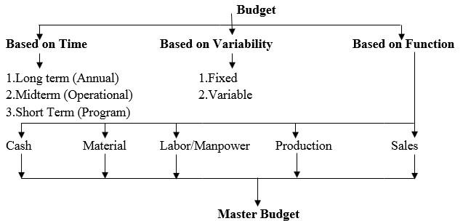

# Figure 7 Types of Budgets

**2.4.2 Material Budget**

* This involves storing of materials, issue of materials to various departments.
* Material budgeting refers to the procedure of preparing material or purchase budget in terms of quantity and money value of materials to be procured in a specified time period.
* Material budget helps in estimating the material prices over a period of time. It also analyses the material requirement.
* Material budgeting ensures low risk of inventory planning, highest purchase lead time, low transportation costs and better vendor relations.
* A material budget shows the quantity of each type of raw material required by months or quarters to produce goods.
* Generally, Material resource planning (MRP) and Just in Time (JIT) methods can also be used for preparing material budget.
* The Materials Budget forecasts the level of purchases required on basis of materials required for production and inventory levels.
* Material to be purchased can be determined using following formula,

Materials Purchased = Materials Required + Ending Inventory – Beginning Inventory

**Format of Material**

**Budget**

Materials Required for Production

Rs.

3500

Desired Ending Inventory

Rs.

500

Total Material

Rs.

4000

Less Beginning inventory

Rs.

600

Total material required (A)

Rs.

3400

Cost per unit (B)

Rs. 10

**Total cost of material purchased = A x B**

**Rs. 340**

**00**

**Table 1**

[**Basic concepts of Materials Budgeting**](http://vskills.in/certification/tutorial/logistics-and-supply-chain-management/purchase-manager/basic-concepts-of-materials-budgeting/)

Following are the basic concept of Material Budgeting:

* **Direct Materials Budget**: Proper material budgeting is of utmost importance, even when it comes to budgeting direct materials, which add up to the production cost of an organization. Correct budgeting can lead to better projections of direct material requirement. Here, direct materials mean the supplies needed for manufacturing goods, i.e. raw materials, stores, stock and productive materials
* **Material Consumption Budget**: This is required after determining the production requirement. The material consumption budget is based on the volume of production. Material consumption per unit of output aids in preparing material consumption budget for various kinds of materials to be used by the output.
* **Material Purchase Budget**: This is required by both manufacturing and merchandising companies.For instance, manufacturing companies measures the quantity of materials to be purchased through production volume and inventory requirement. This along with the value of materials for the period budgeted and the materials inventory needed for sustenance. This is determined by considering the consumption for budgeted production volumes and opening and closing inventory requirement.

**Factors affecting Materials Budget**

Below are the some of the factors that affect material budgeting:

* Production Budget should be considered the foremost factor in preparing such budget.
* Material cost is also equally important. Purchasing the material only when its prices are lowest is considered.
* There are certain materials that are prone to seasonal fluctuations. And therefore, it is recommended to procure them only when they are readily available in the market.
* The store position and the stock of existing material are also key considerations. If your business does not have ample space, you should not be buying the stock in advance.
* Management policy, rules and regulations on JIT (Just-In-Time) inventory, inventory level fixation and EOQ (Equal Order Quantity) are also major influencers to materials budgeting.

**2.4.2 Manpower Budget**

According to Gorden MacBeath, manpower planning involves two stages. The first stage is concerned with the detailed “planning of manpower requirements for all types and levels of employees throughout the period of the plan,” and the second stage is concerned with “planning of manpower supplies to provide the organization with the right types of people from all sources to meet the planned requirements.”

Manpower Planning & Budgeting serves as the foundation for managing an organization’s Human Resources. It enables organizations to plan strategically to meet current and future manpower needs, and prevents unnecessary surprises in maintaining steady-state manpower. The formation of manpower budget is dependent on production budget.

Manpower planning further assists organizations by ensuring positions is filled by the right employees with the needed competencies, and appropriate planning is conducted to align the manpower to meet future organizational goals.

The more effective the development and execution of the manpower plan, the more the organization is able to leverage its Human Resources for the accomplishment of its strategic goals.

* **The Manpower Plan**

The manpower plan defines the number, skills set and timeframe for the Human Resource requirements. It addresses both the maintenance and growth of the existing employee numbers. The Manpower Planning will be a strategic function with objectives and goals in line with the corporate strategic objectives.

* **Determining Future Manpower Requirements**

Future manpower requirements are determined by matching existing Human Resources against projected volumes and types of work, and developing existing staff or recruiting new staff to cater to those needs and develop the most effective mix of core and support staff. To achieve the corporate objectives, all decisions made in connection with the organization structure development and management is incorporated into a manpower plan. Ad-hoc recruitment will be required to overcome unforeseen staff requirements such as, replacements for sudden resignations, new projects etc. Such ad-hoc recruitment will in turn feed into the manpower plan for future planning purposes. The ad-hoc recruitment requirements should be approved by the HR Manager and communicated to the HR Officer as early as possible.

* **Budgeting for Manpower Requirements**

Manpower is an important function that impacts every employee in an organization and that has a cost. Budget approvals for the manpower plan of each Department/Project are sought in writing from the Department Head/Project Manager. All requests for an increase in headcount or related employee costs must be supported by a business case at the beginning of the calendar year and sent to the HR Manager so that the costs are included in the budgets for the year.

* The budgeting for manpower requirement refers to the funds that HR allocates to all HR processes enterprise-wide. The **HR budget** will include funds allocated to hiring, salaries, benefits, talent management, training, succession planning, workforce engagement, and employee wellness planning.
* HR budgets use financial information, performance results and historical data from every department. Since the HR budget considers HR activities company-wide, it is an incredibly complex yet essential document to determining a company’s future HR activities. Information in the HR budget includes but isn’t limited to:
  + - 1. Forecasting on number of employees
      2. Employee turnover rates
      3. Salary data
      4. Recruitment budget
      5. New benefits programs
      6. Training and development
      7. Payroll costs
      8. Overtime
      9. Incentive compensation
      10. Strategic planning (data/consultants)
      11. HR databases
* The manpower budget is developed from the production budget. It allows the company to know in advance possible labor requirements based on production budget.
* Effects of ignoring manpower budget are
  + - * 1. Labour Shortage
        2. Hire Workers at Higher Salary
        3. Layoff Workers at Awkward times
        4. Insecurity, Low morale among workers **How to prepare Manpower Budget?**
    1. Record projected units to be produced (from Production Budget).
    2. Multiply by the Labor Cost per Unit to calculate the Total Labor Cost

**Format of Manpower Budget**

**January**

**February**

**March**

Units to be Produced (A)

1000

900

1100

Manpower cost per unit (B)

2

2.5

1.5

**Total Cost = (A) x (B)**

**2000**

**2250**

**1650**

**Tabl**

**e 2**

We can appoint number of workers based on number of units produced in particular month. Suppose if one worker produces average 100 units of job per month and the demand for one month is 1000 then we will need 10 workers to complete that work. So, accordance with forecast we can appoint workers at right time at right place. It will also help supervisor to make job descriptions in regard to completing that particular work.

**ORGANIZING AT SUPERVISORY LEVEL**

**2.5 Organizing the physical resources**

Organizing is the function of management which is followed after planning. Once person have plans, they should organize the necessary resources for accomplish of desired goals. The organizing become necessary when two or more people work together to achieve common organizational goals. Organizing is necessary for systematic and smoother functioning of any organization. Assigning the work and granting the authority to attain goals are two important elements in organizing at supervisor level.

In organizing the synchronization of all available resources takes place. These resources can be physical resources, human resources, financial resources, information resources, organizational resources etc. Organizing these resources properly can enhance productivity in the organization. Organizing refers to the relationship between people, work and resources used to achieve the unique organizational goals or objectives.

According to Chester Barnard, “Organizing means person is able to define the role positions, the jobs related to the role position, the co-ordination between authority and responsibility.”

According to Theo Haimann, “Organizing is the process of defining and grouping the activities of an organization and establishing the authority relationships between them." According to Louis Allen, "Organizing is the process of identifying and grouping the work to be performed, defining and delegating authority-responsibility, and establishing relationships for the purpose of motivating workers to work most effectively together while achieving the organizational objectives."

In short, we can say that organizing is the process of arranging resources, allocating the work authority, and allocating available resources among the members of an organization to achieve the organizational goals. Organization establishes relationship between people and work resources.

Organizing at supervisory level can be in the form of

* Developing job descriptions,
* Designating tasks,
* Defining responsibilities of the workers with the specific skill sets needed to complete the tasks,
* Fixing locations of equipment,
* Collecting data for developing of budgets,
* Arrangement of workstations and storage areas,
* Resolving conflict among subordinates

An organization is an open system. This is because for every time we have to interact with surrounding while organizing.

Effective organizing depends upon the several important concepts like, specialization of the workers, Chain of command, Authority, Delegation of authority, Supervisor’s Span of Control, Level of Centralization vs decentralization in the organization etc.

**2.5.1 Importance of Organizing**

1. It establishes pattern of relationship by giving duties and responsibilities to the individual and groups.
2. It helps to achieve organizational goal by facilitating good administration. iii. It helps for optimum use of resources like man, machinery & material iv. It provides adequate communication.

v. It helps in effective use of available manpower. vi. It helps to initiates growth and diversification. vii. It helps in good human treatment of employees.

1. It stimulates creativity among workers.
2. It helps to minimize wastage, confusion, corruption and inefficiencies.

**2.5.2 Roles of supervisors while organizing of physical resources**

* Organization of physical resources is very important activity. For this work is required to be divided among workers so that they can performs a specialized portion. This activity will provide the clarity in job assignments. It will also help workers to increase their skill set.
* Supervisors have the right to give orders i.e. authority. They are also liable to accept responsibility for whether the work is done correctly. The status of work done shall be communicated to higher level of management.
* Supervisors are responsible for exacting discipline among workers.
* Supervisors are also responsible for building morale among workers.
* Supervisors must offer loyalty and cooperation towards workers while organizing resources.
* The unity of command requires the workers to report only to one superior. If they report to more than one superior it will create confusion and conflict among them.
* It is also necessary that all individuals including managers and supervisors must have their personal interests as last priority.
* Workers shall be paid according to their quality of work instead of favoring selected people of supervisor/managers choice.
* Orders/instructions shall flow down through chain of command i.e. from the higher manager to the supervisor. Formal communications and complaints are to move upward in the same channel.
* Employees are to be treated equally and fairly.
* Supervisors shall encourage initiative among workers.

**2.5.3 Process of organizing physical Resources**

Following are the steps for organizing resources at supervisory level

1. **Determination of Objectives:** In first stage the goals to establish organization has been established. The nature of work to be accomplished is determined. If we will identify problems then only, we can formulate policies that will eliminate future problems. This activity mostly done by top level management. As per authority given managers and supervisors determines the objectives to be accomplished within limited frame of time.
2. **Deciding various activities**: All activities to be performed are determined. Further these activities are divided into groups, sub-groups and individual activities. For doing this principle of specialization and division of work must be done. For example, preparation of accounts, record keeping, quality control, inventory control, etc.
3. **Grouping of activities:** The supervisor tries to combine and group similar and related activities into smaller units. It is also called as departmentation. The similar activities are then grouped together to avoid duplication of efforts, confusion, wastage of resources, wastage of time etc.
4. **Assignment of responsibilities of definite persons:** In this stage specific jobs are assigned to concerned person. It is the process of giving right work to right man at right place.
5. **Delegation of authority:** The authority has been given to person to whom work is assigned. This is for motivating the person to perform his assigned work independently by using his/her own skills.
6. **Providing physical facilities and proper environment:** Physical facilities like machine, resources, tools are provided to person. Also, it is responsibility of supervisor to provide good healthy environment to the workers so that they can perform well. The proper environment includes adequate lightening, ventilation, reasonable work hours, rest intervals, safety devices etc.

**2.5.4 Principles of Organizing**

Following principles can be used for effective organization of resources,

* Principle of division of work
* Principle of specialization
* Principle of delegation/authority/responsibility
* Principle of span of control
* Principle of unity of command
* Principle of unity of direction
* Principle of balance
* Principle of co-ordination
* Principle of exception

**2.5.5 Effective Delegation**

* A supervisor alone cannot perform all the tasks assigned to him. To complete the targets, the supervisor should delegate authority.
* Delegation means division of authority and powers downwards to the subordinate.
* Delegation is sub-allocation of powers to the subordinates in order to achieve efficiency in getting results.
* Delegation is a process in which the authority and powers are divided and shared amongst the subordinates.
* When the work of a manager gets beyond his capacity, there should be some system of sharing the work. Through delegation, a supervisor, in fact, is multiplying himself by dividing / multiplying his work with the subordinates.
* Delegation of authority is the base of superior-subordinate relationship. For achieving delegation, a supervisor has to work in a system and has to perform following steps: - ➢ Assignmentof Duties
  + Granting of authority
  + Creating Responsibility and Accountability

* **Advantage of Delegation** 
  + It reduces the workload due to division of work and allocate it to sub-ordinates.
  + It leads to effectiveness in work due to reduced work load.
  + Through delegation, the superior-subordinate relationship becomes meaningful.
  + It gives chance to the subordinates to explore their abilities and skill.
  + It leads to the job satisfaction.
  + It brings stability and soundness in the relationship between superior and subordinates.
  + It helps to both superior and subordinates. This brings stability in organization.

* **Elements of Delegation**

1. **Authority** o Authority can be defined as the power and right of a person,
   * + - to use and allocate the resources efficiently,
       - to take decisions
       - to give orders while achieving the organizational objectives.
   * All people who have the authority should know what is the scope of their authority is and they shouldn’t mis-utilize it.
   * Authority is the right to give commands, orders and get the things done. o The top level management has greatest authority. Authority always flows from top to bottom. Authority can be delegated.
   * It explains how a superior gets work done from his subordinate by clearly explaining what is expected of him and how he should go about it.
   * Authority should be accompanied with an equal amount of responsibility.
2. **Responsibility** o It is the duty of the person to complete the task assigned to him. o A person who is given the responsibility should ensure that he completes the tasks assigned to him. o If the tasks for which he was held responsible are not completed, then he should not give explanations or excuses.
   * Responsibility without adequate authority leads dissatisfaction among the person. o Responsibility flows from bottom to top. Responsibility can not be delegated. o The middle level and lower level management holds more responsibility. o The person held responsible for a job is answerable for it. If he performs the tasks assigned as expected, he is bound for praises. While if he doesn’t accomplish tasks assigned as expected, then also he is answerable for that.
3. **Accountability** o It means giving explanations for any variance in the actual performance from the expectations set. o Accountability means being answerable for the end result.
   * Accountability can’t be escaped. It arises from responsibility. o Accountability can not be delegated.
   * For example, if ‘X’ is given a task with sufficient authority, and ‘X’ delegates this task to ‘Y’ and asks him to ensure that task is done well, responsibility rest with

‘Y’, but accountability still rest with ‘X’. o The top level management is most accountable.

**2.5.6 Span of Control / Supervision during supervising:**

Span of control is a span of supervision which depicts the number of employees that can be handled & controlled effectively by a single manager. A manager should be able to handle what number of employees under him should be decided. There are two types of span of control.

1. **Wide span of control (Flat Organization) -** It is one in which a person can supervise and control effectively a large group of persons at one time. According to this span, one person can effectively and efficiently handle a large number of subordinates at one time.

The features of wide span are,

* + It leads to less overhead cost of supervision
  + We can get prompt response from employees
  + Better communication can be happened in group while working
  + Better supervision is possible
  + Better co-ordination is possible
  + It is most suitable for repetitive jobs

1. **Narrow span of control (Tall Organization) –** In narrow span of control, the work and the authority is divided amongst many subordinates. A supervisor doesn't supervises and control a very big group of people under him. The person supervises only the selected number of employees at one time.

The features of narrow span are,

* + It is useful where the work requires tight control and supervision, for ex., handicrafts, ivory work, etc. which requires craftsmanship, there narrow span is more helpful.
  + Co-ordination is difficult to be achieved.
  + Communication gaps can come during work.
  + Messages can be in distorted form.
  + Specialization work can be achieved.

• **Factors influencing Span of Control**

* **Managerial abilities-** Wide span is helpful where managers are capable, qualified and experienced. While narrow span of control is required where strict control is required. So deciding span of control depends on the managers ability to handle number of people
* **Competence of subordinates-** Where the subordinates are capable and competent and their understanding levels are proper, the subordinates tend to very frequently visit the superiors for solving their problems. In such cases, the manager can handle large number of employees. Hence wide span is suitable.
* **Nature of work-** If the work is of repetitive nature, wide span of supervision is more helpful. On the other hand, if work requires mental skill or craftsmanship, tight control and supervision is required in which narrow span is more helpful.
* **Delegation of authority-** When the work is delegated to lower levels in an efficient and proper way, confusions are less and congeniality of the environment can be maintained. In such cases, wide span of control is suitable and the supervisors can manage and control large number of sub- ordinates at one time.
* **Degree of decentralization-** Decentralization is done in order to achieve specialization in which authority is shared by managers at different levels

**2.6 Matching Human need with job Needs**

**2.6.1 Matching Process**

* The supervisor must firstly identify description of job to be done for the particular activity. The written statement which include all detailing about work to be performed by worker is called as job description. The detailing could be in the form of nature of work, procedure or method to carry the work, type of technology, time required to complete work, safety precautions etc.
* After identifying job supervisor must find right people to perform defined job description. Supervisor must be clear about sort of person he is looking for. For this he must be clear about all requirements of the job.
* Job description and finding people for performing this job both are different activities as both require different skill set.
* The major role of supervisor is to match right people for right job description. It is also called as matching people to job needs. It is very complex and time-consuming activity. Success of organization will only follow after careful matching of people to job.
* If matching process is not done properly then we may not get right person, even by offering high salaries, by various manpower sources, by carrying expensive recruitment drives will not give right person.
* For purpose of matching the person shall look for following two important factors
  1. Why people work
  2. Why people work for you

**2.6.1.1 Why People Work**

* Generally, people work for any organization because they need to earn money. But money is not everything, sometimes they can earn more money by doing other jobs.
* Also, person shall find the reasons for why people work to their full capacity and why some of them give their minimum efforts for accomplishing task.
* Thus, the sources of motivating people for shall be identified so that people will work more efficiently.
* Researches on job and work environment has shown that there are certain factors which leads to extreme dis-satisfaction which is also called as **demotivators.** These factors are also called as hygiene or maintenance factors. Improvement in hygiene factors can leads to extreme satisfaction which is also called as **motivators.**
* Following factors can play vital role to answer of question “why people work” which can become motivators if fulfilled. o **Salary:** It is the financial reward given to the worker for doing assigned work using own skills. In addition to salary the rewards like bonus, overtime allowance, honorarium etc can be offered in addition to salary to motivate the workers.
* **Security:** Job security is another aspect for motivating people. Stable job and good work environment can create feeling of job security among workers. Providing good work environment will avoid problem of sickness, industrial accidents, forceful retirement etc.
* **Satisfaction:** Satisfaction means fulfilment of one's wishes, expectations, or needs. The job satisfaction can lead to growth and development of individual as well as an organization. The person leads to contribute willingly if he is satisfied while doing job. Thus, it is the great motivator.
* **Status:** Status is the consideration which makes person to feel proud and wanting to do more in better way. It is social or professional position. It also indicates position of holding certain authority to do work of certain level assigned to him.

**2.6.1.2 Why People Work for you**

The matching process defines the relationship between job description and matching people to the job. The matching process gives the answer of question that why people work for you. The man’s needs must be satisfied by the job requirements.

**Man’s Needs:**

A man can only be stable in his job if it satisfies his needs and developing needs due to upward movement in the hierarchical list. The person must know hierarchy of needs while doing job and during upward movement in hierarchical list.

**According to Abraham Maslow**, individuals are motivated by unsatisfied needs. As each of these needs is significantly satisfied, it drives and forces the next need to emerge.

Maslow broken down the man’s need hierarchy into five specific areas i.e.

1. Physiological Needs
2. Safety Needs
3. Social needs or belonging needs
4. Social esteem Needs
5. Self-actualization Needs

Maslow grouped man’s five needs into two categories - Higher-order needs and Lowerorder needs. The physiological and the safety needs constituted the lower-order needs. These lower-order needs are mainly satisfied externally. The social, esteem, and selfactualization needs constituted the higher-order needs. These higher-order needs are generally satisfied internally, i.e., within an individual. Abraham Maslow theory had three assumptions:

* Human needs are never completely satisfied.
* Human behavior is purposeful and is motivated by the need for satisfaction.
* Needs can be classified according to a hierarchical structure of importance i.e. from the lowest to highest.

**1. Physiological Needs.**

* Maslow grouped all physical needs necessary for maintaining basic human well-being.
* Human beings cannot live without physiological needs and always motivate themselves to satisfy their physiological needs. These are the needs for basic amenities of life.
* Human being continuously motivates themselves till these needs well be satisfied. As soon as these needs get satisfied, human being is no longer is a motivator.
* These are the basic needs, such as food, water, breathing, air, cloth, shelter, sleep etc.
* The management/supervisors must provide suitable lunch breaks, rest breaks and sufficient wages suitable to the worker.

2.**Safety Needs:**

* These needs include the need for basic security, stability, protection, and freedom from fear.
* Safety needs include physical, environmental and emotional safety and protection.
* A normal state exists for an individual to have all these needs generally satisfied.
* If these needs are satisfied then concentration in work, productivity, team work and growth of organization increases.
* Example - Job security, financial security, safe and hygienic work conditions, protection from accidents at workplace, family security, health security, insurance etc.
* The management/supervisors must provide suitable job security, retirement benefits, group insurance and safe working conditions.

**3. Social Needs or Belonging Needs.**

* After the physical and safety needs are satisfied and are no longer motivators, the need for belonging and love emerges as a primary motivator.
* The individual motivate himself/herself to establish meaningful relationships with significant others. These needs are satisfied when we get appreciated socially by others. These needs are never ending. Individual always attract themselves towards higher needs.
* If these needs are satisfied then organizational results are good team work, equal participation in all type of works, Good team spirit, Mutual respect for others, Acknowledging appreciation by others and the good work environment.
* Social needs include the need for love, affection, family, care, belongingness, identification, friendship etc.
* The management/supervisors must create sense of team work by organizing team based projects and social events.

**4. Social Esteem needs.**

* An individual must develop self-confidence and wants to achieve status, reputation, fame, and glory.
* Esteem needs are of two types i.e. internal esteem needs and external esteem needs. ▪ Internal esteem needs: Self-respect, confidence, competence, achievement and freedom ▪ External esteem needs: Recognition, power, status social, attention and admiration.
* The management/supervisors must recognize the achievements of workers so that they will feel valued and appreciated.

**5. Self-actualization needs.**

* Assuming that all the previous needs in the hierarchy are satisfied, an individual feels a need to find himself. This includes identifying what you have the potential to become.
* It includes the need for growth and self-contentment. It also includes desire for gaining more knowledge, social-service, creativity and being aesthetic. It denotes higher level maturity where individual think about all members and contribute more without any expectations.
* The self- actualization needs are never fully able to meet because an individual always grows psychologically, opportunities leads an individual for continue growing.
* Generally, people with low achievement need prefer stability, security, predictable, repetitiveness of work, low pressure supervision etc.
* While people with high achievement needs prefer autonomy, variety of work, frequent feedback from stakeholders, challenging work, complex works etc.
* The management/supervisors must provide the opportunity and challenge to workers to reach their full career potential.

**2.6.2 Components of the Matching Process**

* We must refer to job description for the process of matching people to the job. For this we shall consider following components while matching.
  + - 1. **Knowledge:** The person must look for the depth of knowledge gain by full time or part time education, knowledge gained while working, social activities, leisure activities, by observation etc. It will help to determine activeness and initiative taking ability an individual.
      2. **Skill:** The knowledge gained may be general or specific with respect to any job. The skills are related to a job or category of the job.technical skill set possessed by person
      3. **Experience:** Experience is gaining of knowledge about working of any method or process which have already done repeatedly or at least once before. Based on the experience from prior knowledge one can take right judgement/decision in regard to certain problem.
      4. **Personality:** We must consider standard personality along with knowledge, skills and experience. It will determine how the particular person behaves in different situations. The personality of worker must be judged on the basis of degree to which the worker’s attitudes, values, ethics, and grooming fit those required by the job position. Face to face interviews are generally conducted to judge personality aspects of the candidate.

* The personal qualities and performance requirement must be analyzed for the purpose of matching people to job.
* The personal qualities and skill set can be further judges by interviews, psychological tests, aptitude test, technical test, trade test, medical fitness test etc.
* We can match the right person to the right job by considering two points i.e. first attitude, personality, knowledge, skill and experience possessed by candidate willing to work and second contributions required for completing job requirement by using first point.

**2.7 Allotment of task to the individual and establishing relationship among persons working in group**

* + 1. **Allotment of task to the individual**

Allotment of task to the individual has been done by supervisor. The process of delegation is followed for this purpose. In this supervisor delegates the authority to worker to perform particular task assigned to the worker. This creates the sense of responsibility at the side of worker to completes the assigned task within given time. Thus, allotment of task to the individual creates the superior-subordinate relationship. It gives authority and creates responsibility along with accountability between superior and subordinates. If the task is simple in nature then it can be easily performed by an individual.

If the given task to the individual is very complex in nature then the task can be divided among group of the workers. This can be further divided into sub-groups as per requirement. This will create the culture of group dynamics (team work) in an organization. The supervisor is responsible for top level progress of each group to which the work is allotted.

* + 1. **Establishing relationship among persons working in group or Group Dynamics**
* Two or more person forms a group. The group with common objective or predefined purpose forms a team which has force of relationship among them. For ex. Bus driver carrying 30 people in bus do not form a group but all people in bus pushes bus under leadership of bus driver and starts stopped bus is a form of working in a group/team.
* Group dynamics is a process in which people interact with each other in smaller groups to perform the assigned work.
* Every group creates the group leader or leaders. The suggestions are always welcomed in a group so that the work can be performed more efficiently.
* Forming such groups at workplace provides good human relationship at workplace as persons in a group share their ideas, problems, suggestions and solutions.
* An individual feel secured while working in the group. So indirectly it will enhance the productivity of the group which leads to get championship.
* The smaller group helps person at workplace for identification i.e. to get remembered by everyone. They can understand each other very well. This will result in job satisfaction and protecting themselves from any outside pressure, stress and dangers.
* Every group is characterized by its own structure which has different communication mechanism, method of operation, rules, reward, punishment etc.
* However, group member’s personal interest must be the last priority while working in organization. First priority must be given to organizational interest.

**Types of Groups**

Every organization has two types of groups on the basis of its structuring.

1. Formal Groups
2. Informal Groups

**Formal Groups:**

* It is approved small sub unit of organization.
* It is generally formed for carrying out a specific work to achieve predetermined goal of the organization.
* Formal groups are based on specialization of workers and similarity of skill sets in that specialized group.
* After planning we can group the all activities of the organization and put all these activities under formal structure or formal group. Also, we must decide the goals, objectives and strategies which are supposed to be achieved by individual formal group. Finally, formal group members are responsible to report status of work to the supervisor.
* Formal groups are formed for carrying out more or less homogeneous works like reproducing same job in workshop, resolving customer complaint in call center etc.
* Example of formal groups are Committees, Project Teams, Task Forces, Command Groups, Technological Groups etc.

**Informal Groups:**

* Informal groups are formed within a formal organizational structure. Informal groups are created due to socio-psychological forces exists at the workplace.
* The like-minded people or person with same attitude or personality can form such groups. These groups are not related to the work. So, the constructive use of informal groups may benefit an organization. But its inefficient management may reflect unproductiveness.
* Informal group members primarily meet the social or affiliation needs sharing their commons interests. So, informal groups are not created by organization but the members themselves create such groups to fulfil their needs for social interaction.
* An example of informal groups are friendship group, interest group, reference group, membership group etc.
* Friendship groups or interest groups are formed by like-minded people.
* Interest groupsare composed of individuals who may not be members of the same organization but they are united by their interest in a common issue.
* Reference groups are formed based on the compatibility of decisions and opinions. • Membership groups are formed for the affiliation related needs.

**Difference between formal groups and informal groups**

|  |  |  |  |
| --- | --- | --- | --- |
| **Sr. No.** | **Criteria** | **Formal Groups** | **Informal Groups** |
| 1 | Nature of Formation | Planned | Spontaneous |
| 2 | Purpose | Well-set goals | Social interaction |
| 3 | Structure | Well defined | Undefined |
| 4 | Method of formation | Officially formed | Unofficially formed |
| 5 | Focus | Positions | Persons |
| 6 | Leadership | Relies with superior | Replies with any one |
| 7 | Source of power | Delegated | Given by group |
| 8 | Guidelines for behaviour | Rules and procedure | Group norms |
| 9 | Sources of control | Reward or punishment | Sanctions |
| 10 | Example | Committee, Task force, work force, command groups | Friendship groups, interest groups, reference groups, membership groups |

# Table 4

**Advantages of group dynamics**

* It creates good and pleasant work environment.
* It promotes the creativity.
* It enhances mutual cooperation.
* It provides psychological support to the group members.
* It reduces need of close supervision.
* It reduces any conflict among group members.
* It helps to reduce the absenteeism.
* People feel secured while working in a group.

**Disadvantages of group dynamics**

* It resists work innovation by resisting change in a work method.
* Groups may oppose management rules and policies by the way of strikes.
* It may lead to unequal participation in a group.
* Working in a group may sometime become time consuming.
* Groups may spread rumors which affects productivity of work.
* There can be possibility of role conflict among group members.
* Judicial disputes between workers and management can create problems.

# *REFERENCES*

1. *Management and Entrepreneurship, Veerabhadrappa Havinal, New Age International Publishers*
2. *Industrial Engineering and Management, Dr. O.P. Khanna, A. Sarup, Dhanpat Rai Publications*

**Unit 3:**

**Directing at Supervisory Level**

**3.1 Introduction**

Directing consists of process or technique by which instruction can be issued and operations can be carried out as originally planned. Therefore, Directing is the function of guiding, inspiring, overseeing and instructing people towards accomplishment of organizational goals. Directing is a key managerial function to be performed by the manager along with planning, organizing, staffing and controlling. From top executive to supervisor everyone performs the function of directing and it takes place accordingly, wherever superior – subordinate relations exist. Directing is a continuous process initiated at top level and flows to the bottom through organizational hierarchy.

* Directing consists of supervision, motivation, leadership, and communication.
* It involves issuing orders and instructions to subordinates.
* Guiding and inspiring to subordinates.
* Leading and motivating to subordinates for achieving the desired goals of the Organization.

**Need for directions and instructions to Subordinates** Following situations may arise due to lack of directions, • Unable to execute planned work.

* Unable to identify resources.
* Chances of repetitive mistakes.
* Deviations may be arises in finished job.
* Unable to maintain Disciplinary standard .

**3.1.2 Characteristics of Directing**

* It is managerial function
* It ensures maximum contribution of individual • It coordinates group efforts.
* It provides stability
* It provides balance in organization
* It helps to achieve the objectives of organization.

**3.1.3 Importance of Directing**

* It initiates the action • It integrates employee efforts • It motivates the subordinate.
* It facilitates implementing changes
* It creates balance in the organization

**3.1.4 Principles of Directing.**

While directing a manager should understand the needs, motives and attitudes of his subordinates. The following principles of directing may be useful to a manager.

1. **Harmony of objectives:** Supervisor should direct the subordinates in such a way that

they feel that their personal goals are in the harmony related to organisation objective.

1. **Unity of command:** This principle states that one person should receive orders from only one superior, i.e. One person should be accountable to only one boss.
2. **Direct Supervision:** Every supervisor must maintain the direct personal contact with his subordinates.
3. **Effective Communication:** Communication is the instrument of direction. Supervisor gives orders through the communication only. Effective communication provides for free flow of ideas, information, suggestions, complaints and grievances.
4. **Follow-up:** A manager or supervisor has not only to issue orders and instructions but also to follow-up the performance so as to ensure that work is being performed as desired.

**3.1.5 Elements of Direction**

1. **Supervision** implies overseeing the work of subordinates by their superiors. It is the act of watching & directing work & workers.
2. **Motivation** encourages the employees to give their best. Motivation can be internal or external.
3. **Leadership** may be defined as a process by which manager guides and influences the work of subordinates in desired direction.
4. **Communications** is the process of passing information, experience, opinion etc from one person to another. It is a bridge of understanding.

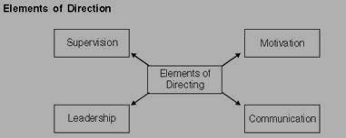

**Figure 1 Elements of direction**.

**Supervision:**

Supervision means overseeing the employees at work, to see that they are working according to plans and policies of the organization and keeping the time schedule, and to help them in solving their work problems. Its mean monitoring, instructing, guiding and observing the subordinates in their task to ensure that both plans and procedures are to be implemented.

**Functions of supervisor:**

* Coordinate between employees and work schedules.
* Plan work as per schedule. • Issuing orders • Guide the subordinates.
* Achieve desired goal.
* Motivate the subordinates.
* Maintaining records.
* Liaison between management and workers.
* Compare the worker’s performance with the standards. • Introduce Modern work methods.
* Maintain Discipline.
* Provide healthy environment.
* Replace broken tools and equipment.
* Sort out operational issues on a day-to-day basis.

**Requisites of Effective Supervision** • Technical and Managerial knowledge.

* Use of authority.
* Knowledge of rules and regulations.
* Skill in leading.
* Skill for Human orientation.
* Issue clear instructions**.**

**Motivation**

* Motivation means inspiring, stimulating or encouraging the sub-ordinates with zeal to work. Positive, negative, monetary, non-monetary incentives may be used for this purpose.
* Motivation is a process of influencing people.
* Motivation is the process of stimulating people to accomplish desired goals of organization.
* Motivation helps individuals and groups in the organization for improved

Performance.

**Definitions of Motivation**

* According to **William G. Scout**, Motivation means a process of stimulating people to action to accomplish desired goals.
* According to **Fred Luthans**, Motivation is a process which begins with a physiological or psychological need or deficiency which triggers behavior or a drive that is aimed at a goal or incentive.
* According to **Mc Farland**, Motivation refers to the way in which urges, drives, desires, aspirations, strivings or needs direct, control and explain the behavior of human beings.

Following factors affect an employee’s motivation,

* + 1. Attitude,
    2. Interests
    3. Needs

**Motivation Process:**

Motivation process is based on how unsatisfied human need gets satisfied and result in reduction of tension.

* **Unsatisfied need :**The need of an individual which is not satisfied.
* **Tension :**Unsatisfied need creates tension
* **Drives :**Tension creates drive and an individual start searching for alternative to satisfy the need .
* **Satisfied need:** After opting the chosen alternative his need gets satisfied.
* **Reduction of tension:** The fulfillment of need results in relieving of tension.

**Positive motivation by means of Incentive-**

Incentives mean all measures which are used to motivate people for improving performance. These incentives may be broadly classified as financial and nonfinancial.

Financial incentives are monetary and may be in the form of

* Salary
* Bonus
* Profit Sharing
* Pension
* Co-Partnership
* Employee Stock Option

Non-financial incentives provide social and psychological satisfaction. These include, • Status

* Promotion
* Responsibility
* Job Enrichment
* Job Recognition
* Job Security
* Employee Participation
* Delegation
* Empowerment

**Communication:**

* It is transfer of information from the sender to the receiver .
* Communication plays key role in the success of a manager.
* Effective communication requires information and understanding.
* Directing abilities of manager mainly depend upon his communication skills.
* Communication refers to process of exchange of ideas between persons.
* Successful communication causes desired changes. **Elements of Communication Process**
* The proper sequence of elements in the expanded communication model is as - a. Sender
  1. Message
  2. Transmission
  3. Recipient
  4. Meaning
* In organisations, both formal and informal communications simultaneously take place.
* Formal communications:
  1. Orders
  2. Memos
  3. Appeals
  4. Notes
  5. Circulars
  6. Agenda
  7. Minutes etc.
* Informal or grapevine communications: -
  1. Rumours
  2. Whispers etc.

**Types of communication**

**Based on the direction of flow of information communications are classified as**

* **Upward communication:**

Upward communication flows from subordinates to superiors i.e. Upward communication is the process of sending information from bottom levels to the top levels of an organization.

1. **The grievance redressal procedure**: Enables employees to appeal to management and seek redressal of their grievances.

2 .**Open-door policy**: Allows employees to approach managers at any time and discuss their problems with them.

1. **Counseling, attitude questionnaires and exit interviews**: The Personnel Department can conduct nondirective counseling programs to help employees deal with their work-related problems as well as work and family conflicts. Attitude questionnaires may be administered periodically to find out employees’ attitudes towards the workplace and the workload. Exit interviews may be held for the employees quitting the organization to find out their reasons for leaving and their suggestions for improving the workplace.
2. **Participative techniques**: upward communication can be achieved through formal participation programs like union-management committees, suggestion boxes, junior boards and quality circles or through informal involvement of employees. Research has shown that employees who participate in these programs are more satisfied with their job, show greater commitment toward the job, and perform better than non-participating employees.
3. **The ombudsperson**: A position created to receive and respond to inquiries, complaints, requests for policy clarification, or allegations of injustice by employees. Through an ombudsperson, employees can have their problems resolved quickly without going through lengthy channels. This position had initially been created in Scandinavia as an outlet for people who felt that they had been treated unfairly by the government bureaucracy

* **Downward communication**

Downward communication flows format upper level to those at the lower level in the organization. The objectives of the downward communication is to communicate policies, procedure, programs and objectives to subordinates Downward communication has five purposes:

* 1. To give instruction to employees regarding their jobs and specific tasks.
  2. To provide information about organizational procedures and practices to new employees.
  3. To explain the rationale of a job to a new employee.
  4. To provide subordinates feedback about their job performance.
  5. To give information required by different teams and departments for the achievement of goals.

* **Horizontal /Lateral communication**

It refers to transmission of information among positions of the same level. Horizontal communication aids to coordinates the activities of various departments.

**Forms of communication**

**Broadly there are three forms of communication**

* **Oral Communication –** face to face, video conferencing, telephone, in meeting, lectures, interviews, etc

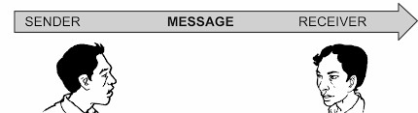

**Figure 2- Face to Face communication Figure 3 Oral communication**



**Figure 4 - Presentation**

* **Written communication -** report, statement, circular, manual handbook, letter or memo.

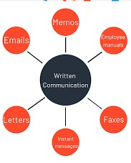

## Figure 5 Written Communication

Merit of written communication

1. It serves as evidence of what has occurred or what was stated.
2. It provides a permanent record for future use.
3. It reduces the chances for misinterpretation and distortion of information
4. It is reliable when transmitting lengthy information on financial, production or other important data.
5. It provides an opportunity to the subordinates to put up their grievances in writing and get them supported by facts

Demerits of written communication.

1. It is generally an expensive and a time-consuming process.
2. Even though such communication has been transmitted, it is not certain whether the receiver has understood it.
3. Written materials not only get out of date but may also be leaked out before time.
4. It sometimes leads to excessive formality and rigidity in personal relations

• **Nonverbal Communication -** Expressed through the body – the facial expression, posture, gestures eye contact, touch etc.

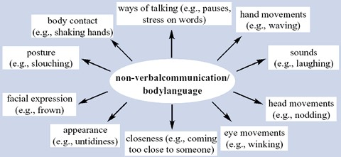

**Figure 6: Non Verbal Communication**



**Figure 7: Nonverbal Communication actions**



## Figure 8 intuintubal Signs

**3.1.6 Completeness and feasibility of instructions**

Operators working instructions are very important at shop floor because it describe how to execute the operation. A good work instruction should:

* Define each individual step in the operation
* Instructions should be specific about task
* Clearly describe the method to complete each task
* Define the required tools and resources
* Instructions should be easily readable
* Instructions should be fulfilling, no additional instructions should be required • Instructions should be logical, practical and technic base.
* Instructions should be given proper authority.
* Instruction should include safety and protective measures • Instructions should be presented in a user friendly format.

**Personal Counselling**

Counseling of staff is becoming an essential function of the Supervisor. Supervisor is counselor, mentor, and advisor of the workers. If he does not get connected with the workers by above roles, it is difficult to achieve the objectives. Counseling at workplace is a way of the organization to care about its employees. Apart from their personal problems, there are various reasons which can create stress for the employees at the workplace.

**Need for personnel counseling**

* Unrealistic targets or work-load
* Constant pressure to meet the deadlines
* Responsibility and accountability
* Conflicts or bad inter-personal relations with superiors and subordinates, • Problems in adjusting to the organizational culture • Workers lose confidence in job.
* Workers make repetitive mistakes.
* Stress in work is affecting mental condition
* Counseling helps the employee to share and look at his problems from a new perspective.

**Qualities of supervisor as a counselor**

* A counseling supervisor must demonstrate leadership skills • Must have expertise in his/her field • Motivational approach.
* Problem solving nature
* Counselor should possesses positive thinking
* Good communication skill
* Ethical manner

### 3.2.1 Advanced predictions of possible mistakes

As a successful supervisor one must have logical skill and thinking ability to predict what mistakes are possible in near future at work place. Mistakes may be predicted by

1. Supervising the current working condition
2. Comparing deviation with standards
3. Analyzing workers general work attitude
4. Complexity of used technology

**Elaborating decision**

In many conditions, subordinates are unknown of decision taken by higher or middle management. This creates confusion among the workers. Hence decision may be elaborated in some cases.

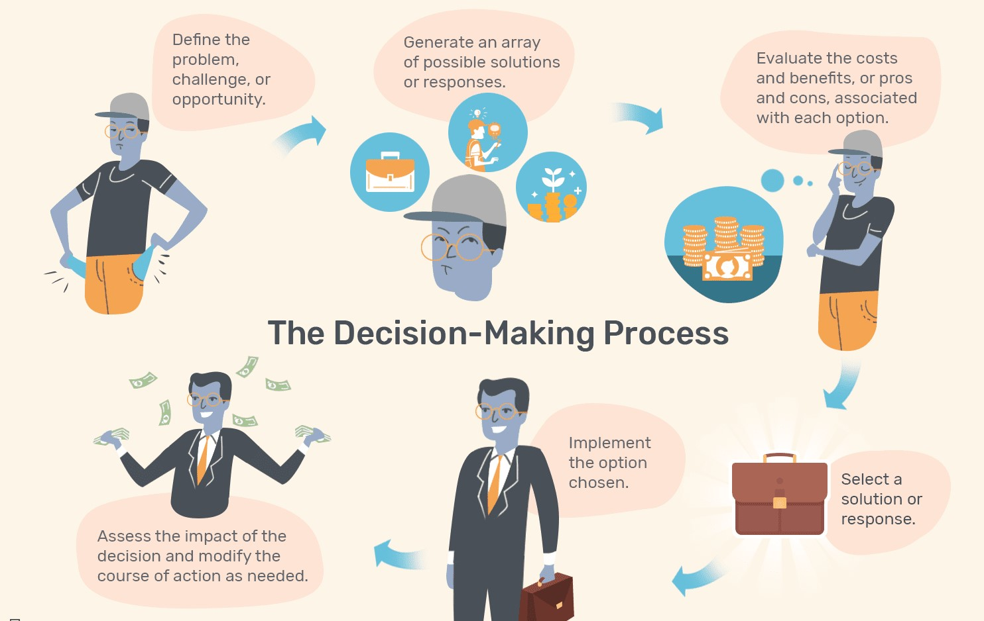

## Figure 9 Decisions Making by Supervisor

**Need to elaborate decision.**

* To create awareness about decision.
* To emphasis policies of management • To avoid confusion
* To get clarity about their future work.
* To understand duties and responsibilities regarding these decisions**.**

**Ways to elaborate decision**

Respective management at their level can elaborate decision by following ways:

* On notice board
* Written format
* In meetings
* During counseling
* By common Circular

**Decisions that can be elaborated regarding following issues-**

* Uniform of workers
* Overtime times working hours
* Bonus and benefits
* Changes of Scheduled work
* Transfer of employee within organization
* Need of training to the employees

**Laying Disciplinary Standards in overall working Importance of disciplinary standards.**

* Maintains Workplace Standards
* Controls Problem
* Quality in work performance
* Time factor followed
* Prevents More Serious Problems • Standardization of work gets improved. • Avoids Lawsuits • Losses are reduced.
* Avoids Misconduct

**Ways of laying disciplinary standards**

* Disciplinary action
* Training for discipline
* Awards to disciplined practices
* Punishment to non- disciplined employee
* Time-in time, Out time , Before time
* Quality – zero error

**Controlling at Supervisory Level**

**Managerial Control**

Control is significant process in management. Controlling is a forward looking and a backward-looking function. Controlling is the process that ensures the performance is according to the pre-established standards. The main objective is to find out mistakes so that they may be corrected and prevented from recurring. In order to seek planned results from the subordinates, a manager needs to exercise effective control over the activities of the subordinates. Thus controlling is • A goal-oriented function.

* It is a primary function of every manager.
* The controlling function finds out an actual performance deviates from standards, analyses the causes of such deviations and attempts to take corrective actions

**Importance of Controlling**

Control is an indispensable function of management. Without control the best of plans can go away. A good control system helps an organisation in the following ways:

### *i. Accomplishing organisational goals*

* The controlling function measures progress towards the organisational goals and brings to light the deviations, if any, and indicates corrective action.
* It guides the organization and keeps it on the right track so that organizational goals might be achieved.

### *ii. Judging accuracy of standard*

* A good control system enables management to verify whether the standards set are accurate.
* An efficient control system keeps a careful check on the changes taking place in the organisation and in the environment. ***iii. Making useful usage of resources***
* To reduce wastage and spoilage of resources.
* To perform activities according to predetermine standards and norms.
* To use the resources in most effective and efficient manner.

### *iv. Improving employee motivation*

* A good control system ensures that employees know well in advance what they are expected to do?
* It helps employee to give better performance

**Understanding team**

Understanding the team by supervisor is necessary to • Control activities of team.

* Assign work to team.
* Train team members.
* Utilize team member effectively.
* Avoid conflict among team members

**Links between various departments in respect of process and quality standards.**

In industry there are various departments such as Sales department, Production department, Service department, Maintenance department, Purchase department, Quality control . The supervisor must maintain the coordination between different departments to avoid machine breakdown, delay in material receiving, inventory, quality related problems of finished product.. Supervisor can maintain the link with to - a) Maintenance department:-

* Avoid machine breakdown time.
* Routine machine overhauling.
* Intimate about breakdown..

1. Quality control department
   * Communicate Quality issues. • Restrict the errors in job.
2. Stores Department
   * Requisite the material for production.
   * Communicate the quality of material.
   * Keep record.
3. Marketing Department
   * Collect Market survey information
   * Communicate available resources to Marketing department • Provide information of new product.
4. Human resource department
   * Requisite of Human requirement • Provide employee information.
   * Communicate H.R related issues.
   * Resolve issues regarding human resources
5. Design and Development Department
   * Provide information about available resources on the shop floor.
   * Coordinate design related issues.
   * Train the employee for new development of product
6. Sales and Services Department
   * Fulfill the customers requirement • Communicate available resources. • Availability of material.

**3.4.3 Steps in control process**

Controlling is a systematic process involving the following steps.

1. Setting performance standards
2. Measurement of actual performance
3. Comparison of actual performance with standards
4. Analysing deviations
5. Taking corrective action

**1. Setting performance standards**

* The first step in the controlling process is setting up of performance standards.
* Standards are the criteria against which actual performance would be measured.
* Standards serve as benchmarks towards which an organisation strives to work.
* Standards can be set in both **quantitative** as well as **qualitative** terms.

Quantitative Standards set in terms of • Cost to be incurred.

* Revenue to be earned.
* Product units to be produced and sold.
* Time to be spent in performing a task/

Qualitative standards should-

* Improve goodwill and motivation level of employees
* be flexible enough to be modified whenever required.

**2. Measurement of Actual Performance:**

Once performance standards are set, the next step is measurement of actual performance. There are several techniques for measurement of performance. These include personal observation, sample checking, performance reports.

**Following are the ways for measuring performance:**

1. Preparing performance report of an employee.
2. Measure Company’s performance by calculating gross profit ratio, debtor turnover ratio, return on investment, current ratio at periodic intervals
3. Inspect every unit or sample checking to ensure the quality standards **3. Comparing Actual Performance with Standards:**

This step involves comparing the actual performance with standards laid down in order to find the deviations. For example, performance of a salesman in terms of unit sold in a week can be easily measured against the standard output for the week.

1. **Analyzing Deviations:**

Deviations in key areas of business need to be attended more urgently as compared to deviations in certain insignificant areas. Critical point control and management by exception should be used by a manager

1. **Taking Corrective Action:**

• The final step in the controlling process is to take corrective action.

|  |  |
| --- | --- |
| **Causes of deviation** | **Corrective action taken** |
| Defective material | Change the quality specification for the material used |
| Defective machinery | Repair the existing machine or replace the machine if it cannot be repaired |
| Obsolete machinery | Undertake technological upgradation of machinery |
| Defective process | Modify the existing process |
| Defective physical conditions of work | Improve the physical conditions of work |

**Controlling methods Traditional Techniques** a. Personal observation

1. Statistical reports
2. Breakeven analysis
3. Budgetary control

**(a) Personal observation**

* Personal observation enables the manager to collect first-hand information.
* It also creates a psychological pressure on the employees to perform well as they are aware that they are being observed personally on their job.
* it is a very time-consuming exercise and cannot effectively be used in all kinds of jobs.

1. **Statistical reports**

Statistical reports can be defined as an overall analysis of reports and data which is used in the form of averages, percentage, ratios, correlation, etc., present useful information to the managers regarding the performance of the organization in various areas. This type of useful information when presented in the various forms like charts, graphs, tables, etc., enables the managers to read them more easily & allow a comparison to be made with performance in previous periods & also with the benchmarks.

1. **Breakeven analysis**

* Breakeven analysis is a technique used by managers to study the relationship between costs, volume and profits.
* It determines the probable profit and losses at different levels of operations.

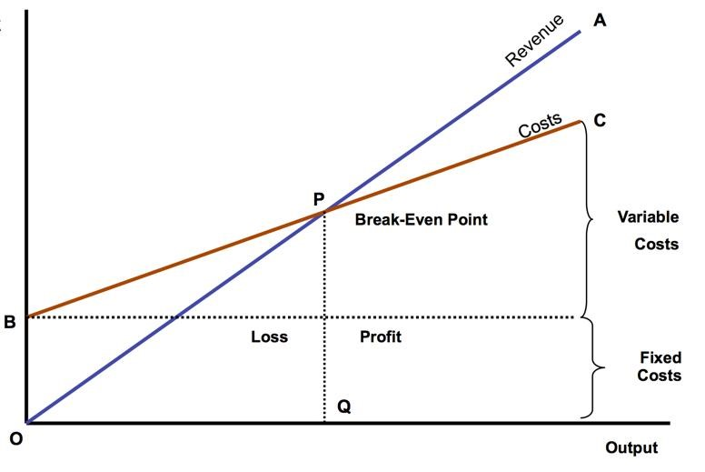

**Figure 10 Break even Analysis**

* The sales volume at which there is no profit, no loss is known as breakeven point.• It is a useful technique for the managers as it helps in estimating profits at different levels  of activities.

**Breakeven Point = Fixed Costs /Selling price per unit – Variable cost per unit**

**(d) Budgetary control**

* Budgetary control is a technique in which all operations are planned in advance in the form of budgets and actual results are compared with budgetary standards.
* It helps to take necessary actions so that organisational objectives are accomplished• A budget is a quantitative statement for a definite future period of time for the purpose of obtaining a given objective.
* It will contain figures of forecasts both in terms of time and quantities.

|  |  |  |  |  |  |
| --- | --- | --- | --- | --- | --- |
| **Sales Budget** | **Production Budget** | **Material Budget** | **Cash Budget** | **Capital Budget** | **Research and**  **Development Budget** |
| A statement states an  organisation  expects to sell in  terms of quantity as well as value | A statement states an  organisation plans to  produce in  the budgeted period | A statement of estimated quantity and cost of  materials  required for production | Anticipated cash in flow  and out flow for the  budgeted period | Estimate spending on long-term  assets like  new factory or major equipment | Estimate spending for the  development  or refinement of products and processes |

## Table No 2

**Advantages of Budgeting**

* Budgeting focuses on specific and time-bound targets and thus, helps in attainment of organisational objectives.
* Budgeting is a source of motivation to the employees who know the standards against which their performance will be appraised and thus, enables them to perform better.
* Budgeting helps in optimum utilisation of resources by allocating them according to the requirements of different departments.
* Budgeting is also used for achieving coordination among different departments of an organisation and highlights the interdependence between them. For instance, sales budget cannot be prepared without knowing production programmes and schedules.
* It facilitates management by exception by stressing on those operations which deviate from budgeted standards in a significant way.

**Controlling Tools** These include:

* 1. Return on investment
  2. Ratio analysis
  3. Responsibility accounting
  4. Management audit
  5. PERT and CPM
  6. Management information system

**Unit 4:**

**Safety Management**

**Introduction:**

Safety is very important aspect for any industry as an accident free environment boosts the morale of the team members working in any hazardous situations. Safety means continuing and healthful living without injury. Safety is free from harm or danger of harm. The word safety also refers to the precautions people take to prevent accident, harm, danger, damage loss and pollution. Safety also deals with improvement in working conditions for better health. Similarly, all hazards, i.e. source/situation capable of injury or ill health, damage to properly or workplace environment etc., should be identified and action plan drawn for safeguard against them.

**4.1 Need for Safety Management:**

A **Safety Management system** (SMS) is a continuous improvement process that reduces hazards and prevents incidents. It protects the health and safety of employees and should be integrated into everyday processes throughout the organization.Safety management system (SMS) is a comprehensive management system designed to manage safety elements in the workplace. It includes policy, objectives, plans, procedures, organisation, responsibilities and other measures. The SMS is used in industries that manage significant safety risks, including aviation, petroleum, chemical, electricity generation and others.

Workplace safety is so important for every industry because workers desire to work in a safe and well protected environment. Healthy and safety workplace is essential for all industry in order to promote the well-being of both employers and employees.

Industrial safety is important as it safeguards human life, especially in high risk areas such as nuclear, aircraft, chemical, oil and gases, and mining industries, where a fatal mistake can be catastrophic. Industrial Safety reduces risks to people, and processes. ‎

Safety management is needed for managing workplace safely which is the important goal of an organization. It ensure better working environment for employee and place employees in jobs suitable to their work restrictions. Safety management using software system helps to record, manage and analyse safety related data, enhance communication and sharing of appropriate data among supervisors, managers and medical staff. It also ensures centralized compliances from all locations to avoid accidents. safety management make standardization and automates the safety investigation process.

**4.2 General safety norms for an industrial unit, Preventive measures:**

While working in any industry we should aware about safety norms to be followed for everyone’s safety. Following are some safety rules to be kept in mind while working:

## General Safety Rules/Norms

1. Be sure you know how to perform the job and perform it safely.
2. be sure you know its hazards and how to protect yourself, e.g., head protection, eye and face protection, hearing protection.
3. Report all near misses, incidents, injuries and illnesses immediately.
4. Wear the required personal protective equipment (PPE) necessary for the job during welding and working on cutting tools.
5. Always work clear of suspended loads – head and foot protection.
6. Inform Supervisors of Unsafe Conditions.
7. Use Equipment, Machines, and Tools Properly, e.g., hand tool and portable power, tool safety.
8. Wear Safety Equipment like protective clothing and personal hygiene.
9. Prevent Slips and Trips.
10. Keep Work Areas and Emergency Exits Clear.
11. Eliminate Fire Hazards.
12. Avoid Tracking Hazardous Materials, lockout of energy sources.
13. Norms to use compressed gas cylinders.
14. Avoid lack of oxygen on a space that could cause immediate respiratory failure.
15. Serious care must be taken where toxic gases or vapours can poison the workers.

**Preventive measures:**

To prevent accidents there is a need for consistent implementation of safety measures.

Some of the important safety measures helpful for preventing accidents are:

1. **Safe workplace and working condition**:

* Good layout. Good layout includes sufficient space for movement, non-skid type floors • Reduced Noise level. Use of such machines which produces less noise, provide separate space For such works which produces noise, make efforts for reducing the vibrations help in Minimizing harmful effects of noise.
* Inflammable materials should be stored separately.
* Machines or their parts should be fenced when it is not possible to provide safeguards.
* All boilers and other pressure vessels must be kept in proper condition. Safety valves, Pressure gauges and water gauges must be examined thoroughly at regular intervals.
* Physical conditions, sufficient illumination, ventilation and height should be provided. Floor Should be free from oiliness and clean.

2**. Safe material handling**:

* Hoist, cranes, lifts along with its accessories must be periodically tested. They must be of sound construction.
* The crane must be fitted with interlocks and limit switches.
* The load lifting capacity or safe working load should be prominently marked on the equipment
* The lifting and carrying operation should be steady and free of jerks.
* Avoid fatigue of workers, use handling devices where possible.

3. **Personal Protection Equipment’s (PPE):**

The personal protective equipment is used to save from the danger from sharp edge, hot surface, dust, toxic gas etc. A PPE cannot remove the hazard but it acts as barrier between the danger and the user.

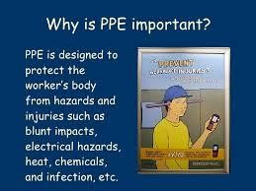

**Figure 1 Personal Protection equipment**

Usually human body needs protection for the parts or systems and PPE used is as below

* Hand protection- Hand gloves
* foot protection-Leather/Rubber shoes
* Head protection-Safety helmet
* Eye protection- Safety goggles/shield fitted with special dark glass
* Face protection-Face shield
* Skin and body protection-Aproan,boiler suit
* Protection against fall-safety belt,rope,anchoring point
* Hearing conservation/protection against noise-Air plugs, air muff
* Respiratory protection-Respirator, breathing apparatus, half face mask, dust filter

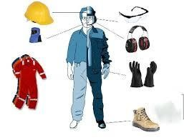

### Figure 2 Personal Protection Equipments

Use of above PPE is necessary where required.

4. **Safe activities in the following situation:**

* Repair work on the machine should not be done when it is running.
* All the tools should be kept at their proper places
* Chips should not be removed by hand
* Worker should be trained about correct procedures and they should be educated about safety Precautions
* Constant warning, publicity and play cards carrying slogans are also helpful to reduce accidents
* To avoid danger, inflammable materials should be kept away from general storage at a safe distance (15.25m).Fire extinguishers should be kept at suitable places

5. **Prevention of electric accidents**:

* Electrical insulation should be periodically tested
* Use proper tools for testing and repairing
* Repair Work should be done after switching the power off
* Use safety equipment’s such as insulated tools and rubber gloves whenever necessary

6. **Good housekeeping:**

Housekeeping includes cleanliness in building, work area, rest areas, equipment’s, and machinery tools etc.

* Good housekeeping minimizes fatigue and discomfort to the workers and motivate them
* It reduces the chances of fire and other hazards
* Increases the life of machinery, equipment and tools
* Improves productivity and quality of the product
* Better utilization of floor space
* Enhances the moral of workers

1. Safe Working Methods
2. Proper selection of workers
3. Training for safe working
4. Accident prone areas
5. Safety Devices
6. Safety Programme
7. Promoting Safety awareness in Employees

**4.3 Definition of accident, types of industrial accident; Causes of accidents;**

Definition of accident: An accident is an unplanned and undesired event, which results in to unacceptable and undesired consequences. The consequences might be injury and / or damage to equipment, machinery, raw material or finished product or damage to environment. A person may receive a minor physical or bodily injury while working as the outcome of accident. After such injury if he resumes his duties within 48 hours when such an accident is called as non-reportable accident.

If the injured person remains absent for 48 hours or more due to injury at workplace, the accident is called as reportable or lost time accident. The injury in such case is called as major or disabling injury.

Accident is an unfortunate and sudden miss happening which causes damage or loss of property, material or human. Safety management is concentrating on preventions of accidents.

**Losses Due to accident**

* **Direct Losses**: This type of losses measured in terms of money. Employer has to pay to the worker for compensation; medical expenses are coming under direct losses.
* **Indirect losses:** The sources of indirect losses are as follows,
  1. Loss of time of injured person and also of his fellow workers, who stop work at the time of accident
  2. Loss of time of supervisors :
     1. in assisting injured worker;
     2. in making alternate arrangement;
     3. in investigating and preparation of report of accident;
     4. In selecting and training the new worker to replace the worker who lost his life in accident.
  3. Loss due to damage caused to machine.
  4. Loss due reduction in the efficiency of worker and other workers due to fall in their moral
  5. Losses to the injured worker due to loss to his income, loss in medical expenditure and pain felt by worker which cannot be compensate

**Types of industrial accidents:**

Industrial accidents is divided in two general classes

* + 1. Machinery accidents- Cause due to inadequate safeguard of machines. These can be reduced by providing safety guards on belts, gears, etc.
    2. Non machinery accidents-Cause due to personal reasons such as age, physical weakness, inexperience and carelessness or from the plant conditions such as poor ventilation and illumination.

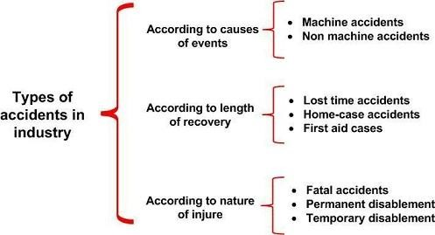

### Figure 5 Types of Accidents

Further the accidents can be classified as:

1. **Based on severity, durability and degree of injury**

1) Minor accidents

* + - * Less harmful in nature
      * Preventing employees for the period less than 48 hours from working
      * Not necessary to report to higher management

2) Reportable accidents

* + - * Supervisor should report to the higher management
      * Accident is little complicated than the minor accident
      * Prevent worker for the period of 48 hours or more from working after injury

3) Fatal accidents

* + - * It result in to death of employee
      * Reporting to top management, legal bodies and police is must

4) Accidents due to dangerous occurrences

* + - * Explosion, fire leakages are the reasons for this type of accidents
      * Man and property both can be damage
      * It gives greater loss to the industry

5) Internal accidents

• Injury without showing external science(eg.fractured bone) are called as internal accidents

6) External accidents

• Injury with external signs is called external accidents

7) Major accidents

• Accident causing death/permanent/prolonged disability to injured employee is called major accident

8) Temporary accidents

• Accident which causes disability to worker for a short period (a day/a week)

9) Permanent accident

• Injury after accident disable the affected worker permanently

1. **Based on place of accident**

1) Construction accident

• Accident occurs at construction sites are often happening and injuries are serious

2) Chemical plant accident

• Accident occurs due to hazardous gases, vapours and fumes. The uses of several toxic chemicals and fluid are the most dangerous industries.

3) Industrial plant accidents

• Industries accident occurs due to mistakes by worker, management or situation in manufacturing plants

4) Mining accident

* + Collapse of soil layer, suffocation, poisons gases are the causes of accidents in mines

**Causes of accidents:**

Majority of industrial accidents are due to transmission machinery for eg. gear, belts, pullies, coupling, shafting, cutters , tools and clutch of cutting machines etc.

To minimize the accidents, it is necessary to know about the cause of accident.

General causes of accidents are given below:

* + Accidents due to dangerous machines-These accidents occurs from boilers, pressure vessels, prime movers, transmission system
  + Unsafe physical conditions-it includes improper guard, improper illumination, improper Ventilation, unsafe clothing .
  + Moving objects-sometimes moving objects or foreign objects causes accident.
  + Personal factors-Lack of knowledge, physical weakness are the personal factors which Causes accidents.
  + Unsafe act-These includes working at unsafe speed, loading machine beyond capacity, not Using safety devices, adopting unsafe procedure..
  + Unsafe acts are the violence of Commonly accepted safe procedure.
  + Electrical causes- Some of the important causes are
    1. Do not providing proper protecting devices
    2. not obeying proper instructions and safety precautions
    3. Failure to use insulated pliers, screw drivers and rubber gloves, etc.
* Exposure to harmful substances-injuries due to accidents are also caused due to exposure to harmful substances, like toxic gases, fumes, dust, vapour mist and aerosols

Accidents are unfortunate, sudden and not planned by anybody. But accidents definitely cause by one or other reasons. Further are the few causes of accidents: **A) Causes of accidents due to worker:**

* Stress in work.
* Overtime work.
* Poor knowledge of work.
* Unnecessary daring less work experience.
* Use of mobile while working.
* Lack of confidence.
* Undisciplined nature.
* Bad habits like alcoholism, smoking.
* Working without authority.
* Unstable mental condition.
* Fear of accident.
* Mischievous behavior.
* Lack of concentration.
* Less work experience.
* Unstable mental condition.
* Not aware about rules and regulations of that specific work.
* Physical problems like eyesight’s and hearing inabilities.

1. **Causes of accidents due to management** • Poor housekeeping.
   * Untrained workers.
   * Bad construction of the plant.
   * Unsafe workplace to worker. • Extra load of work.
   * Poor discipline at workplace.
   * Heavy mental pressure.
   * Lack of safety procedure.
   * Heavy mental pressure on workforce.
   * Arrangement of machines, equipment in accident prone manner.
   * No plans for plant protection.
   * No provision of safety equipment .
   * Less control on habits of worker, employees behavior, their movements.
   * Faulty equipment’s.
   * Unguarded moving parts.
   * Wrong assignment of works.
   * Careless management approach.
   * Overcrowding of machines at shop floor.
   * Overcrowding of persons near to the workplaces.
   * Lack of safety awareness .
   * No arrangement for accident control.
   * No alternative arrangements of escape at the time of accident.
2. **Causes of accidents due to unsafe working conditions:** 
   * Suffocation at work.
   * Poor illumination.
   * Weak machine foundations.
   * Poor electrification.
   * Poor workplace layout.
   * Oily surfaces, sleepary floor.
   * Unnoticeable turns and crossings.
   * Unnecessary slopes and steps on shop floor.
   * Humidity at workplace.
   * Irregular floor heights, unscientific gangways, galleries and staircases.
   * Unavailability of basic facilities near to workplace.
   * Exposure to knowing parts.
   * Storage of explosive without proper care.
   * No support at work by others.
   * Negative competitions, groupism at workplace.
   * Lack of human factor consideration while designing furniture, operating system of machines. • Bad housekeeping.
3. **Natural causes of accident** 
   * Floods
   * Snowfalls
   * Heavy rains
   * Earthquake
   * Temperature strokes
   * Cyclones
   * Land slides

**Effects of accidents**

The effects of accident on various elements of society is given as follows.

**a) Effect on worker:** • Injury to body .

* + - Financial loss of worker.
    - Skill loss of worker .
    - Leave for recovery.
    - Confidence level of worker.
    - Loss of job.
    - Loss of life due to fatal accident. • Growth in career may get affected. **b) Effect on management**
    - Faith of workers gets disturbed
    - Longer time to solve the case
    - Issues related to court, police, compensation and hospital
    - Status among competitors
    - More attentiveness becomes necessary in future
      1. **Effects on industry**
      * Low reputation
      * Stoppage of production
      * Additional cost of recovery on machine, place, building
      * Create bad message among workers
      * Financial loss for compensating the affected worker
      1. **Effect on family**
      * insecurity feeling
      * earning member loss
      * money and time losses due to hospitalisation
      * stability of family is disturbed
      * other family members may lose working hours or study hours after accident of their family members
      * patient needs attention
      * effect of accident on nearby society

**SOP: Safe Operating Procedure (SOP)**

It is a written document setting out the logical sequence of steps that must be followed to safely perform a workplace activity. The name, Safe Operating Procedure (SOP), is one of the names that may be given to a work procedure that is created and written after; identifying and assessing the health and safety risks involved in a work activity, and then identifying how to eliminate the risks or otherwise what reasonably practicable actions can be done to minimize those risks

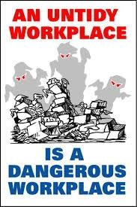

### Figure 3 Safety Poster

Basically, an SOP is the "how to do this work activity and remain safe and healthy".

A safe operating procedure is sometimes also called a safe work procedure or a safe work method statement.

**Need of Safe Operating Procedure**

Workers doing work activities that have risks need SOPs because; these procedures tell them "how to do their work activities and remain safe and healthy", and doing the work as set out in the SOP helps workers satisfy their duty of care to take ‘reasonable care’ for the health and safety of themselves and others and cooperate with reasonable policy and procedures of the organization

The Supervisors of those workers need SOPs because they know that; by making sure the workers they supervise follow those SOPs, they will be helping to keep those workers safe and healthy,

The Manager who manages those Supervisors needs those SOPs because they help the Managers to take reasonable care for the health and safety of workers that the Manager has overall control and responsibility for.

The Safety Committee and any employees engaged in safety inspection need SOPs because they are a stable and reliable reference point for them when they are doing workplace inspections and carrying out their vital functions of helping to make a safe and healthy workplace

**Benefits of Safe Operating procedures.**

* SOPs provide a stable reference point for all employees on “how to do this work activity and remain safe and healthy”.
* But an SOP is more than just a stable reference point and useful means of controlling workplace risks and helping employees to comply with their duty.
* In workplace risk situations where it is not possible for the management to eliminate the risks to health and safety then the management must use risk controls to minimize the risks so far as is reasonably practicable.
* An SOP is a procedure that is in that category of risk controls that is known as an administrative control and it must be used where relevant if the risks have not been minimized by other controls you put in place.

Safe work procedures for your facility do not have to follow a particular format, however, your safe work procedures should include,

* Name or description of the work task
* Date of SOP was created and Date it was last reviewed or revised
* Hazards that may cause harm to a worker
* Equipment / devices, personal protective equipment (PPE), or other safety considerations necessary to perform the task safely
* Required training and / or relevant documentation needed to perform the task safely
* Steps to perform the task safely including safe body positions and / or movements as appropriate
* Indication that workers are to be trained on the SOP and employers must ensure workers follow them

Safe Operating procedures must be based on a risk assessment. They must also be developed in consultation with the workplace safety and health committee Workers must be trained in the safe work procedures for your facility so they understand the steps and equipment they must use to work safely. Supervisors must ensure that safe work procedures are followed. Safe work procedures should be readily available to workers for reference.

The SOP must be reviewed periodically to ensure they are accurate and effective. If a task or equipment changes, the safe work procedure(s) that relate to this change must also be updated.

* + **A system / procedure is in place**
  + **It is written down**
  + **It is communicated**
  + **It is understood**
  + **It is practised**
  + **It is reviewed and updated**

### Figure 4 SOP

**4.4 Hazards**

**Hazard** is a situation to cause harm in terms of human injury or ill-health, damage to property or environment or both. Hazards may be classified as

1. Mechanical hazards
2. Electrical hazards **3)** Chemical hazards
3. Radiation hazard
4. Fire hazards

|  |  |
| --- | --- |
|  | |
|  | **Figure 6 Types of hazards** |

1. **Mechanical hazard**: These are responsible for the majority of accidents in work situations, therefore every workplace and equipment should be properly examined for identifying mechanical hazards.

Common sources of mechanical hazards are:

* 1. Machine tools, handling materials, hand tools and other appliances
  2. improper use of tools
  3. Improper ventilation, unsafe dress etc.
  4. Unguarded moving parts or pits etc.

1. **Electrical hazards**: These may be due to contact of body with wire, cable, rail and other electrical appliances. The immediate effect of this is shock which may be relatively mild or severe so as to cause death depending upon the strength of the current. Another result is burning and the burns may be severe and deep, especially with higher voltage

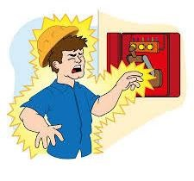

**Figure 7 Example of hazard**

Types and causes of electric hazards:

* + - By direct contact –while working on electrical circuits without protective equipment for maintenance or repair, one may come in contact with the live conductor
    - Arc burns-An arc is a result of flash-over. At high voltage flash over is intense and can cause severe burn injury to a person with high tension power transmission cable
    - Radiation burns-This is a result of short circuit and can cause discomfort to the person
    - Metal vapours – The metal vapour results from fusing of conductor at a joint, this may cause burn injury. The emitted metal particles may get impregnated on the hands or face of a person working close to it
    - Deep burns and necrosis- This results from contact with the live conductor at high voltage

1. **Chemical hazards**: The usages of chemicals with hazardous gases, vapours and fumes are one of the most dangerous industries. The effect of noxious gases are • Simple asphyxiates, e.g. Nitrogen gas , methane gas , carbon dioxide

• Chemical osphysciants ,e.g. carbon monoxide, hydrogen sulphide, hydrocyanic acid

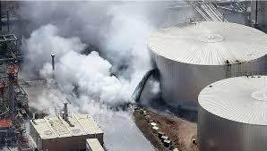

### Figure 8 Chemical Hazard

a) irritant gases e.g. nitrogen dioxide or peroxide, fluorine, hydrogen fluoride, Sulphur dioxide, ammonia, Organic metallic gases e.g. Arsenic hydride, Inorganic metallic gases

1. **Radiation hazard**: Radiation hazards in industrial radiography are mainly caused by external sources, as x-rays and gamma rays are penetrating in nature and can irradiate organs deep inside the body. Some examples of radiation include sunlight, radio waves, x-rays, heat, alpha, beta, gamma ionizing radiation, and infrared, just

to name a few. Not all of these types of radiation are harmful, in fact, in moderation; most radiation will not pose a health risk.

Putting distance and shielding between you and a radiation source is an immediately effective way of reducing your exposure. Reducing the time you are being exposed is another way. Use a Respirator or Face Mask if you are exposed to airborne sources.

There are four basic types of ionizing radiation: Alpha, beta, gamma and x-ray, and neutron particles. All of these types of radiation are caused by the activity of unstable atoms.

1. **Fire hazard:**

According to old concept, three elements are necessary to start fire. They are (1) Fuel (2) Oxygen and (3) Heat or Source of ignition. Fire is not possible if any one of these elements is not available. This is shown in figure

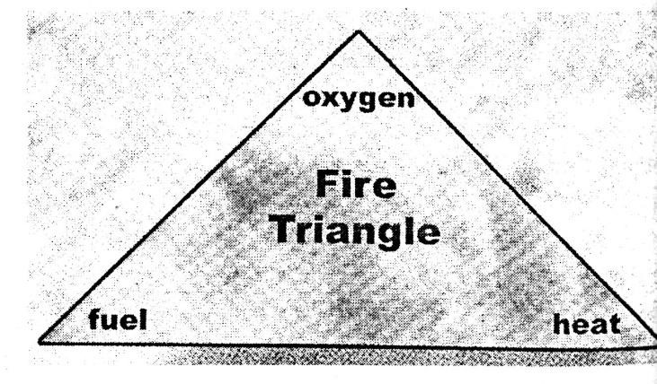

### Figure 9 Triangle of Fire

According to this concept, four elements are' necessary to start fire. They are as under ▪ Fuel (combustible material and reducing agent).

* Oxygen or oxidant or oxidizer (from the atmosphere).
* Heat or source of ignition (necessary to start the fire initially, but maintained by the fire itself once it has started and
* Chain reaction through free radicals to maintain the fire.

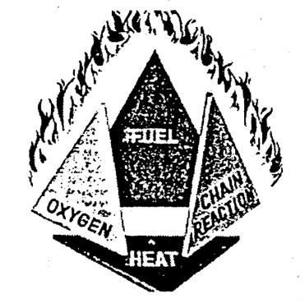

Figure 10  **Pyramid of fire**

If any one of above four elements is removed, the fire goes out. Therefore methods of fire extinguishment are dependent on:

* Removing or shutting off the source of fuel.
* Excluding oxygen or decreasing it below 14 to 18% by adding inert gases.
* Removing heat from the fire faster than its liberation and
* Removing free radicals to discontinue chain reaction and flame propagation. Dry powder chemicals and halogenated hydrocarbons capture free radicals and put out fire in this way.

Thus fire is a rapid chemical oxidation reduction reaction. Oxygen in air acts as an oxidizer and fuel acts as a reducing agent and burning material. It is an oxidation of a substance (which burns i.e. fuel) accompanied by heat, light and flame. Due to incomplete combustion it evolves smoke and carbon monoxide which creates invisibility and toxic atmosphere for fire fighters

An excess of air can cool the combustion gases to quench the fire, if the combustible material is small, otherwise it cannot, as in case of forest fire where the combustible material is too much to cool.

The chemical reaction is exothermic as it evolves heat and the heat released is used for the reaction to continue.

**Classification Of Fire And Extinguishers**

### Table 1 : Classes of Fire and Extinguishers

|  |  |  |  |  |
| --- | --- | --- | --- | --- |
| **Class fire** | **Description** | **Extinguishing Medium** | | **IS No.** |
| **A** | **Fires involving ordinary combustible materials like wood, paper, textiles, fibers and vegetables etc. where the cooling effect of water is essential for the extinction of fires.** | **Water type (Soda acid)** | | **934** |
| **Water type (gas pressure)** | | **940** |
| **Water type (constant air**  **pressure),** | | **6234** |
| **B** | **Fire in flammable liquids like oils, grease, solvents, Petroleum products, varnishes paints etc. where a blanketing effect is essential.** | **Chem. Foam** |  | **933** |
| **Carbon dioxide** |  | **5507**  **10474**  **2878**  **8149** |
| **Dry Powder** |  | **2171**  **4308** |
| **Dry Powder foam** | **Mechanical** | **10658**  **10204** |
| **Halon 1211** |  | **11108** |
| **Sand buckets** |  |  |
| **C** | **Fires involving gaseous substances under pressure where it is necessary to dilute the burning gas at a very fast rate with an inert gas or powder.** | **Carbon dioxide** |  | **2878**  **8149** |
| **Dry powder Dry powder** |  | **2171**  **4308** |
| **Halon 1211** |  | **11108** |
| **D** | **Fire involving metals like magnesium, aluminium, zinc, potassium etc., where the burning metal is reactive to water and which requires special extinguishing media or technique.** | **Dry powder** | | **2171** |
| **Special dry powder for metal fire** | | **4861**  **11833** |
| **E** | **Fires involving electrical equipment where the electrical non-conductivity of the extinguishing media is of first importance.** | **Carbon dioxide** | | **2878** |
| **Dry chemical powder** | | **2171**  **4308** |
| **Halon 1211** | | **11108** |
| **When electrical equipment is de-energized, same as for Classes A & B Sand buckets.** | |  |

**Classification of Fire Extinguishers:**

• **Class A:** Fires in ordinary combustible material, such as wood, cloth, paper, rubber and many plastics that require the heat-absorbing coolant effect of water or water solutions, the coating effects of certain dry chemicals that retard combustion, or the interruption or the combustion chain reaction by the dry, chemical or halogenated agents.

* **Class B:** Fires in flammable or combustible liquids, flammable gases, grease and similar material that must be put out by excluding air (oxygen), by inhibiting the release of combustible vapor with AFFF or FFFP agents, or by interrupting the combustion chain reaction.
* **Class C:** Fires in live electrical equipment. The operator's safety requires the use of electrically nonconductive extinguishing agents, such as dry chemical as halon. When electric equipment is de-energized, extinguishers for class A or B fires maybe used.
* **Class D:** Fires in certain combustible metals, such as Mg, Ti, Zr, Na, & K that require a heat absorbing extinguishing medium that does not react with the burning metals.

**Fire drill:**

Fire drill is a method of practicing how a building would be evacuated in the event of fire. Usually, the building existing fire alarm system is activated and the building is evacuated when the emergency occurred.

Flammable materials and their processes must be identified first. Based on these flammable materials, their quantities, storage parameters and flammable processes, probable scenarios should be decided and listed in the fire emergency action plan. In periodical fire drill, different scenarios should be selected at different times from the above list. This will help to train our plant personnel to fight with all types of fire. Necessary PPE should be used while participating in such drills. Scenario of fighting fire with floating pump can also be a part of drill.

Fire control room should be well established. Audio visual indication should be available by fire call bells. Fast communication and public address system should be provided. Trained staff should be available. Necessary documents including lists of telephone numbers and mutual help contact persons should be readily available in the control room. It is desirable to conduct at least one fire drill in one quarter or statutory periodicity should be followed.

**Fire Emergency Action Plan and Drill:**

Fire emergency action plan should be similar to 'On-Site Emergency Plan'. Here type of emergency is a fire or explosion emergency. Key elements of such plan are as under:

1. Assess all possible fire emergencies or the maximum foreseeable loss (MFL) factor. Mark fire/explosion prone areas on the factory plan.
2. Assess resources (men, material, equipment etc.) available in the plant and make a list of them with their locations, contact phones and incharge persons.
3. Assess resources needed from outside and make a list of them with their places of availability, contact persons and phone numbers.
4. Prepare a central control room for co-ordination of emergency time activities.
5. Prepare an organized group of key persons who will act to control the emergency. Site Main Controller, Incident Controller and other responsibilities should be decided. Everybody should be given their role in writing. Table top exercise and rehearsal will be carried out to shape their actions. Established an in-house safety committee 6. All communication systems shall be maintained in workable order.
6. Double gates (one for entry, one for exit), unobstructed inner roads and proper sign boards shall be displayed.
7. Housekeeping shall be regularly checked. Accumulation of rubbish and combustibles shall be removed soon.
8. Fire water, working order of fixed fire installations and placement of charged portable extinguishers shall be regularly checked.
9. Alternate power source shall be kept ready.
10. Runners shall be arranged to act in the event of communication failure.
11. Distinctive garments or cap, band etc. shall be given to emergency controllers.
12. Decide assembly points for safe gathering by other people.
13. Keep arrangement for medical, security and transport in readiness to handle the emergency.
14. Train firefighting crew, medical staff and other workers for their emergency time and cost emergency time activities.
15. It should be assured before restarting the normal work that fire is fully extinguished, environment is cooled, debris etc. removed, all-clear signal is given and the plant is ready for restart.

**Steps in fire drill:**

1. Established an in-house safety committee
2. Communicate with the fire marshal
3. communicate evacuation path to peoples
4. Suggest alternate routes in case of emergency 5) conduct fire drill regular **During the fire drill:**

Supervisory staff has to monitor the fire drill process and note any of the following 1) Whether individuals are closing the doors after exit?

1. Are individuals remains calm and proceed towards the nearest exit?
2. All the individuals assembled at the designated point or not.
3. Are fire wardens ensuring the safe evacuation of all individuals

**After the fire drill:**

1. Reset the fire alarm system
2. Record the total evacuation time in the report
3. Ensure the fire alarm system is back to normal operating condition
4. Inform individuals that they can reenter the building
5. Keep records of the fire drill

**Advantages of fire drill:**

1. Peoples exit the building in time and assemble at designated area
2. Evacuation routes are known to people
3. Evacuation procedures will be familiar to all due to practicing fire drill regularly. 4) Fire drills are also helpful for testing escape routes to evaluate their effectiveness
4. Fire drills ensure that alarm system and fire safety equipment’s are in working condition
5. After mock drill, improvement can be suggested for effective evacuation process

**Fire drill objectives:**

1. Giving employee an opportunity to practice emergency procedures in a simulated but safe environment
2. Evaluating effectiveness of evacuation procedures
3. Complying with requirements of the local fire code
4. Determining if employees understand and can carry out emergency duties

**Frequency of fire drill:**

1. Fire prone places-once in three months
2. Other work places-once in six months

**4.5 Work permit:**

A **permit-to-work** system is a formal written system used to control certain types of **work** that are potentially hazardous. A permit-to-work is a document which specifies the **work** to be done and the precautions to be taken. Permits-to-work form an essential part of safe systems of **work** for many maintenance activities.

Permit to work (PTW) System is an integral part of a safe system of work and can assist in the management of work activities, including non-routine work. This system allows Occupiers, PTW Authority and PTW Users to communicate hazards involved in the work activities to enable safe execution of onsite.

A PTW system is a formal written system used to control and execute certain types of jobs safely, which are identified as potentially hazardous. It is also a means of communication between different departments, plant supervisors, operators, agencies etc**.**

The objectives, methodology, issue of permit, its execution and termination, foreseeing of hazards and arrangement for their controls, testing and certification of working atmosphere, use of tools and personal protective equipment, first-aid and rescue equipment and training of workers for such work are the common factors in any type of work permit application. Its sole purpose is to save life and avoid accident.

There are types of Work Orders

1. Work order for working at height
2. Hot work permit
3. Cold work permit
4. Permit or Electrical maintenance etc.

Hazardous substances are many. They may be explosive, flammable, toxic, hot, and corrosive and may be in the form of dust, gas, vapour, steam, hot oil etc. They pose high degree of hazards, have caused many accidents world-wide and need strict safety precautions while working with them.

Other factors being common, the vital part of devising any safety work permit is to concentrate on typical hazards involved and then to apply their remedial measures. Material Safety Data Sheet will expose property hazards. Storage, process and vessel conditions can reveal their specific hazards and due consideration to all such hazards is necessary before devising any substance wise work permit.

Normally hazardous works of maintenance or modification need work permit system. It is given for the following category of works:

**Operations**: Excavation, vessel entry, working at height, hot work, welding and cutting, equipment removal, pipe breaking, line breaking, lining in furnace, waste disposal, ship breaking and cutting.

**Equipment:** Electrical, pneumatic, hydraulic lifting machine, crane, sprinkler or hydrant system.

**Hazardous area:** Explosive, flammable, corrosive, radioactive or toxic atmosphere.

**Time :** Overtime or after hours work.

General and special hazards both should be considered. For example, work with flammable dust, gas, vapour or liquid requires flameproof equipment and avoidance of all sources of ignition, but depending upon the class of fire, specific fire extinguisher is required. Work with a toxic dust or gas needs local exhaust or capture device, but depending on type (e.g. chlorine, phosphine, CO) and concentration, specific respirator is required. Work with corrosive acid needs acid-proof hand-gloves, goggles and apron, but depending on fumes given by it (e.g. HCI, SO, nitrous fumes) specific respirator is required. Work with hot substance requires shielding and hand protection but depending on its nature (e.g. steam, oil, molten metal, liquid glass, hot surface), the specific type of hand protection (cotton, leather, asbestos) can be selected. Working on a fragile roof needs a crawling board, substantial platform or support and a safety belt but the height, place and position will decide the type of ladder or platform and type of anchoring as specific requirement. Work with dust requires exhaust or suction device but the type (e.g. sand, coal dust, wood dust, chemical powder, bio-organism) and size (microns) decide specific type of respirator.

**Features of permit-to-work systems:**

1. A hazard and risk assessment
2. Standard operating procedure
3. Instruction in the issue ,use and closure
4. A tool box sign by all workers
5. The permit issue, extension and withdrawal details
6. The name and signature of those who are responsible for the job
7. Essential control measures, mitigating actions and precautions
8. The equipment and tools used

**A standard procedure essential of work permit system consists of**

1. Training of authorized person
2. formal recorded process
3. clearly defined responsibilities
4. preparatory work method statement
5. Audits and monitoring the system works as intended
6. It is for authorize person

**Types of Permit-To-Work (PTW):**

The types of work for which PTW systems shall be applied include maintenance and repair, inspection, testing, construction, dismantling, modification and cleaning. The types of work for which PTW systems shall be applied include maintenance and repair, inspection, testing, construction, dismantling, modification and cleaning.

**Types of work permits:**

1. Cold work permit: a cold work permit shall be obtained for all general work that does not involve activities related to hot work.

Example: Routine maintenance, inspection, hand tools

1. Hot work permit: It is any work that could create a source of ignition that could result in fire or explosion.

Examples: Spark producing tools, hammering in high risk gas areas, explosives, welding. **Responsible person:** A person authorised by manager who will responsible for keeping his area and staff safe.

* **Issuer:** A person trained, competent and authorise to issue a permit to work after insuring that all the hazards associated with the work being done in that area and all necessary safety precautions are being implemented to ensure that the work can be completed safely. • **Executor:** A person who is trained, competent and authorised for the work being completed as described in the permit to work.
* **Field operator:** A competent person an supports the isolator at site, checks the site compliance to permit conditions and signs the permit.

In emergency and in routine activity work permit is not required

**Elements of work permit system:**

**1 Issue:**

* It means prejob check
* Description of work to be carried out
* Description of plant and location
* Assessment of hazards
* Identification of controls

**2. Receipt:**

* It means handover of permit
* competent and authorised person issues permit to workers
* Work can now start
* Workers sign to say the accept control
* Plant is now under the control of workers

**3. Clearance:**

* It means hand back to permit
* Workers sign to say they have left the job site and equipment’s can restart

**4. Cancellation:**

* Authorised person accept plant back and can remove isolation
* Plant is now returned to the control of the site

**Need of Work permits:**

* complex machineries
* pressure testing
* work at height
* operational pipelines
* high voltage electrical equipment
* Non production work e.g. maintenance,cleaning,testing,repair
* High risk activities
* Work which affect the safety personal adversely
* The rescue systems
* Work near energized lines
* Electrical trouble shooting or repair on live circuits
* Work involving the use of dangerous substances including radioactive materials and substances
* Critical lifting using mobile cranes

**Unit 5:**

**Legislative Acts**

**5.1. Introduction**

The Ministry of Labour and Employment seeks to protect and safeguard the interests of workers in general and those who constitute the poor, deprived and disadvantaged sections of the society, in particular, with due regard to creating a healthy work environment for higher production and productivity, and developing and coordinating vocational skill training and employment services. Government's attention is also focused on promotion of welfare activities and providing social security to the labour force both in the organised and unorganised sectors, in tandem with the process of liberalisation. These objectives are sought to be achieved through enactment and implementation of various labour laws, which regulate the terms and conditions of service and employment of workers.

The following are the thrust areas of the Government concerning labour laws:

* Labour policy and legislation;
* Safety, health and welfare of labour;
* Social security of labour;
* Policy relating to special target groups such as women and child labour;
* Industrial relations and enforcement of labour laws in the central sphere;
* Adjudication of industrial disputes through Central Government Industrial Tribunalscum-Labour Courts and National Industrial Tribunals;
* Workers' education;
* Labour and employment statistics;
* Emigration of labour for employment abroad;
* Employment services and vocational training;
* Administration of central labour and employment services; and • International cooperation in labour and employment matters.

India has a number of labour laws that govern almost all the aspects of employment such as payment of wages, minimum wages, payment of bonus, payment of gratuity, contributions to provident fund and pension fund, working conditions, accident compensations, etc. The Government has enacted certain central legislations, viz, the Employees Provident Fund and Miscellaneous Provisions Act, Employees State Insurance Act, Payment of Wages Act, Minimum Wages Act, Equal Remuneration Act, Maternity Benefits Act, etc.

In addition, at the State level, the State Governments usually have a separate Labour Ministry, which seeks to ensure compliance with State labour laws (viz, State Shops and Establishments Act, Labour Welfare Fund Act, etc) through its Labour Department, which is generally operational at the district level.

The various labour legislations enacted by the Central Government can be classified into the following different broad categories: A. Laws relating to Industrial Relations- 1. Industrial Disputes Act, 1947

2. Trade Unions Act, 1926

1. Laws relating to Wages
   * + 1. Minimum Wages Act, 1948
       2. Payment of Wages Act, 1936
       3. Payment of Bonus Act, 1965
2. Laws relating to Social Security
   * + 1. Employees' Provident Funds and Miscellaneous Provisions Act, 1952
       2. Employees' State Insurance Act, 1948
       3. Labour Welfare Fund Act (of respective States)
       4. Payment of Gratuity Act, 1972
       5. Employee's Compensation Act, 1923
3. Laws relating to Working Hours, Conditions of Services and Employment
   * + 1. Factories Act, 1948
       2. Industrial Employment (Standing Orders) Act, 1946
       3. Shops and Commercial Establishments Act (of respective States)
       4. Contract Labour (Regulation and Abolition) Act, 1970
       5. Inter-State Migrant Employee (Regulation of Employment and Conditions of Service) Act, 1979
       6. Weekly Holiday Act, 1942
       7. National and Festival Holidays Act (of respective States) 1963
       8. The Plantation Labour Act, 1951
       9. The Mines Act, 1952
       10. The Dock Workers (Safety, Health & Welfare) Act, 1986
4. Laws relating to Equality and Empowerment of Women
   * + 1. Equal Remuneration Act, 1976
       2. Maternity Benefits Act, 1961
5. Prohibitive Labour Laws
   * + 1. Bonded Labour System (Abolition), Act, 1976
       2. Child Labour (Prohibition & Regulation) Act, 1986
       3. The Beedi and Cigar Workers (Conditions of Employment) Act, 1966
       4. The Sexual Harassment at the Workplace (Prevention, Prohibition and Redressal) Act, 2013
6. Laws relating to Employment and Training
   * + 1. Apprentices Act, 1961
       2. Employment Exchanges (Compulsory Notification of Vacancies) Act, 1959

**5.2 Necessity of Legislative acts**

* + - 1. They improve industrial relations, i.e., employee-employer relations.
      2. They help in paying fair wages to workers.
      3. They minimize unrest among the workers.
      4. They help to give compensation to workers, victims of accidents.
      5. They help in reduces conflicts, strikes etc,
      6. They help to procure job security for the workers.
      7. They help to promote wholesome environmental conditions in the industry.
      8. They help in fixing hours of work, rest pauses, etc.

**5.3 THE FACTORIES ACT, 1948**

**5.3.1 Objective and Scope**

The main object of the Factories Act, 1948 is to ensure adequate safety measures and to promote the health and welfare of the workers employed in factories. The Act also makes provisions regarding employment of women and young persons (including children and adolescents), annual leave with wages etc.

The Act extends to whole of India including Jammu & Kashmir and covers all manufacturing processes and establishments falling within the definition of ‘factory’ as defined under Section 2(m) of the Act. Unless otherwise provided it is also applicable to factories belonging to Central/State Governments. (Section 116)

The factories act regulates conditions of work (health, safety etc.) in factories, it safeguards the interest of workers and it is for the welfare of factory workers.

This act received the assent of Governor-General of India on September 23, 1948 and came into force on April 1, 1949. This act was further amended in 1950, 1951, 1954,etc.,and lately in 1987.

This act is applicable to any factory in which ten or more than ten workers are working. The factories act has a provision in respect ofEmployee health and safety, Hours of work, .Sanitary conditions and wholesome work environments, Employeewelfare, Leave with wages, etc.

**5.3.2. Applicability of the Factories Act, 1948:** The Act is applicable to the premises wherein:

1. 10 or more workers are employed with use of power
2. 20 or more workers are employed without the use of power
3. Less than 10 workers, if activity is notified by the State Government.

Engaged in manufacturing activities

1. Factories Act, 1948, is a central act, enforced by the state governments making the relevant rules to extend scope and objectives of the Act.
2. The Act is applicable to all the factories including state, and Central Government.
3. Onus is on the part of the factory management to comply with the provisions of the Act and Rules made there under.

**5.3.3 Important definitions**

* Factory. A place wherein ten or more persons are working and in which a manufacturing process is going on using electricity, steam, oil, etc.
* Manufacturing process. A process formaking, altering, repairing, finishing, packing, washing, cleaning, or otherwise treating a substance for its use, sale, transport, disposal, etc. pumping oil, water or sewage, or generating, transforming, or transmitting power, orcomposing types for printing, printing for letterpress, lithography, photogravure or other similar process or book binding ; constructing, reconstructing, repairing, refitting, finishing or breaking up ships or vessels.
* Worker. Worker means a person employed directly or through any agency, whether for wages or not, in any manufacturing process or in cleaning any part of the machinery or premises used for a manufacturing process or in any other kind of work incidental to or connected with, the manufacturing process or the subject of manufacturing process.
* Adult. A person who has completed his eighteenth year of age.
* Child. A person who has not completed his fifteenth year of age.
* Power. Electrical energy or any other form of energy which is mechanically transmitted and is not generated by human or animal agency.
* Machinery. It includes
* Prime movers; engine, motor, etc. Transmission machinery: shaft, wheel, drum, pulley, belt etc. And all other appliances whereby power is generated transformed or transmitted.
* Occupier of factory. A person who has ultimate control over the affairs of factory and where the- said affairs are entrusted to a managing agent, such agent will be considered as the occupier of the factory.

**5.3.4 Approval, Licensing and Registration of Factories**

Before starting a factory,

* Take permission of the state government or chief inspector for the site on which factory is to be made.
* Get the factory plans and specifications approved by the inspector of industries.
* Pay the necessary fees and get the registration and licensing of the factory. If on an application to chief Inspector to usea particular site for a factory, nothing is heard within three months, the permission is deemed to have been granted.

In case of refusal from chief inspector or state government, the applicant within 30 days of the date of such refusal may appeal to central government in this connection.

An occupier should, at least 15 days before he occupies a placeas a factory, send to Chief Inspector a written notice containing name and address of occupier and factory, nature of manufacturing process, nature of power to be used, name of factory manager, number of workers required, etc. **5.3.5 The Inspecting Staff**

State government appoints Chief Inspector and other Inspectors who may

1. Enter any factory,
2. Make examination of premises, plants, machinery and any documents related to factory.

**Duties of the Inspectors**

The Inspectors are required:

1. To carry out duties as laid down under Section 9 (b) and (c);
2. To ensure that statutory provisions and rules framed are carried out properly; an
3. To launch prosecutions against factory-owners under the provision of Chapter X of the Act.

**Certifying Surgeons**

State government may appoint qualified medical practitioners as certifying surgeons for

1. The examination and certification of young workers, and
2. The examination of workers engaged in dangerous occupation or processes.

**5.3.6 Main Provisions of the Act**.

**Welfare Measures for Workers**

They are of two types – health measures and welfare measures.

**a. Health Measures**

1. **Cleanliness**

* Removal and disposal of dirtfrom floors, benches etc., everyday.
* Washing of floors of work room at least every week, using disinfectant.
* Effective means to drainage to avoid collection of water, etc., on the work floor.
* All inside walls and partitions, all ceiling tops of rooms, passage and staircase to be repainted once in 5 years if they are already painted; andto be white-washed and the white-washing to be carried out at least once in fourteen months.

1. **Disposal of Wastes and Effluents**

Effective and suitable arrangements should be made for the disposal of wastes and effluents due to the manufacturing process.

1. **Ventilation and Temperature**

In every factory, effective and suitable provision shall be made for securing and maintaining in every workroom,

* 1. Adequate ventilation by fresh air circulation,
  2. Suitable temperature to provide conditions of comfort and prevent injury to the health of workers.

1. **Dust and Fumes**

Employer shall take necessary steps to keep workrooms free from dust or fumes offensive or injurious to the health of the workers.

1. **Artificial Humidification**

In factories (e.g., textile) where humidity of air is artificially increased, state government may make rules ( Prescribing standard of humidification ;

* 1. Regulating the method of artificially increasing humidity ;
  2. Directing prescribed test for determining humidity ; and
  3. Prescribing method for achieving adequate ventilation and cooling the air in workroom. The water employed for humidification shall be from a source of drinking water.

1. **Overcrowding:** No workroom should be overcrowded to an extent, which is injurious to the health of workers. The minimum space provided for a worker should be 4.2 cu. m.
2. **Lighting:** Light whether artificial or natural or both, should be sufficient and suitable in all workrooms, Skylights and glazed windows for lighting the workrooms should be kept clean and unobstructed. Glares and shadows which cause eye strain or risk accidents should be prevented. & Drinking Water
3. **Drinking Water**

Section 18 deals with the provisions relating to arrangements for drinking water in factories. In every factory, effective arrangements shall be made to provide and maintain at suitable points conveniently situated for all workers employed therein, a sufficient supply of wholesome drinking water.

1. **Conservancy Arrangements**

In every factory, there shall be provided and maintained, separate arrangement for toilets for male and female workers at convenient places. These should be adequately lighted, ventilated and maintained in a clean sanitary condition.

1. **Spittoons**

Section 20 (1) lay down that in every factory, there shall be provided a sufficient number of spittoons in convenient places. They shall be maintained in a clean and hygienic condition.

**5.3.7. Welfare measures**

* + Washing facilities
  + Washing facilities adequately screened for male and female workers should be provided in the factory. Washing facilities shall be easily accessible and kept clean.
  + Facilities for sitting Suitable sitting facilities shall be provided for all workers obliged to work in standing position so that they may take rest if an opportunity occurs in the course of their work, without affecting the work.
  + First aid appliances
  + For every 150 workers, minimum one fully equipped first-aid box shall be kept available during all working hours. A factory employing more than 500 workers shall have a properly equipped ambulance room.
  + Canteens: A canteen shall be provided in each factory in which more than 250workers are ordinarily employed.
  + Shelters, rest-rooms and Lunch-rooms Every factory in which more than 150 workers are ordinarily employed, adequate, suitable, clean, sufficiently lighted and ventilated rest and lunch rooms shall be provided.
  + Creches:
  + Every factory shall provide clean, adequately lighted and ventilated rooms for the use of children (under the age of six years) of women workers, if the number of such women workers exceeds 30.
  + Welfare officers.
  + Every factory employing 500 workers or more shall employ welfare officers. The state government may prescribe the duties, qualifications and conditions of service of welfare officers so employed.

**5.3.8. Safety measures**

1. Encasing and fencing of machinery in every factory the following shall be securely fenced unless they are in such position as to be safe for each worker • Moving parts of prime mover and flywheel connected to it.
   * The head race and tail race of water wheel and water turbine.
   * Any part of a stock bar projecting beyond the lathe head-stock.

The following parts should be securely fenced by safeguards which shall be kept in position while the parts are rotating,

* + Parts of electric generator, motor, etc.
  + Parts of transmission machinery.
  + Dangerous parts of any other machinery.

1. **Work on or near machinery in motion**

Any part of machinery if it is required to be examined while it is in motion shall be examined only by a specially trained adult male worker wearing tight fitting clothing.

Now man or young worker shall be permitted to clean, lubricate or adjust any part of a moving machinery which involves a risk of injury.

1. **Employment of young person’s on dangerous machines**:

No young person shall work on a dangerous machine unless he has got sufficient training to work at that machine ; and he is under adequate supervision of an adult experienced worker/supervisor.

1. **Hoists and lift:**

* Every hoist and lift shall be of good mechanical construction, adequate strength and sufficiently protected and fitted with gates; and Adequately maintained and periodically (at least once in six months) examined.
* Hoists and cranes meant for carrying persons shall have at least two ropes or chains separately connected with the cage. Each rope or chain with its attachments shall be able to carry weight of the cage together with its maximum load (e.g., weight of persons). Devices should be provided to support cage in the event of breakage of the ropes or chains.

1. Lifting machine, chains, ropes and lifting tackles Factory cranes and other lifting machines such as crab, winch toggle, pulley block, etc., shall be ofgood construction, sound material, adequate strength, properly maintained and thoroughly examined atleast once a year.
2. **Pressure plants** 
   * It should be ensured that the working pressure of such parts does not exceed the safe value.
3. **Floors, stairs and means of access to different places** 
   * They should be of sound construction, properly maintained and provided with handrails.
4. Pits, sumps, openings in floors, etc., shall be either securely covered or suitably fenced
5. Excessive weights No person shall be asked to lift, carry or move any load so heavy as to cause him an injury.
6. **Protection of eyes**

To protect the eyes of workers from the flying particles (such as in fettling, rivet cutting, scale removal, etc.) or from exposure to welding rays, each worker shall be provided with effective screens of suitable goggles.

1. **Precautions against dangerous fumes**

No person shall be allowed to enter any confined space, chamber, tank, pit, etc. in which dangerous fumes are likely to be present so as to involve risk to the entering person.

1. Explosive or inflammable dust, gas, etc. If a manufacturing process is producing dust, gas, fumes or vapour which can explode on ignition,
   * + 1. The plant should be effectively enclosed ; and
       2. Such dust, gas fume, etc., should not be allowed to accumulate.
2. Precautions in case of fire Every factory shall be provided with means as follows and others to help escape in case of fire :
   * + 1. Fire warning signal.
       2. Unlocked doors and openings towards outside the workroom.

(iii)Free passageways and easily openable windows.

**5.3.9. Working Hours**

* + - * Weekly hours An adult worker shall be required to work in the factory for not more than 48 hours a week.
      * Weekly holidays No adult worker shall be required to work on Sunday unless the factory manager substitutes Sunday by a holiday one or three days immediately before or after Sunday.
      * Daily hours No adult worker shall be required to work for more than nine hours on any day.
      * Intervals for rest
      * No adult worker shall be required to work for more than 5 hours continuously,

é.e., after five hours, the worker shall have a rest for at least half an hour.

* + - * Extra wages. For over-time
      * If a worker works for more than nine hours on any day or for more than 48 hours in any week, he will get his overtime wages at the rate of twice his ordinary rate of wage (Le. basic wages + allowances).
      * Restriction on double employment
      * No adult worker shall be allowed to work in a second factory on any day on which he has already been working in one factory.
      * Register of adult workers
      * Factory manager shall maintain a register of adult workers (stating their names, nature of work, group work, etc.) and make it available to the Inspector at all times during work hours.
      * Restrictions on employment of women No women shall be employed in any factory except between the hours of 6 A.M. and 7 P.M.

**5.3.10 Employment of Young Persons**

1. **Prohibition of employment of young children**

No child under 14 years of age shall be allowed to work in any factory.

1. **Non-adult workers**

A child who has even completed his 14 years of age shall not be allowed to work in a factory unless he carries while at work a token giving reference to certificate of fitness.

3. **Certificate of fitness**

It is a certificate of fitness for working in a factory which is given to a young person by a certifying surgeon after examining him (i.e. the young person).

**5. Working hours for children**

Act regulates the working hours for children above age of 14 years as eligible for employment in a factory. They can be employed for maximum hours of work lasting 4-1/2 hours in a day.

The other prohibitions relating to their employment are:

* The period of work is to be limited to two shifts only;
* The shifts are not to overlap;
* The spread-over is not to exceed 5 hours;
* The child is to be employed only in one relay;
* The spread-over is not to change except once in 30 days;
* Employment during night, i.e. Between 10 p.m. And 6 a.m. Is prohibited.

**Annual Leave with Wages**

A worker who has worked for 240 days or more during a calendar year shall be permitted during the subsequent calendar year, leave with wages for a number of days at the rate of • One day for every 15 days of work performed by a child worker.

* One day for every 20 days of work performed by an adult worker .A worker interested to take leave shall apply 15 days in advance.

**Special Provisions**

Dangerous operations - Where the state government feels that any operation is of serious risk or bodily injury, poisoning or disease, it may make rules :

* + - 1. Declaring the operation dangerous;
      2. Stopping employment of women and children in this operation ;
* providing protection of all concerned with that operation ; and
* Periodical medical check-up of all concerned with that operation, etc.

**Notice of accidents**

An accident causing death or bodily injury due to which the worker cannot work for a period of 48hours or more immediately after the accident, shall be brought to the notice of such authorities, within such time as may be prescribed.

**Notice of disease.**

If a worker is suffering from any disease specified in the schedule, a report immediately shall be sent to Chief Inspector giving particulars of the worker and the disease from which he is suffering. Power to take samples. An inspector, during working hours, after informing the manager may take samples of any substance being used in the factory.

**5.3.11. Penalties and procedure**

**General Penalty for Offences**

In case of any contravention of any of the provisions of this Act, the occupier and factory manager shall each be guilty of an offence and punishable with up to 2 years of imprisonment or fine up to Rs. 100,000 or both.

If contravention continues after conviction, there will be a fine of Rs. 1000 per day. After being convicted for an offence, if the person does contravention of the same provision again, he shall be punishable with imprisonment up to 3 year, a fine up to Rs 10000 to 3 lakhs or both. Penalty for Obstructing Inspector

An Occupier/Manager shall be punishable with imprisonment up to 6 months or fine up to Rs. 10,000 or both if he

* + - Fails to produce registers or other documents on demand by Inspector ; and
    - Prevents any factory worker from being examined by the Inspector. Offence by Workers
    - If any worker contravenes any provisions of the act, he shall be punishable with fine up to Rs. 500.

**Appeals**

An occupier/manager on whom a written order by an Inspector has been served under the provisions of the Act may within 30 days of the service of order, appeal against it to the prescribed authority. Obligations of Workers

No factory worker will misuse any appliance provided for the purpose of securing health, safety and employee welfare. ,

A worker who contravenes this provision shall be punished with up to 3 months imprisonment or a fine of Rs. 100, or both. Restriction on Disclosure of Information No inspector will ever disclose any information relating to manufacturing processes, etc., which comes to his knowledge in course of his official duties. An inspector who does so shall have up to 6months of imprisonment, or a fine of Rs. 1000, or both

**Recommendation of the National Commission on Labour**

The Government of India has set up the second national labour on 15th October, 1999. The commission has made valuable suggestions to improve the harmonious relations among the laborers working in the factory premises. It is an umbrella of the legislation to ensure a minimum level of protection to the workers in the unorganized sector. It has recommended that-

* Existence of child labour in hazardous industries is a major obstacle for Indian government and steps should be taken to eradicate it from the country. For this, a special scheme of establishing the special schools to provide the non-formal education, vocational training, supplementary nutrition, stipends, health care, etc. should be provided to children withdrawn from employment in hazardous industries.
* Ministry of labour in 1978 formulated a scheme for the rehabilitation of the bonded laborers. The responsibility for the identification, release and rehabilitation of the free bonded laborer rest entirely with the state government. Bonded laborers on release is paid immediately 1000/- as subsistence allowance and is rehabilitated as per the situation with a rehabilitation packages of 10,000 keeping in view the price escalation and increase in the cost of the rehabilitation packages.
* With the intention to focus on the heath of the women workers & to improve their conditions, a women cell has been set up which provides the opportunities for increasing the employment opportunities for women & providing grants & aids to the voluntary organizations for carrying out the research on the problems faced by the women workers. It also helps the women to be aware of their rights and opportunities so as to become economically independent.
* To achieve for the occupational safety and health of the workers, the Directorate General of Mines Safety (DGMS) and Directorate General of Factory Advice Services and labour Institutes( DGFASLI) have been set-up in mines, ports and factories. It monitors the working environment, man-machinery interface training and safety requirements of the workers.5. It also recommended that the formation of the craft and occupation trade unions should be discouraged and formation of the industrial trade unions and industrial federations should be encouraged.
* Penalties may be legally provided to curb a management policy of victimization and • similar unfair labour practices which prevent the emergencies of internal leadership.
* It also entrusts the labour bureau to be responsible for collection, compilation and
* publication of the labour statistics and other information regarding employment, wages, earnings, industrial relations, working conditions, etc. It also complies and publishes the data related to consumer price index numbers for industrial and agriculture workers.
* It also recommends educating the workers to help them avoid the wasteful expenditure, adopting cost effectiveness and by enhancing productivity of the qualitative nature. It includes rural awareness programmes, adult literacy classes, participative management, etc.
* It is also responsible for the social security and welfare of the working laborers through certain Acts like the Workmen's Compensation Act, 1923, the Employees State Insurance Act 1948, etc.

**5.4 THE INDUSTRIAL DISPUTE ACT**, **1947**

**5.4.1 Introduction and scope of Act**

According to parts, 1947, Industrial dispute is any dispute or difference between employees and employees, or between employers and employers, which is connected with the employment or non-employment, or the terms of employment or with the conditions of work of any person.

Conflict is inevitable in the industrial organization. Labour and management oppose each other in numerous ways in the course of daily work. Most industrial jobs are repetitive, monotonous, difficult, dirty and even accident prone. As a result of this management uses strict supervision to get the work done, on the other hand, the normal sentiment of the worker is one of discontent. The interests of these two parties are in conflict with each other.

**Objectives of the Act**

The Preamble to the Act reads thus, "An Act to make provision for the investigation and settlement of industrial disputes and for certain other purposes." the principal objectives of the Act may be stated as below:

1. To ensure social justice to both employers and employees and advance progress of industry by bringing about harmony and cordial relationship between the parties.
2. To settle disputes arising between the capital and labour by peaceful methods and through the machinery of conciliation, arbitration and if necessary, by approaching the tribunals constituted under the Act. If disputes are not settled, it would result in strikes or lockouts and entail dislocation of work, essential to the life of the community.
3. To promote measures for securing and preserving amity and good relations between the employer and workmen.
4. To prevent illegal strikes and lockouts.
5. To provide compensation to workmen in cases of lay-off, retrenchment and closure.
6. To protect workmen against victimization by the employer and to ensure termination of industrial disputes in a peaceful manner. **Causes of Industrial Disputes/Conflict**

Industrial includes three different possible sets of antagonists in industrial conflict. However, the present discussion is confined to disputes arising between management and workers.

The causes of dispute are:

* + - * 1. **Economic causes** – Wages, salaries, profit, etc.
        2. **Social causes** – Low morale, corruption, pollution, rising unemployment,
        3. **Political causes** – Political rivalry, unstable government, etc.
        4. **Technical causes** – Loss of jobs due to automation, unsuitable technology,
        5. **Psychological causes** – Loss of job, propaganda, instigation, etc.
        6. **Market causes** – Competition, loss, recession, etc.
        7. **Legal causes** – Court order of closing down factories, shifting (under zoning laws).

Disputes arise from a variety of sources for a variety of reasons. The following sections review the various causes under two categories: conflicts caused by unions and those caused by management.

**Important Aspects of the Act**

* + - * An industrial dispute may be referred to an Industrial tribunal.
      * An award shall be binding on both the disputing parties for a period not exceeding one year.
      * Strikes and lockouts are prohibited during the pendency of, conciliation and adjudication proceedings; settlement reached in the course of conciliation proceedings, awards of industrial tribunals declared binding by the appropriate government.
      * In public interest or emergency, appropriate government can declare the following industries to be a public utility service for a maximum period of 6 months, Transport by land, air, and water, Foodstuff, Coal, Cotton textile, and Iron and Steel.

**5.4.2. Important Definitions**

* 1. Award: It means an interim or a final determination of an industrial dispute. Decisions of Labour Court and Industrial Tribunals are awards.
  2. Average pay: It means the average of wages payable to employee:

• In case of monthly paid employee, in the 3 calendar months • in the case of weekly paid employee, in the 4 completed weeks; and • in the case of daily paid employee, in the 12 full working days.

* 1. Industry: It means any business undertaking, manufacture, etc, It includes any calling, service, employment, handicraft or industrial occupation or a vocation of employee.
  2. Industrial dispute: It means any dispute or difference, between employers and employers, employers and employee, employee and employee; and connected with employment, or non-employment, or terms of employment or conditions of labour, or any person
  3. Lay-off: It means Failure, refusal or inability of an employer, on account of shortage of coal, power, raw material, accumulation of stock, breakdown of machinery or for any other reason to continue to employ workers (in his industry) whose names are borne on the muster-rolls and who have been retrenched. Lay-off is a temporary phase ; the employee-employer relations do not come to an end, but are simply suspended for some period (of emergency).
  4. Lock-out: It means the closing of a place of employment or suspension of work or the refusal by ar employer to continue to employ any number of workers employed by him.
  5. Public utility services: It mean Railway or transport service, Postal, telegraph or telephone service, Any industry supplying power, light or water, Sanitation, Foodstuffs, and Coal, textile, etc.
  6. Retrenchment: It means the termination of the services of a worker by the employer for any reason whatsoever other than due to disciplinary action. Retrenchment does not include, Voluntary retirement of the worker, Termination of services on reaching the age of superannuation, and Termination of services on the ground of continued ill health.
  7. Strike: It means refusal to work or cessation of work by a body of employee for enforcement of a demand against the employer during an industrial dispute.
  8. Settlement: It implies a settlement arrived at in the course of conciliation proceeding. It includes a written agreement between the workers and employer.
  9. Employee: It means any person (including an apprentice) employed in any industry for hire or award to do manual, technical, supervisory or clerical work.

**5.4.3 Authorities Under This Act**

1. **Works Committee** 
   * Any industry, in which 100 or more workers are and have been employed on any day in the preceding 12 months, shall constitute a works committee.
   * Works committee shall have representatives of workers and employer both. Employee representatives will not be less than those of employer in number.
   * Works committee shall promote measures for securing and preserving amity and good relations between the workers and employer. It will comment upon matters of their common interest and try to compose any material difference of opinion in respect of such matters.
   * Works committee shall smooth away frictions that might arise between the workers and the employer in day-to-day work.
2. **Conciliation officers**

Conciliation officers will be appointed by any Appropriate Government and they shall mediate and promote the settlement of industrial disputes.

1. **Board of Conciliation**

Appropriate Government may constitute a Board of Conciliation to promote settlement of an industrial dispute.

Board of conciliation will be headed by a chairman (an independent person) and shall have two or four other members which will be representatives of the parties to dispute. Both parties, ie., workers and employer shall have equal number of representatives.

1. **Courts of Enquiry**

Appropriate Government may constitute a court of enquiry to look into any matter connected with industrial dispute Court (of enquiry) may consist of one or more independent persons.

The court shall inquire and submit a report ordinarily within six months from the commencement of inquiry.

1. **Labour Court**

The appropriate government may constitute Labour Court consisting of one person only for adjudication second of industrial disputes relating to any matter specified in the 2nd Schedule.

The matters within the jurisdiction of Labour Court as per 2nd schedule are :

* + - ‘The propriety or legality of any order passed by employer under the standing orders
    - The application and interpretation of standing orders.
    - legality or otherwise of a Strike or Lock-out.
    - Dismissal of workers including reinstatement or relief to workers wrongly dismissed
    - Withdrawal of any concession or privilege.

1. **Tribunals** 
   1. The appropriate Government may by notification in the Official Gazette, constitute one or more Industrial Tribunals for the adjudication of industrial disputes relating to any matter whether specified in the Second Schedule or the Third Schedule and for performing such other functions as may be assigned to them under this Act.
   2. A Tribunal shall consist of one person only to be appointed by the appropriate Government.
   3. A person shall not be qualified for appointment as the presiding officer of a Tribunal unless:
   4. he is, or has been, a Judge of High Court; or
   5. he has, for a period of not less than three years, been a District Judges or an Additional District Judge.
   6. The appropriate Government may, if it so thinks fit, appoint two persons as assessors to advise the Tribunal in the proceedings before it.

Further, the person appointed as a Presiding Officer should be an independent person and must not have attained the age of 65 years. (Section 7-A)

The duties of Industrial Tribunal are identical with the duties of Labour Court, i.e., on a reference of any industrial dispute, the Tribunal shall hold its proceedings expeditiously and submit its award to the appropriate Government.

1. **National Tribunals** 
   * Under Section 7-B, the Central Government alone has been empowered to constitute one or more National Tribunals for the adjudication of industrial disputes which (a) involve questions of national importance or (b) are of such a nature that industrial establishments situated in more than one State are likely to be interested in or affected by such disputes.
   * A National Tribunal shall consist of one person only to be appointed by the Central Government.
   * A person shall not be qualified for appointment as the Presiding Officer of a National Tribunal unless: he is, or has been, a Judge of a High Court; or
   * The Central Government may, if it so thinks fit, appoint two persons as assessors to advise the National Tribunal in the proceeding before it.
   * Section 7-C further provides that such a presiding officer should be an independent person and must not have attained the age of 65 years.

**Duties**

When a matter has been referred to a National Tribunal, it must adjudicate the dispute

expeditiously and submit its award to the Central Government. (Section 15)

**Strikes and Lock-out**

* 1. No employee of a public utility service shall go on strike,
     + 1. Without giving notice of strike, within six weeks before striking ; or
       2. Within fourteen days of giving such notice; or before the expiry of date of strike mentioned in the notice. ; or
       3. During the pendency of conciliation proceeding.
  2. No employer of any public utility service shall lock-out,

(i) without giving notice of lock-out within six weeks before locking out, or (ii) before the expiry of date of lockout mentioned in the notice, or (iii) during the pendency of conciliation proceeding.

The employer shall send information of strike or lock--out to the specified authority on the day on which it is declared.

* 1. Prohibition of financial aid to illegal strikes and lock-out. A strike or lock-out is illegal if it is declared in contravention of points 1 & 2 above (Le., section 22 and 23 of the act, respectively). Nobody shall knowingly expend any money in direct support of an illegal strike or lock-out.

**Lay-off and Retrenchment**

For definition of Lay-off and retrenchment refer Important Definitions given earlier in this Act.

**Difference between lay-off and lock-out**

* In lay-off, the employer refuses to give employment due to certain specified reasons, but in lock-out, there is deliberate closure of the business and employer locks out the workers not due to any such reasons.
* In lay-off, the business continues, but in lock-out, the place of business is closed down for the time being.
* In a lock-out, there is no question of any wages or compensation being paid unless the lockout is held to be unjustified.
* Lay-off is the result of trade reasons but lock-out is a weapon of collective bargaining.
* Lock-out is subject to certain restrictions and penalties but it is not so in case of lay-off. However, both are of temporary nature and in both cases the contract of employment is not terminated but remains in suspended animation.

**Right of Employee laid off for compensation**

A worker having more than one year of continuous service under an employer, ifis laid off, shall get compensation equal to 50% of the total of his basis wages and dearness allowance, subject to the following limitations :

Provided that if during any period of 12 months, a employee is so laid-off for more than 45 days, no such compensation shall be payable in respect of any period of the lay-off after the expiry of the first 45 days, if there is an agreement to that effect between the employee and the employer, etc.

**Employee not entitled to compensation in certain cases**

No compensation shall be paid to a worker laid-off under following conditions :

* If he refuses to accept alternative employment involving same wages, offered to him in the same concern or in any other concern of the same employer. • If the lay-off is due to a strike, etc.

**Conditions precedent to retrenchment**

No worker who has a continuous service of more than one year shall be retrenched by the employer until

* The worker has been given one month’s written notice stating the reason for retrenchment and the period of notice has expired or the worker has been paid in lieu of such notice, wage for the period of notice.
* At the time of retrenchment, the worker has been paid compensation equivalent to 15 days average pay for every completed year of service.
* An employer who intends to close down an undertaking shall serve, at least 60 days before the date on which he intends closure to become effective, a notice to Appropriate Government stating clearly the reasons for closing the undertaking.
* Compensation by reference to section 25-FFF of the Act is provided to workers who are in continuous service for not less than a year with the undertaking. .

**Penalty for Illegal Strikes and Lock-outs**

Any workman who commences, continues or otherwise acts in furtherance of a strike which is illegal under this Act, shall be punishable with imprisonment for a term which may extend to one months, or with find which may extend to fifty rupees, or with both.

**Penalty for Instigation etc.**

Any person who instigates or incite others to take part in, or otherwise acts in furtherance of a strike or lock-out which is illegal under this Act, shall be punishable with imprisonment for a term which may extend to six months, or with fine which may extend to one thousand rupees, or with both (section 27).

**Penalty for giving financial aid to illegal strikes:**

Any person who knowingly expends or supplies any money in furtherance or support of a strike which is illegal under this Act, shall be punishable with imprisonment for a term which may extend to one year, a fine which may extend to one thousand rupees, or both.

1. **Power to arrest without warrant:** Power to arrest without warrant. Notwithstanding anything contained in the Code of Criminal Procedure of 1898 (5 of 1898), any police officer may arrest without warrant any person who is reasonably suspected of having committed any offence under this Act.
2. **Act to override other laws:** The provisions of this act and of any order issued there under, shall have effect notwithstanding anything inconsistent therewith contained in the Industrial Disputes Act of 1947 (14 of 1947), or in any other law for the time being in force.

**Collective Bargaining**

Collective bargaining is a procedure by which the terms and conditions of workers are regulated by agreements between their bargaining agents and employers. Ever since the advent of modern trade unions, the workers have been pressurizing their employers in a concerted manner for improving the terms and conditions of employment, but the term 'collective bargaining' was seldom used for this concerted action.

There are three concepts of collective bargaining with different emphasis and stress, namely,marketing concept, government concept, and the industrial relations or managerial concept.

1. **Marketing Concept:** The marketing concept views collective bargaining as the means by which labour is bought and sold in the market place. In this context, collective bargaining is perceived as an economic and an exchange relationship. This concept focuses on the substantive content of collective agreements on the pay hours of work, and fringe benefits, which are mutually agreed between employers and trade union representatives on behalf of their members.
2. **Government Concept:** The governmental concept of collective bargaining, on the other hand, regards the institution as a constitutional system or rule making process, which determines relation between management and trade union representatives. Here collective bargaining is seen as a political and power relationship.

**5.5 THE MINIMUM WAGES ACT, 1948**

This act has been amended in its local application by many states. For example, Bihar State amended it recently in 1988.

**5.5.1 Objective**

To prevent exploitation of the employees (workers), this act aims at fixing minimum wages which they must get.

1. Important Aspects of the Act

The act lays down for fixation of

A minimum time rate of wages,

A minimum piece rate,

A guaranteed time rate,

An overtime rate, for different occupations, classes of work, for adults, children, etc.

1. The minimum wage may consist of a basic rate of wages and a cost of living allowance.
2. Cost of living allowance shall be computed by competent authority such as the Director, Labour Bureau.
3. Wages shall ordinarily be paid in cash.
4. The act empowers the appropriate government to fix number of working hours ina day, a weekly holiday, and payment of overtime wages.
5. The employer is required to maintain registers and office records in proper manner.
6. Inspectors may be appointed to hear and decide claims arising due to payment of less than minimum wages.

(viii)Penalties shall be imposed for violating the provisions of the act.

**5.5.2 Fixation and Revision of Minimum Wages**

1. Appropriate government shall fix the minimum rates of wages for persons employed. 2. Appropriate government shall review at interval not exceeding five years, the minimum rates of wages so fixed and revise the minimum rates.

3. In fixing or revising rates of wages:

different minimum rates of wages be fixed for different scheduled employments, different classes of work and for adults, children and apprentices,minimum rates of wages may be fixed either by hour, by day, by month or by other longer wage period as may be prescribed.

3. For fixing or revising minimum rates of wages, the appropriate government shall,

* + - * 1. either appoint committees and sub-committees; and
        2. or publish its proposals for the information of persons likely to be affected and consider all representations received from those persons.

4. The appropriate government shall appoint an Advisory Board for • coordinating the work of committees and sub-committees; and • Advising it as regards fixing and revising minimum wage rates.

**5.5.3 Payment of Minimum Wages**

Minimum wages shall be Payable in cash.

An employer shall not pay less than the minimum wage rate fixed.

The government may

fix number of working hours in a day ;

provide a day for rest in every period of seven days ;

provide payment for work on a day of rest at a rate not less than the overtime rate. These provisions shall apply to

employees engaged on urgent work, preparatory or complementary work ;employees whose employment is essentially intermittent, etc.

If an employee does two or more classes of work, each having a different minimum wage rate, he shall get payment in respect of time spent in each class or work.

* + 1. **Maintenance of Records**

Every employer shall maintain registers and other records giving details of employees, nature of work performed by them, wages paid to them, receipts given by them, etc., in such a form as may be prescribed.

* + 1. **Inspectors and their Powers**

Appropriate government may appoint Inspectors for the purpose of this act.

• The Inspectors shall have the following powers:

To enter at all reasonable hours, any premises for examining registers, records of wages, etc.

To examine any person.

To seize relevant records in respect of an offence.

**5.5.6 Claims**

An employee, an official of registered trade union on behalf of the employee or an Inspector can apply to the Authority (e.g., commissioner for Employee’s Compensation, Labour commissioner, etc.) appointed by appropriate government to hear and decide claims:

Arising out of payment of less than minimum wage rate,

In respect of wages at the over-time rate,

In respect of payment of remuneration for days of rest, etc.

Application for claim should be presented within six months from the date on which the claimed amount becomes payable.

After receiving the application, the Authority shall hear both the employee (ie. applicant) and the employer.

If employee’s stand is found correct, for claims-arising out of payment of less than minimum wages, the employee shall get the extra amount plus a compensation not exceeding 10 times the amount of such excess.

In cases other than that of minimum wages, employeeshall get the amount due towards him plus compensation not more than Rs. 10. (3) If employee’s application is found to be malicious or vexatious, he may be penalised to pay to the employer an amount up to Rs. 50.

**5.5.7 Offences and Penalties**

An employer who contravenes any provision of the act, be punishable with fine extending up to Rs. 500 and an imprisonment for a term up to six month or both.

• An employer charged with an offence under this act, can file a complaint against the actual offender and if he succeeds in proving the offence by the other person, the actual offender (i.e, the other person) shall be liable to punishment.

**The Payment of Wages (Amendment) Act, 2017**

The Payment of Wages (Amendment) Act, 2017 changes the method of payment of wages to the employees. Now the employer can pay wages to its employees by the following modes without obtaining written authorization (as required earlier):

* + - 1. in coin or currency notes; or
      2. by cheque; or
      3. by crediting them into his bank account.

The relevant government may notify establishments, whereby the employer should pay the wages only by cheque or crediting the wages in employees' bank account (and not through cash).

**5.6 THE WORKMEN’S COMPENSATION ACT,1923**

The Workmen's Compensation Act,1923 has been renamed as the Employees’ Compensation Act, 1923. For the words “workman” and “employee” and “employees” have been substituted respectively for making the Act gender neutral. The amendment has been brought about by the Workmen's Compensation (Amendment) Act, 2009 came into force on January 18, 2010. For the purpose of calculation of compensation under the Employees’ Compensation Act, 1923 monthly wages has been increased by the Government and minimum rates of compensation for permanent total disablement and death are increased from ` 80, 000/- and ` 90,000/ to` 1,20,000/- and ` 1,40, 000/- respectively.

* + 1. **Background**

The Employee’s Compensation Act came into force in 1924. Before this act, it was a lengthy and costly process for a worker who had got injured in the course of employment to get proper compensation from the employer.

Originally the act covered workers of certain specified industries, not drawing more than Rs. 300 p-m. :

The Act was amended subsequently in 1933, 1938, 1939, 1946, 1958, 1962, 1976 and 1986). The details of this act are as follows :

* + 1. **Major features of the Act**

The worker (or his dependents) can claim compensation if the injury has been caused by an accident in the course of the employment; provided he was not under the influence of drink or drug and the accident was not due to his willful disobedience of the rules.

The amount of compensation depends upon the result of the injury and the nature of disablement.

All fatal accidents are to be brought to the notice of the commissioner and the employer shall deposit the amount of compensation with him (ie. the commissioner) within 30 days.

* + 1. **Important Definitions**

1. Dependents mean

A widow, a minor son, unmarried daughter or a widowed mother, and If wholly or in part

dependent on the earnings of the worker at the time of his or her death,

1. A widower, a minor brother and unmarried sister ;
2. A widowed daughter-in-law ; and
3. A minor child of predeceased daughter, etc.
4. Minor. A person below 18 years of age.
5. **Partial disablement** means disablement of temporary nature and which reduces the earning capacity of an employee.
6. **Total disablement** implies such disablement which (temporarily or permanently) incapacitates an employee for all work and he cannot earn at all (for a period or forever).
7. **Workman**  means a person (other than one whose employment is of casual nature and who is employed otherwise than for the purpose of the employer's trade or business) who is

* A railway servant and not permanently employed in any administrative capacity ; • Getting wages not exceeding • Rs. 500-As per Act of 1923 .
* Rs 1000-As per Act modified in 1976.

**5.6.4 Employer's Liability for Compensation**

The employer is liable to compensate if

1. injury has been caused by accident
2. during the course of employment; and
3. has resulted in employee’s death ; permanent or temporary, total or partial disablement.

The employer is not liable to pay compensation if

1. the injury disables a employee for less than 3 days ;
2. the injury is caused by an accident which occurred while the employee was under the influence of drink or drugs ;
3. the injury is caused due to willful disobedience of the rules by the employee ; or
4. the injury is caused owing to the willful removal of any safety guard by the employee.

**5.6.5 Employer’s Liability in Case of Occupational Diseases**

The list of the occupational diseases is contained in Schedule III of the Act. Schedule III is divided into three parts, A, B and C. The disease contracted must be an occupational disease peculiar to the employment specified in Schedule III. In respect of every such disease mentioned as occupational disease in Schedule III, a list of a number of employments is given. To support any claim for compensation in case of occupational disease in Part A, no specified period of employment is necessary; for diseases in Part B, the workman must be in continuous employment of the same employer for a period of six months in the employment specified in that part; and for diseases in Part C, the period of employment would be such as is specified by the Central Government for each such employment, whether in the service of one or more employers. The contracting of any disease specified in Schedule III shall be deemed to be any injury by accident, arising out of and in the course of employment, unless the contrary is proved.

• If the disease contracted is an occupational disease peculiar to the employment (such as silicosis to foundry workers), the employer shall give compensation to the employee.

**Amount of Compensation**

(a) Where death results from the injury- An amount equal to 40% of the monthly wages of the deceased employee multiplied by the relevant factor (Schedule iv) or an amount of 20,000 rupees, whichever is more.

(b)Where permanent total disablement results from the injury- An amount equal to 50% of the monthly wages of theinjured employee multiplied by the relevant factor or an amount of 24000 rupees, whichever is more.

Where the monthly wages of a employee exceed one thousand rupees, the monthly wages for the purpose of classes (a) and (b) above shall be deemed to be 1000 rupees only.

**5.6.6 Distribution of Compensation**

Payment of compensation in respect of death of a employee or under legal disability shall be deposited by the employer with the commissioner. Employer should not make payment of compensation directly.

An employer of course can give advance to any dependent on account of compensation not exceeding Rs. 100.

The commissioner, after deducting this advance, may allot the entire amount of the compensation to any one dependent.

**5.6.7 Notice and Claims of Accident**

An employee injured in an accident should first off all give in writing a notice of the accident to the employer.

The purpose of giving a notice is to enable the employer to check the facts of the accident and also to enable the employee to take steps to mitigate the consequences of the accident. The notice should contain particulars of the employee, date of accident and cause of accident. Aclaim for compensation must be made within two years of the occurrence of the accident or within two years of the date of death.

In case of occupational diseases the period of two years is counted from the day the employee gives notice of the disablement to his employer.

Where the commissioner receives information about fatal accident, he may send notice to employee’s employer asking the circumstances which led to employee’s death, about deposition of compensation, etc.

**5.6.8 Medical Examination**

An injured employee who has submitted a notice, shall present himself for the medical examination, if the employer wants.

Such an offer by the employer must be free of charge and within 3 days from the time at which service of notice has been affected.

If an employee does not present him for the medical examination, his right for compensation shall be suspended for the period of refusal and he will get full compensation only after he provides sufficient cause for not presenting himself for the medical examination.

If an employee whose right to compensation has been suspended, dies without presenting himself for the medical examination, the commissioner, if he thinks fit, may direct the amount of compensation to the dependents of the deceased employee.

**5.6.9 Appointment of Commissioner**

The State government may, by notification in his Official Gazette appoint any person to be commissioner for employee’s compensation for such areas as may be specified in this notification. Every commissioner is deemed to be a public servant within the meaning of the Indian Penal Code.

**Please refer** [*https://labour.gov.in/industrial-relations*](https://labour.gov.in/industrial-relations) **For SCHEDULE III**

**Summary of recent labour law changes in 2017**

* Payment of Wages (Amendment) Act, 2017 enabling payment of Wages to employees by Cash or Cheque or crediting it to their bank account.
* The Employee Compensation (Amendment) Act, seeks to rationalize penalties and strengthen the rights of the workers under the Act.
* Ministry has notified “Ease of Compliance to maintain Registers under various Labour

Laws Rules, 2017” on 21st February 2017 which has in effect replaced the 56

Registers/Forms under 9 Central Labour Laws and Rules made there under into 5 common Registers/Forms. This will save efforts, costs and lessen the compliance burden by various establishments.

* Employees’ State Insurance (ESI) Corporation raises wage limit to Rs 21,000 for coverage from Rs 15,000.

**References**

1. Management and entrepreneurship, By Veerabhadrappa, Havinal , New age international publishers, New Delhi, 2014: ISBN: 978-81-224-2602-1
2. Principles of Management, Chaudvary O P, New Age international publishers, 2012, New Delhi, ISBN: 978-81-224-3039-4
3. Industrial Engineering and Management, Khanna O P, Dhanpathrai and sons, New Delhi 4. Industrial Engineering and Management, Banga and Sharma, Khanna Publication, New Delhi.
4. https://labour.gov.in/industrial-relations
5. https://www.icsi.edu/media/webmodules/publications/7.%20Industrial,%20Labour%20a nd%20General%20Laws.pdf
6. http://ebooks.lpude.in/management/mba/term_3/DMGT516_LABOUR_LEGISLATION

S.pdf

1. http://www.mondaq.com/india/x/631074/employee+rights+labour+relations/A+Brief+G uide+To+Labour+And+Industrial+Laws+Of+India
2. https://www.citehr.com/589120-list-recent-amendment-labour-law-2017-india.html